Roadside Safety Pooled Fund Program  Problem Statement/Research Proposal | State:  Alaska 2015 (AK-65)
Title:
W-Beam Bridge Rail for temporary timber deck bridge installations - Phase II
Problem Statement:
Many locations in Alaska are remote and without highway access. Timber deck bridges are sometimes installed as temporary structures until a permanent structure can be built. Because of seasonal working conditions, construction may require two construction seasons.

The Alaska DOT&PF policy for temporary timber bridge decks requires portable concrete barrier (PCB) as bridge rail meeting TL-3. Transporting PCBs to villages and communities off the road system can be expensive and another bridge rail solution is sought for temporary construction on low-volume roads that meets crashworthiness standards. A light-weight cost-effective alternative to transport of PCBs is sought.

Phase I of this project has been completed. The design is a relatively flexible 31” w-beam design using S3x5.7 posts on ½ post spacing, mounted to base plates and through-bolted to a 6” transverse laminated wood deck. Full scale crash testing would be required to evaluate performance of the design.

A Phase II full scale testing is proposed using the TXDOT T631 bridge rail design anchored to a timber deck. Due to the successful performance of the TXDOT T631, we propose using this design on the Alaska timber deck system. The successful performance of the post anchorage to the timber deck is needed for this project. Full scale pendulum testing of the post anchor to the deck system will be investigated Several post and deck configurations will be pendulum tested for this project. Preliminary details of the timber deck system are attached to this problem statement.
TTI will construct 3 pendulum deck specimens for full-scale testing. Approximately $3250 for each additional pendulum test.

Objectives of the Study:
Evaluate whether the post design is crashworthy at for TL3 under MASH conditions (similar performance as seen in TXDOT T631 MASH TL-3 crash testing).
Expected Benefits:
The result of this study could provide an alternative standard for bridge rail on temporary bridges and for low-volume, and/or low speed routes.

Description of the Proposed Feature to be Tested: (Be as detailed as possible. Include drawings and/or plans, if available.)
31” w-beam design with S3x5.7 posts on ½ post spacing, mounted to base plates and through-bolted to a 6” transverse laminated wood deck or thicker. See drawings

Estimated Cost (of the feature per linear foot installed):  $4,000 (construct 3 deck panel specimens) + full day pendulum testing (3 tests estimated) | Total Estimated Cost: –  $22,000
Contact Person:  Jeff Jeffers – AK DOT&PF | Telephone:  907-465-8962

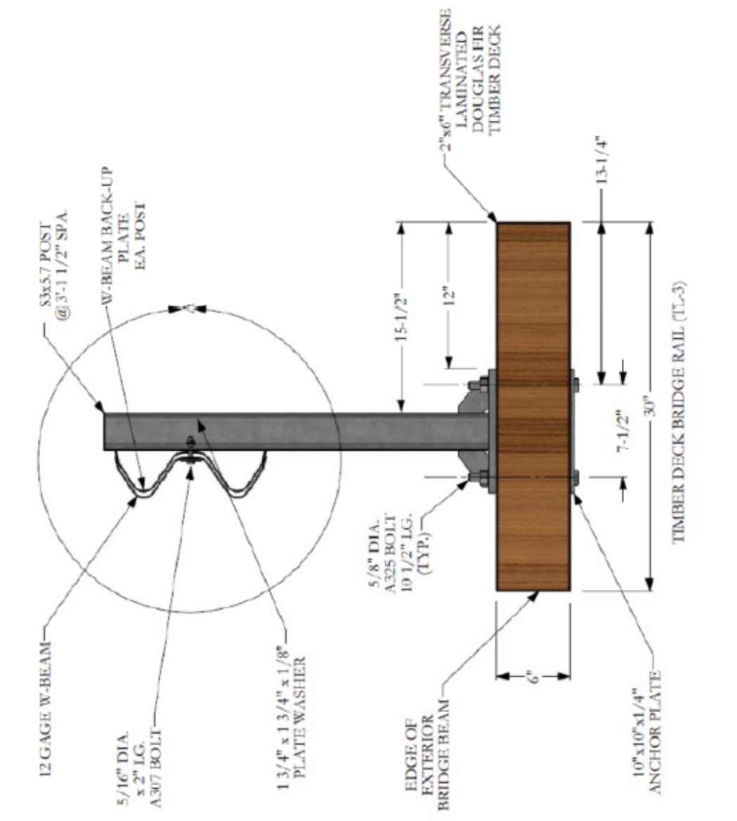

Graphical representation for illustrative purposes only.

