Roadside Safety Pooled Fund Program  Research Problem Statement | State:  Florida
Title:
MASH End Treatment for Rigid Barrier
Problem Statement:
Shielding the ends of rigid bridge rails in urban areas is difficult due to limited right-of-way and longitudinal space. These conditions are typically coupled with sidewalks and curbs, which combines with space constraints that prevent the use of guardrail transitions and their associated end treatments. Currently, the only options are Crash Cushions or a turn-down (mitered) of the barrier end. Mitered ends create potential ramping hazards if not constructed over a significant distance, which could still induce roll-over for non-end-on hits. Additionally, Crash Cushions are not specifically designed to be used adjacent to or in combination with curbs and typically have a much larger cross-section than the ridge barrier.

The development of a non-proprietary end treatment for use with common bridge traffic rail shapes (i.e. F-Shape, Single-Slopes, Vertical, etc.), which work in combination with curbing (i.e. Design Speeds ≤ 45 mph, TL-2), and require minimal cross-section and length, would provide a better option to the available alternatives.
Objectives of the Study:
Develop a MASH TL-2 compliant Ridge Barrier End Treatment, which would work in combination with standard 6” AASHTO Type B curb and have a cross-section only minimally wider than the rigid barrier.
Expected Benefits:
A MASH TL-2 Rigid Barrier End Treatment would provide a crashworthy alternative to bridge railings in urban area where space is limited, curb is present, and current options have proven to be ineffective.

Description of the Proposed Feature to be Tested: (Be as detailed as possible. Include drawings and/or plans, if available.)
The picture below shows a fairly typical location in Florida where the right-of-way is constrained, a pedestrian facility is provided and there is insufficient room for a crash cushion or guardrail transition/end terminal. The research would need to explore options for an end treatment that was fairly short (≈15-ft), similar cross-section to the rigid barrier (12 to 18-in wide), no projections on the backside that could be dangerous to pedestrians, and crashworthy in combination with a curb.

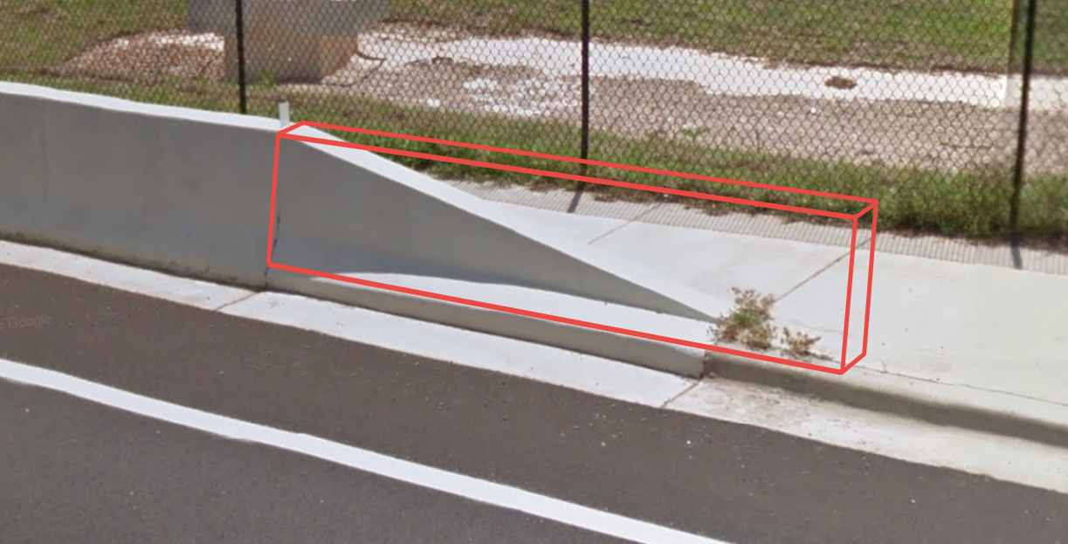

Estimated Cost (of the feature per linear foot installed): | Total Estimated Cost of Crash Test:
Contact Person: | Telephone:

