Roadside Safety Pooled Fund Program  Research Problem Statement | State:  Florida
Title:
F-Shape Concrete Barrier MASH Compatibility
Problem Statement:
A large amount of the existing Concrete Median Barrier installed, and currently planned for construction, is 32-in tall F-Shape barrier. Additionally, 32-in barriers are typically the maximum practical height allowed in urban areas, near intersections, and other locations where site distance is of particular concern. For the purposes of maintaining existing installations and for continued use of existing construction equipment, it is important to know whether or not this barrier shape and height will be acceptable based on MASH TL-3 criteria. It is also important to establish the minimum reinforcement requirements for a MASH TL-3 32-in Concrete Median Barrier.
Objectives of the Study:
Establish the acceptable MASH Test Level of 32-in F-Shaped Concrete Median Barriers and the resulting minimum amount of reinforcement.
Expected Benefits:
With the impending adoption of the MASH Implementation Agreement evaluating currently used alternatives is necessary for their continued use. This project would allow States to continue to use 32-in F-Shape Concrete Barrier for TL-3 design conditions after MASH Implementation is effective.
Description of the Proposed Feature to be Tested: (Be as detailed as possible. Include drawings and/or plans, if available.)
32-in F-Shaped Concrete Barrier. Evaluation of the most common dimensions, outside of the face shape, and material specification will be needed to establish the most representative overall test features. A Standard Concrete Median and Shoulder Barrier are shown below.

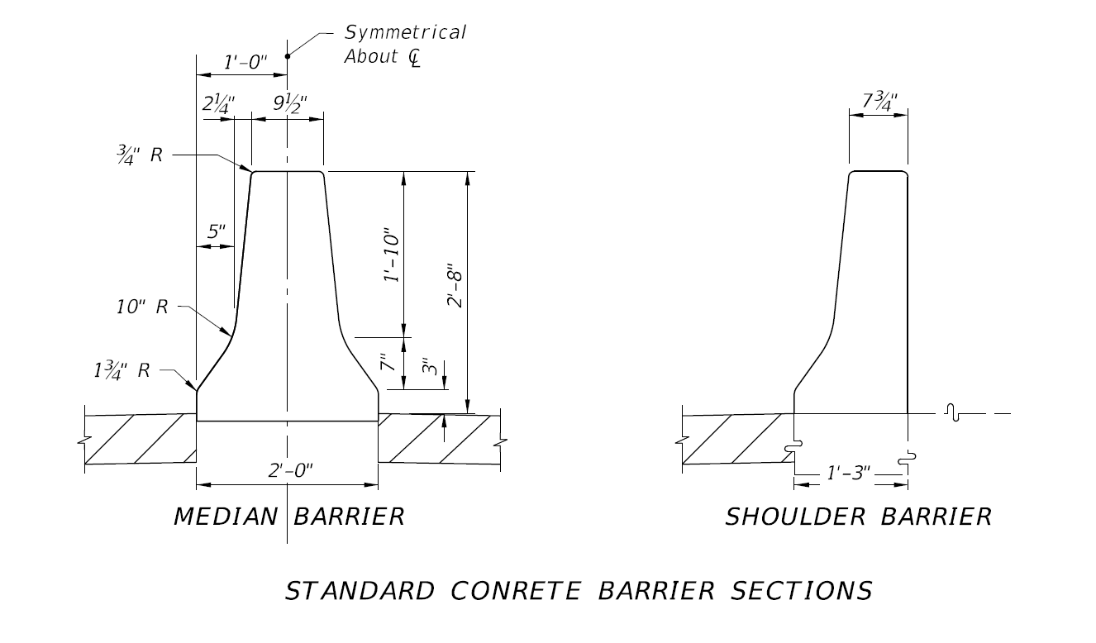
Estimated Cost (of the feature per linear foot installed): | Total Estimated Cost of Crash Test:
Contact Person: | Telephone:

