Roadside Safety Pooled Fund Program  Research Problem Statement | State:  Florida
Title:
MASH testing of Rub-Rail
Problem Statement:
Rub-Rail (RER01 and RLR01) in combination with w-beam guardrail has been utilized for both mitigation of crash severity for motorcycle impacts and to improve the redirective capabilities of guardrail (i.e. reduce underrides) in median/slope applications. This post option needs to be reevaluated to establish MASH acceptability when used with 31-in w-beam guardrail.
Objectives of the Study:
Provide MASH acceptance of w-beam guardrail in combination with RubRail.

Determine if the Rub-Rail improves the redirective and capture capacity of 31-in w-beam guardrail.
Expected Benefits:
With the impending adoption of the MASH Implementation Agreement evaluating currently used alternatives is necessary for their continued use.

Will also provide valuable information to supplement ongoing research (NCHRP 22-22(02) – Effectiveness of Traffic Barriers on Non-Level Terrain) to evaluate the acceptable placement location of barriers in medians if the Rub Rail improves the capture capacity of double-faces w-beam guardrail.
Description of the Proposed Feature to be Tested: (Be as detailed as possible. Include drawings and/or plans, if available.)
Research will be needed to evaluate the most appropriate Rub-Rail standards from the TF13 Barrier Hardware Guide (i.e. RER01 or RLR01) for MASH testing. Example photo below.

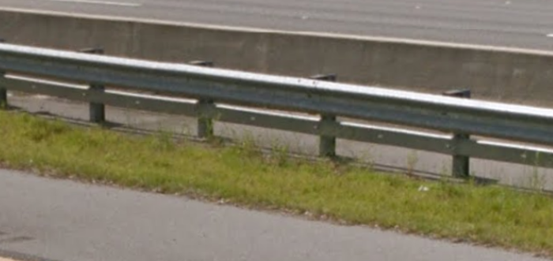

Estimated Cost (of the feature per linear foot installed): | Total Estimated Cost of Crash Test:
Contact Person: | Telephone:

