Roadside Safety Pooled Fund Program  Research Problem Statement | State:  Florida
Title:
Vertical-Face Bridge Rail MASH TL-3/TL-4 Testing
Problem Statement:
Vertical-Face traffic railings are commonly used to minimize space requirements and reduce vehicle ride-up when placed in conjunction with curbs/raised sidewalks. The Vertical-Faced shape induces the least amount of vehicle climb as compared to other barrier shapes, which makes it more conducive for areas where curbs or sidewalks may be present in advance of the barrier.

Therefore, when a pedestrian way (sidewalk) is required in areas with drop-off/slope hazards, limited space is available, and the hazard requires shielding for both vehicles and pedestrians a Vertical Faced barrier option would likely provide the most acceptable option.
Objectives of the Study:
Part 1) Evaluate the 32-in and 42-in Vertical-Face traffic railings and provide MASH acceptance for TL-4.

Part 2) Establish the MASH Test Level for Vertical-Face traffic railing used in combination with raised sidewalks or curbs in advance of the barrier (TL-2, TL-3 or TL-4).
Expected Benefits:
With the impending adoption of the MASH Implementation Agreement evaluating currently used alternatives is necessary for their continued use.

Will also provide valuable MASH tested alternative for rigid barrier placed at the back of sidewalk.
Description of the Proposed Feature to be Tested: (Be as detailed as possible. Include drawings and/or plans, if available.)
Evaluation of Critical Sidewalk width would be needed. Photograph of existing installation and examples of current designs shown below.

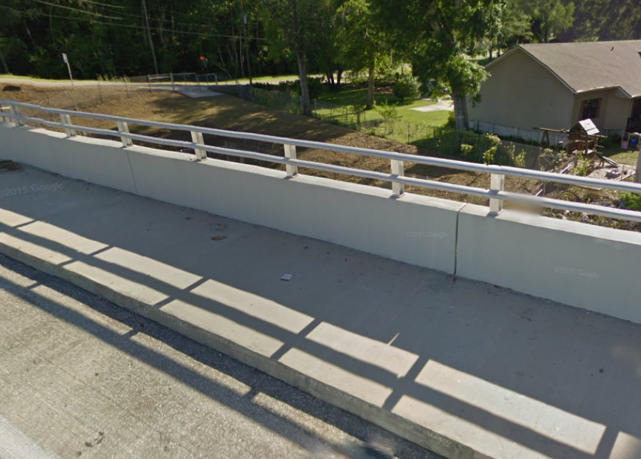

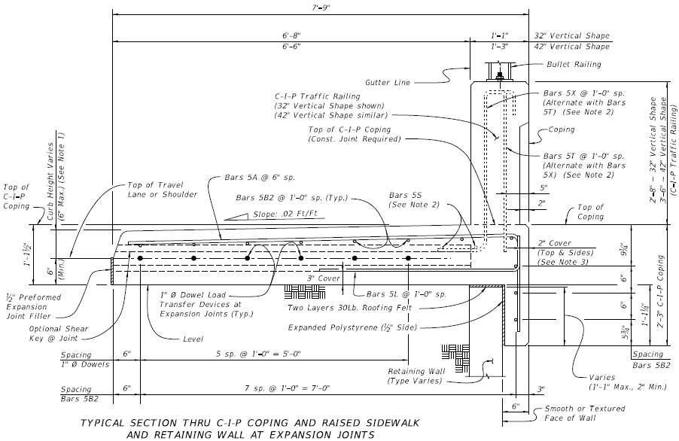
Vertical-Face Behind Raised Sidewalk (Wall Coping w/Moment Slab Option)

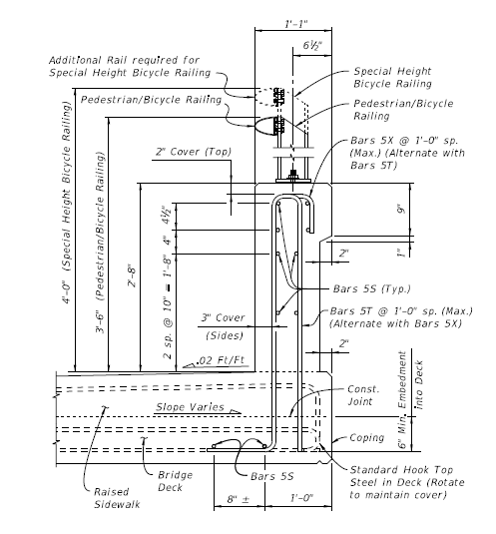
32-in Vertical-Face Behind Raised Sidewalk

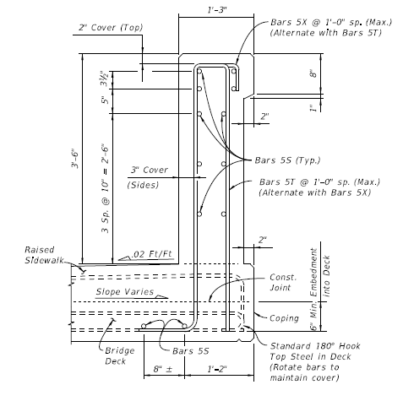
42-in Vertical Face Behind Raised Sidewalk

Estimated Cost (of the feature per linear foot installed): | Total Estimated Cost of Crash Test:
Contact Person: | Telephone:

