Roadside Safety Pooled Fund Program  Research Problem Statement | State:  PA-108
Title:
MASH Compliant Generic TL-2 (MELT)
Problem Statement:
Frequently there are needs on low speed, low ADT roadways for a less than TL-3 terminal. There are projects on rural, under 45 mph roadways where guide rail is being updated to current standards as part of an improvement project. A generic TL-2 terminal, such as the MELT, would fit into the scope and context of these projects.

However, many DOTs are now moving to the MGS/Modified MGS (8 blockouts) at 31” to top of rail. This necessitates retesting/modifying the MELT.

Objectives of the Study:
The objective of this study is to determine if the generic MELT terminal is crashworthy at a MASH TL-2 level at 31” with Modified MGS (8” blockouts). The results could be integrated into many DOT Standard Drawings as an alternate to proprietary terminals.
Expected Benefits:
This project will result in a generic alternative to proprietary TL-2 terminals. These terminals could be bid competitively against proprietary terminals. Since they would be generic, maintenance could be done either by DOT Maintenance Forces or maintenance contracts. The competitive bidding would help keep costs of either option low.

Description of the Proposed Feature to be Tested: (Be as detailed as possible. Include drawings and/or plans, if available.)

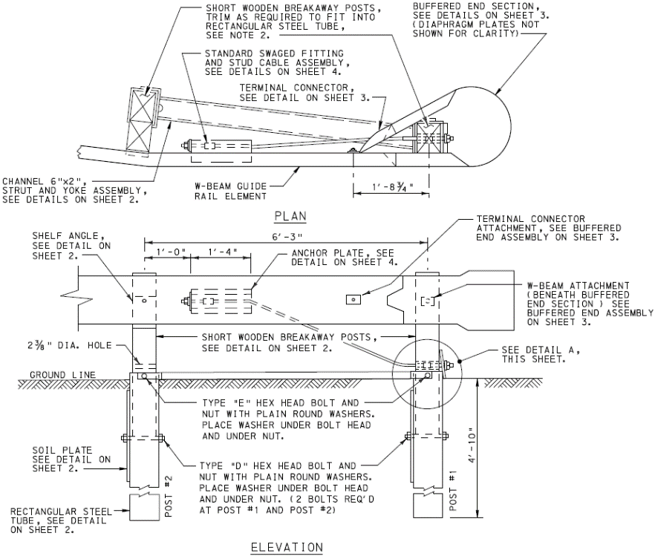
The project would be to update the generic MELT terminal for testing at a MASH TL-2 level.

It is anticipated that the first phase of the project would be FE Modeling of the current MELT terminal at 31”. The results would be examined for any minor “tweaks” before full scale testing.
Estimated Cost (of the feature per linear foot installed):  $1000 - $1500 ea. | Total Estimated Cost of Crash Test:  $60,000
Contact Person:  Mark Burkhead | Telephone:  717-783-5110

