Roadside Safety Pooled Fund Program  Research Problem Statement | State:  Pennsylvania 2014 – PA-78
Title:
F-shape Precast Barrier at Top of Slope
Problem Statement:
Most rigid concrete barriers have been crash tested on a flat surface. These barriers are typically designed with the barrier embedded in the ground or with some type of foundation to make them rigid. This configuration is fairly typical for median applications. Project 405160-13, Concrete Barriers for Slopes or MSE Walls, was completed to develop and test a design for a single slope rigid concrete barrier that can be placed in front of slopes as steep as 1.5H:1V or on top of an MSE wall. The design does not require a moment slab and minimizes the amount of widening behind the barrier, which greatly reduces costs. Adjacent barrier segments are connected using a grouted rebar-grid connection.

This project would utilize a similar concept except the barrier sections would be a single face F-shape which potentially would reduce the barrier width slightly. It should be assumed that the barrier would be precast with a 20 ft maximum length. A TL-4 compliant system is desired.

Objectives of the Study:
The objective of this research is to utilize a single face F-shape barrier for placement at the top of 1H:1V (or flatter) slope with no moment slab. The pavement in front of the barrier could be either bituminous or concrete. The system would target 32” height barrier first and, depending on the results, move on to 50” high (glare screen) barrier. This system would be a TL-4 barrier for use when an extra level of protection is desired at the top of very steep or high drop-off conditions.
Expected Benefits:
A successful project will result in a crash-tested TL-4 compliant concrete barrier system for use at the top of slopes as steep as 1:1 where penetration of the system would be catastrophic. A system without a moments slab would greatly reduce costs and with a narrow cross section to maximize the shoulder width would further enhance safety. Costs will be much less than constructing a moment-slab as an alternate

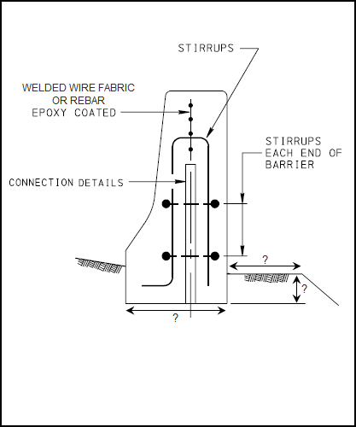
Description of the Proposed Feature to be Tested: (Be as detailed as possible. Include drawings and/or plans, if available.)

The feature to be tested would be a single face F-shape concrete barrier system for use at the top of very steep or very high drop-off slopes. The system should be as close as possible to the slope break-point.

The barrier would be precast at up to 20 ft lengths. Using what was learned from Project 405160-13, (Concrete Barriers for Slopes or MSE Walls) a connection system consisting of a grouted rebar grid is anticipated. This continuity would add to the resistance of the system. A minimum length of the system would be determined by the research.

The optimum reinforcing pattern of the barrier itself (either rebar or welded wire fabric) would be determined.

The slope in front of the system should be as steep as 6:1. A target top width of the barrier is 10”.

It is anticipated that strength calculations and simulations would initially determine the feasibility and dimensions of the feature. Based on the successful outcome of the standard height barrier system, the Pooled Funds Panel would determine if to extend the project to include glare screen height (50”) sections.

Estimated Cost (of the feature per linear foot installed):  $85 +/- | Total Estimated Cost of Crash Test:  $80,000
Contact Person:  Mark Burkhead | Telephone:  717-783-5110

