Roadside Safety Pooled Fund Program  Research Problem Statement | State:  PA-82 (Revised)
Title:
Guide Rail Through Rock Protection at Top of Slope
Problem Statement:
Frequently designers will add a layer of rock protection at the top of a steep existing slope during rehabilitation or minor widening projects to protect the roadway edges from washouts. Typically this layer of rock protection is 18” thick, minimum. It is unknown as to what this layer of rock does to the performance of typical strongpost guide rail during an impact.

Objectives of the Study:
The objective of this study is to determine how strongpost W-beam (modified MGS – 8” blockouts) performs with a layer of rock slope protection around the posts. The rock is typically bucket dumped in an 18” (minimum) loose lift.
Expected Benefits:
This project will result in known performance of standard strongpost W-beam (modified MGS – 8” blockouts) guide rail when installed in a layer of rock protection. Recommendations for changes in standard post length and maximum rock size and thickness would be developed if needed.

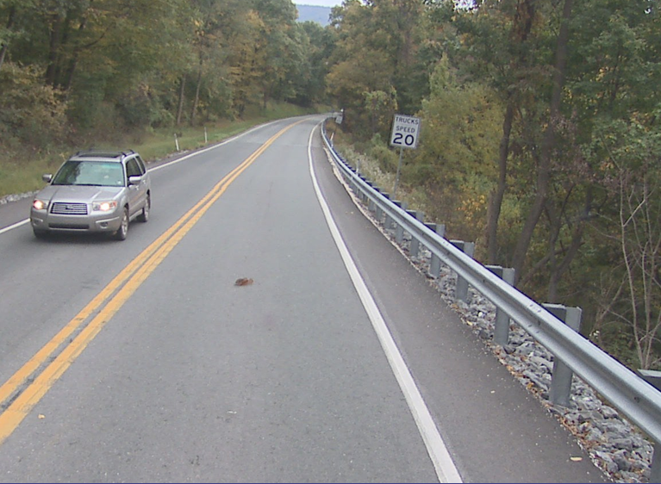
Description of the Proposed Feature to be Tested: (Be as detailed as possible. Include drawings and/or plans, if available.)
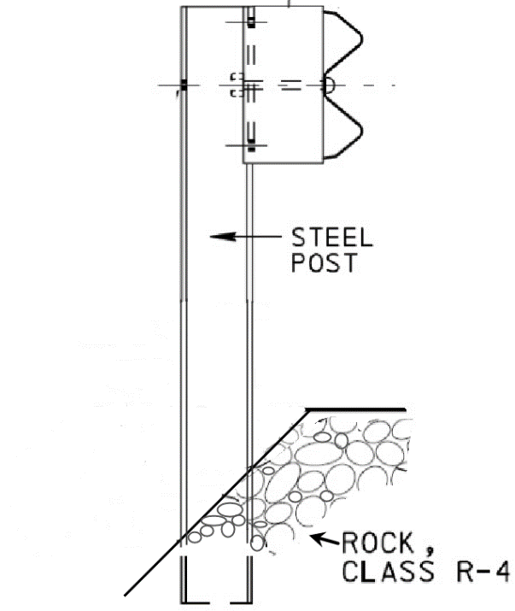
Rock protection at the top of slope is commonly called for during rehabilitation or minor widening projects in areas with already steep embankment slopes. This is placed as a countermeasure for erosion and washouts at the edge of the roadway. This is also standard practice around short span bridge ends due to the lack of deck drains.

R-4 Rock (12” max, 15-50% passing 9”, 0-15% passing 3”) placed 18” thick (min) is the preferred treatment. The construction community feels this is the minimum gradation that resists washout during most rainfall events. In areas of concentrated flow larger rock may be called for.

The test installation would use the Modified MGS - 31” top of rail with mid-span splice and 8” blockout system.

Use on slopes as steep as 1.5:1 is desired.

It is also common that there may not be the two foot backup behind the post available. Using what has been learned from prior Pooled Fund projects for W-beam at the top of slopes, post location would either be at the slope break or a short distance down the slope.

Two phase approach is proposed; first phase consisting of literature search and FE modeling. Second phase – final design and TL-3 testing.

Estimated Cost (of the feature per linear foot installed):  $15 - $20/LF | Total Estimated Cost of Crash Test:  $90,000
Contact Person:  Mark Burkhead | Telephone:  717-783-5110

