Roadside Safety Pooled Fund Program  Problem Statement/Research Proposal | State:  Tennessee 2015 – TN-81
Title:
Design and Evaluation of a Low Profile Temporary Concrete Barrier for Urban Work Zone Protection
Problem Statement:
In the United States, there are only a few widely known low-profile barrier options. The versions developed or tested by Caltrans, Florida DOT, Texas Transportation Institute, and the Midwest Roadside Safety Facility are by far the examples most commonly cited by industry professionals. These have been tested and passed crash tests at TL-2.

However, these existing barriers do not offer much flexibility if one prefers to install it curved or with any slight deflection due to the connection type. Florida DOT’s detail provides some flexibility, however details seem to be complex (need of two bolts, etc.), and it is proprietary. TXDOT’s 20’ long barriers also require a flat terrain with no vertical curve (sag or crest).

The purpose of this research is to design, develop and evaluate a low profile temporary concrete barrier for urban work zone protection that would provide some level of installation flexibility (better curved installation; very easy connection detail – no bolts and nuts).

Below is a preliminary example detail aiming at providing placement flexibility in tight urban construction zones (minimum 18 ft. radius): ½ size 10’ long segments (½ of 20’) will be connected by horizontally dropped (dropped in 1.5 “ wide x 6” deep grove) 40” long 1 ¼” diameter pin. This size pin is commonly used for the roadway projects such as dropped pin anchored barrier design installation or concrete pavement joints. There are two opening at the bottom for forklift and drainage. The barrier will be designed and evaluate according to MASH TL-2.

The information compiled from this research will provide the Departments of Transportation with a low profile temporary concrete barrier option for use in tight urban construction zones and curved instillation sites.

Objectives of the Study:
The objective of this study is to design and evaluate a MASH Test Level 2 low profile temporary concrete barrier for urban work zone protection.

Expected Benefits:
This study would provide evaluation on a newly designed MASH TL-2 low profile temporary concrete barrier for urban work zone protection.

Description of the Proposed Feature to be Tested: (Be as detailed as possible. Include drawings and/or plans, if available.)

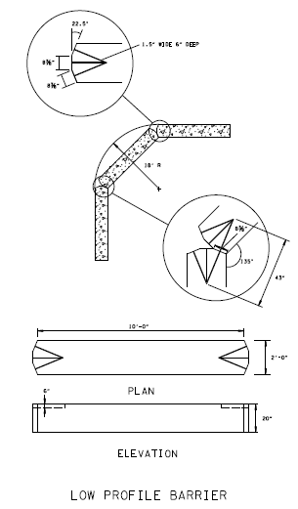

Estimated Cost (of the feature per linear foot installed):  $xx,000 | Total Estimated Cost of Crash Test:  $xx,000
Contact Person:  Ali Hangul | Telephone:  Ali Hangul – (615) 741-0840

