Roadside Safety Pooled Fund Program  Problem Statement/Research Proposal | State:  Tennessee-Minnesota 2015 – TN-MN 80
Title:
Guidance for Raising Beam Guardrail Blockout for Rail Height Adjustment
Problem Statement:
With recent changes/clarifications about appropriate height for beam guardrail, there are more and more existing locations identified where rail height is below the recommended heights. Pavement overlays create additional locations where this occurs. Raising blockout on the post is a low cost safety means to adjust the rail height; however there is still some unknown regarding how the rail system would perform when including use of composite blockouts.
The purpose of this research is to analyze steel and posts W-beam rail performance when composite and wood blockouts are raised on the posts as a mean for adjusting rail height. Specifically, this research will evaluate wood post/composite blockout, steel post/composite blockout, and steel post/wood blockout systems. Outcome of this study will complement any existing guideline regarding the procedure of raising blockouts mounting height on steel and wood posts to achieve recommended rail height for a W-beam guardrail.
Constructability issues related to the possibility of raising blockouts will be addressed throughout this research study.
The information compiled from this research will enable the Departments of Transportation to decide whether raising blockouts on the posts can be chosen as a low cost safety mean to adjust rail height when below recommended value, without compromising the rail system performance.

Objectives of the Study:
The objective of this study is to provide with guidance for raising beam guardrail blockouts for rail height adjustment. Guidance will include use of steel and wood posts with wood and composite blockouts.

Expected Benefits:
This study would provide a guidance to complement any existing guideline regarding the procedure of raising blockouts mounting height on steel posts to achieve recommended rail height for a W-beam guardrail.

Description of the Proposed Feature to be Tested: (Be as detailed as possible. Include drawings and/or plans, if available.)
TDOT current standard drawing showing the extra holes (S-GR31-1):
http://www.tdot.state.tn.us/Chief_Engineer/engr_library/design/StdDrwgEng_PDFs/SGR311_000000.pdf

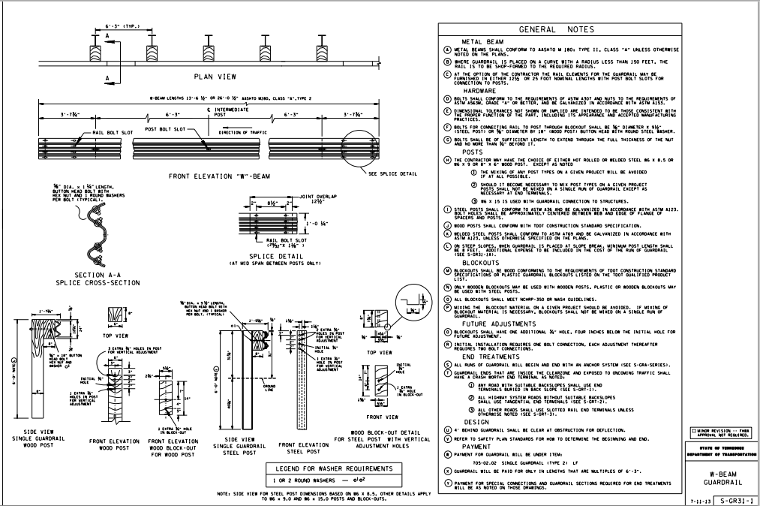

Estimated Cost (of the feature per linear foot installed):  $xx,000 | Total Estimated Cost of Crash Test:  $xx,000
Contact Person:  Ali Hangul, Mike Elle | Telephone:  Ali Hangul – (615) 741-0840 / Mike Elle (651) 366-4622

