**2019 Roadside Safety Pooled Fund Problem Statements**

**Breakaway Devices**

1. **Need to continue using wood post supports**.

Representatives: Scott (OR), Jeff (AK), Rodney (MD)

Comments:

1. TxDOT tested wood sign supports and the tests failed:

<https://www.roadsidepooledfund.org/breakaway-device/single-embedded-wood-post-sign-system/> (SYP wood used)

<https://www.roadsidepooledfund.org/breakaway-device/embedded-wood-post-dual/> (SYP used)

TxDOT Project 469688-4 (SYP used)

1. OR: Comments regarding use of a different type of wood (Doug Fir), as well as component pendulum testing
2. MD: Reported on needs for different post sizes (4x4, 4x6, 6x6, 6x8), and different embedment.
3. AK: interested in larger post single supports with holes and allowable spacing for two posts
4. Possible ISPE to investigate wood sign support behavior in real car crashes.
5. **Luminaire post acceptable size and weight investigation to establish performance limits**.

Representatives: Erik (WI), Scott (OR), Ethan (MN)

Comments:

1. Need to investigate the acceptable requirements (pole size and weight) for a luminaire support;
2. Possible test on a slipbase & transformer base (if not proprietary);
3. Coordination with NCHRP 03-119;
4. Need for survey to investigate the types of luminaires used among the Members;
5. Look for existing study /testing conducted to investigate the performance limits.
6. **Steel and wood dual sign support on slipbase**.

Representatives: Corey (MA), Joe (TN)

Comments:

1. Typical supports W-beam;
2. TN: interested in MASH determination of W-beam slipbase.
3. **Pedestrian Signals and Detectors Assemblies.**

Representative: Derwood (FL)

Comments:

1. See Attached FDOT Standard Plans, Index 665-001;
2. There are two different options that are used frequently that are intended to be crashworthy: “Aluminum Pole” and “Pedestal” mounted (box in red in the attached copy of the Index).
3. Would like to see a project that provides guidelines for these types of sign assemblies for MASH Compliance.
4. Would like to see a project that provides guidelines for these types of pedestrian signals and detector assemblies for MASH Compliance.
5. As an add-on, it would be great if small traffic signals like the picture below could also be addressed.

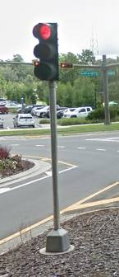

1. **Enhanced Highway Signing Assemblies.**

Representative: Derwood (FL)

Comments:

1. See Attached FDOT Standard Plans, Index 700-120 & 654-001, this Index includes various options for mounting various enhanced signing options (e.g., Flashing Beacons, Highlighted Signs, RRFB’s, Speed Feedback, etc.);
2. There has been some work done for TxDOT with flashing beacon sign assemblies:

<https://www.roadsidepooledfund.org/breakaway-device/txdot-pedestal-pole-with-beacon-and-solar-assembly/> However, there are many other options out there. Would like to see a project that provides guidelines for these types of sign assemblies for MASH Compliance;

**Longitudinal Concrete Barriers**

1. **MASH TL-4 Full-Scale Crash Testing of Free-standing Precast Concrete Barriers**.

Representatives: Chris (OR), Josh (CO), Nina (PA)

Comments:

1. Oregon interested in investigating MASH compliancy for their 42” F-Shape PCB system, pin&loop segment connection, 12.5’ segment length;
2. PennDOT investigating MASH compliancy of their 32”, 42”, 50” tall PCB systems when embedded; testing 50” and anticipated professional opinion for 32” and 42”;
3. Colorado would be interested in the PennDOT testing results and the professional opinion results derived from it;
4. Oregon would be satisfied with professional opinion.
5. **Light Poles, Luminaires and Sign Truss Mounted Guidance for Attachments on Top of Concrete Barrier**.

Representatives: Carlos (MI), Jim (MA)

Comments:

1. Previous TxDOT projects of interest: <https://www.roadsidepooledfund.org/longitudinal-barrier/txdot-42-inch-single-slope-concrete-median-barrier-with-light-pole/>; <https://www.roadsidepooledfund.org/longitudinal-barrier/sign-on-concrete-median-barrier-2/>
2. Guidance might be directed towards allowable mass of the system on top of barriers.
3. **Investigation and Testing of the Shallowest Embedment or Footing Required for a Cast-In-Place Concrete Median Barrier at MASH TL-5 Conditions**.

Representatives: Jim (MA), Chris (TX)

Comments:

1. MassDOT needs to install TL-5 median barrier for pier protection. Existing median has conduits with fiber optic cables in them that would be prohibitively expensive to move. Need to investigate the shallowest embedment or footing required to achieve TL-5 conditions. Alternatively, need to investigate the shallowest embedment required to achieve TL-5 conditions;
2. Previous research of interest: <https://www.roadsidepooledfund.org/longitudinal-barrier/single-slope-concrete-barrier-in-1-inch-aspahlt/>; <https://www.roadsidepooledfund.org/mash-testing-of-keyed-in-single-slope-barrier-610221-01/>
3. **Guardrail to Portable Concrete Barrier Transition**Representatives: Shawn (UT)  
   Comments:
4. Utah interested in Thrie-Beam transition to anchored PCB for permanent application
5. **Portable Concrete Barrier to Cast in Place Concrete Barrier Transition**Representatives: Shawn(UT)  
   Comments:
6. Previous Roadside Safety Pooled Fund project of interest: <https://www.roadsidepooledfund.org/transition/pinned-barrier-transition/>
7. Previous project is for roadside application; Utah is interested in Median application
8. **Transition from W-Beam guardrail to concrete barrier**Representatives: Steve(AL), Mark(DE), Carlos(MI), Hassan (PA)  
   Comments:
9. Previous project of interest: <https://www.roadsidepooledfund.org/transition/w-beam-transition/>
10. 31” W-Beam guardrail to permanent concrete barrier (multiple shapes)
11. **Permanent Concrete Low Profile Barrier**Representatives: Derwood (FL)  
    Comments:
12. Florida has a need to include items closer to the roadway in Urban Areas (e.g., trees, street furniture, parklets, etc.) or to provide positive protection for separated pedestrian/bicycle facilities.  Having a permanent MASH TL-2 Concrete Barrier would be a viable solution in many of the these cases.

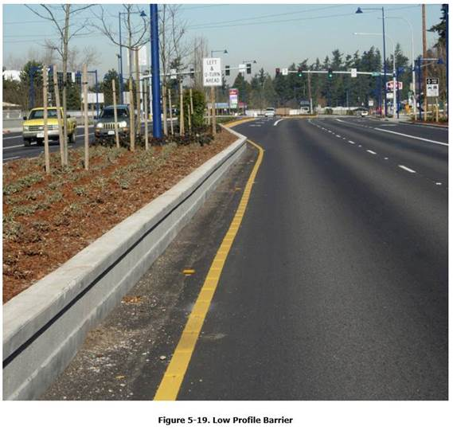

**Longitudinal Semi-rigid Barriers**

1. **Design and Testing of a MASH TL-3 and TL-4 Thrie-Beam for Roadside Applications**.

Representatives: Jim (MA), Joe (WV), Kurt (LA)

Comments:

1. Previous G9 Thrie Beam Guardrail design tested under MASH TL3 conditions and failed 3-11 test:

<https://www.roadsidepooledfund.org/longitudinal-barrier/g9-thrie-beam-guardrail/>

1. Need to revise existing design to propose solution for successful MASH testing
2. **Design and Testing of a MASH TL-3 and TL-4 Thrie-Beam for Median Applications**.

Representatives: Jim (MA), Fil (IL), Nina (PA)

1. **MASH TL-3 Testing of 31” rectangular wood-post W-Beam guardrail in concrete mow-strips**.

Representatives: Kurt (LA)

Comments:

1. Previous 31” W-beam rectangular wood-post system tested under MASH TL3 conditions and failed 3-11 test:

<https://www.roadsidepooledfund.org/w-beam-guardrail-with-steel-and-wood-posts-in-concrete-mow-strip-608551/>

1. **MASH TL-3 Testing of 31” steel-post W-Beam guardrail in asphalt pavement**.

Representatives: Jeff (AK), Aimee (MD)

Comments:

1. Looking at full-depth asphalt pavement;
2. Possibly serving as mow-strips;
3. Interest in investigating asphalt depth needed for specific applications
4. **BIB Terminal Variations in Foreslope/Backslope/Ditch Configurations**.

Representatives: Jeff (AK), Chris (OR), Josh P. (CO), Fil (IL)

Comments:

1. Backslope conditions (what are the applicable ranges and the critical slope for the system that was tested under MASH)
2. Ditch configuration (V-ditch / Flat bottom ditch)
3. Width of the ditch (specifically, how far the rail installation location is in the ditch, from the road edge line – this would influence the rail height and consequently the space between the local ground and the bottom of the rubrail)
4. Possibly: foreslope conditions (flatter than 4:1 – maybe remove the rubrail) – depending on Members’ poll results
5. **31-in. MGS system with variation in curb height and offset for MASH TL-3 application**.

Representatives: Aimee (MD), Nina (PA)

Comments:

1. Existing NCHRP 22-39 project on “31-in. Midwest Guardrail System (MGS) and Curb Combination Guidelines for MASH TL-3”:

<https://apps.trb.org/cmsfeed/TRBNetProjectDisplay.asp?ProjectID=4585>

1. Some DOTs interested in using an 8-inch tall curb
2. **Professional Opinion for MASH TL-3 thrie-beam transition from 31” W-beam guardrail to concrete parapet**.

Representatives: Joe (WV), Nina (PA)

Comments:

1. TxDOT standards include the following transition:

<https://www.dot.state.tx.us/insdtdot/orgchart/cmd/cserve/standard/rdwylse.htm>

(see GF(31)TR-14)

1. Some DOTs are interested in obtaining a professional opinion regarding the crashworthiness of the above transition system

Submitted by Email:

1. **Length-Of-Need for Unanchored Guardrail**.

Representatives: Derwood (FL)

Submitted by Email:

1. **Options for Shallow Embedment W-Beam Guardrail Posts.**

Representatives: Derwood (FL)

Comments:

1. We often run into cases where shallow buried utilities (e.g., buried water, sewer, or fiber optic lines) prevent the use of standard guardrail posts and the guardrail location is limited by right-of-way or terrain. Having a shallow embedment post option (preferably <2 ft) or a surface mounted moment slab design would very helpful in spanning these conditions, which could sometimes stretch for hundreds of feet. Below is a design from FDOT Standard Plans. TTI led a project for the pooled fund several years back “Steel Post over Underground Structures”: <https://www.roadsidepooledfund.org/steel-posts-over-underground-structures-405160-12/>; however, this system was for only one post and it’s a fairly difficult system to repair if impacted. A surface level or curb height moment slab that had very little to no movement when impacted would work best.

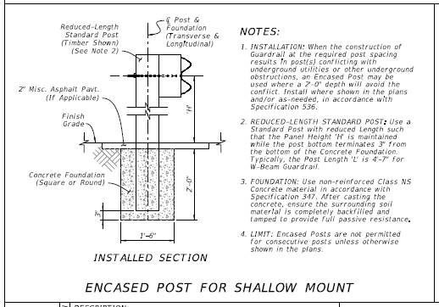

FDOT Standard Plans, Index 536-001

1. TxDOT is planning to fund a research and testing study on “Evaluation of Surface Mounted Median Guardrail”

**Bridge Rails**

1. **MASH TL-5 investigation of the TBTA rail system when mounted on traditional concrete deck**.

Representatives: Carlos (MI), [Alex (OR)??]

Comments:

1. The TBTA bridge rail system was tested to the full matrix of MASH TL-5 criteria: <https://www.roadsidepooledfund.org/longitudinal-barrier/tbta-bridge-rail-2/>

(<https://www.roadsidepooledfund.org/wp-content/uploads/2017/04/b274-1.pdf>)

1. The previously tested TBTA system was evaluated on a surrogate composite bridge span;
2. Suggestion to utilize loads from previously published NCHRP 20-07 Task 395 report.
3. **Evaluating TL-4 thrie beam retrofit option.**

Representatives: Carlos (MI), Derwood (FL), Alex (MA), John (WA), Alex (OR)

Comments:

1. Retrofit options to be attached to existing bridge deck/curb
2. Looking into basic idea for geometric design characteristics
3. Interested in steel posts.
4. **TL-4 bridge rail system for shared used facilities.**

Representatives: Carlos (MI), Kevin (IL), Kenneth (ON)

Comments:

1. With multi-modal facilities, there is a need to design and evaluate a TL-4 bridge rail that accommodates both vehicles and pedestrian /bicyclists;
2. MI: in need for 54” steel tube railing barrier for shared used facility;
3. IL: 39” concrete + steel tube on top
4. **TL-4/5 noise-walls on top of barriers.**

Representatives: Alex (MA), Kenneth (ON), Kevin (IL), Taya (TX)

Comments:

1. Interested in incorporation of the noise walls with existing barriers 🡪 need direction on where to place them;
2. ON. IL: interested in TL-4;
3. MA: highways in urban areas; TL-5
4. Zone of Intrusion (ZOI) consideration - maybe attach to back of the barrier to reduce severity of impact and limit ZOI?)
5. NCHRP 22-34 on ZOI envelopes for MASH TL-4
6. Potential simulations to investigate loads on sound-walls for TL levels, for different lateral offsets
7. TX interested on loads for sounds-walls behind the barriers

**Work Zones**

1. **Testing type 3 barricades with aluminum panel and mounted sign on top**.

Representatives: Ken (MN), Steve (WA), Hassan/Brian (PA), Fil (IL)

Comments:

1. MN and PA have drawings available of desired test article
2. Need site adjustability
3. MASH tested Type 3 barricade with Al sign support: <https://mwrsf.unl.edu/researchhub/files/Report346/TRP-03-394-18%20Revision-1.pdf>
4. **Testing of type 3 of a generic skid-mounted system for guide signs**.

Representatives: Ken (MN), Fil (IL), Dan S (IA)

1. **Testing type 2 barricades and ballast guidelines**.

Representatives: Fil (IL), Carlos (MI)

Comments:

1. MI: need for ballast guideline for barricade Type 2; what is the amount of ballast needed and what is the material to be used?
2. **Portable sign supports for aluminum signs with variation on mounting height**.

Representatives: Ken (MN), Shawn (UT), Hassan/Brian (PA)

Comments:

1. Sign mounting height varies depending on the base type and application (1 ft off the ground for skid-mounted; 3-ft off ground when placed along with channelizing devices)
2. PA has available drawings for testing
3. **Testing of ITS system for smart work zones**.

Representatives: Carlos (MI), Ken (MN)

Comments:

1. Consider issue that some are proprietary in nature;
2. MN commented there are no many directives to mount these systems and still provide crashworthiness;
3. Some of these systems come on breakaway bases, include a solar panel attachment on top, and might have conduit included in part of the device
4. TxDOT tested: <https://www.roadsidepooledfund.org/breakaway-device/txdot-pedestal-pole-with-beacon-and-solar-assembly/>
5. **Generic sign cover for variable speeds**.

Representatives: Carlos (MI), Ken (MN), Steve (WA)

Comments:

1. MN allowed corrugated plastic; however, still needs something to hang over the sign panel;
2. WA: similar issue for variable speeds and material
3. **Crashworthiness of work zone category 1 and 2 device with light accessory**.

Representatives: Fil (IL)

Comments:

1. Light accessory could be solar panels, beacon, etc…
2. **Generic global “warning” sign size design**.

Representatives: Fil (IL), Carlos/Chris (MI), Ken (MN)

Comments:

1. Generic sign support and sign size for oversized warning/message signs