***2019 Roadside Safety Pooled Fund Annual Meeting***

***College Station, Texas***

***September 24-25, 2019***

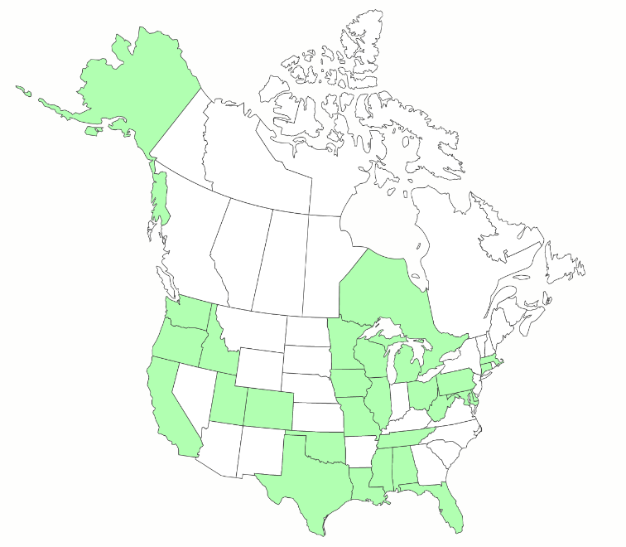



***TPF-5(343)***

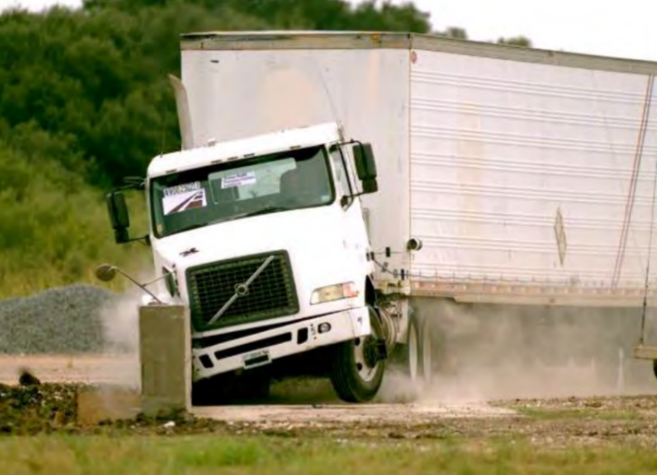

* *

*College Station, Texas*

September 24-25

# Tuesday, September 24th

|  |  |  |
| --- | --- | --- |
| **8:30** | Welcome and Introductions | 15 min |
| **8:45** | Organization Overview | 15 min |
| **9:00** | Ongoing Research Status | 1hr. 15 min |
| **10:15** | Midwest Pooled Fund Program Overview | 10 min |
| **10:25** | FHWA Update | 15 min |
| **10:40** | Morning Break | 20 min |
| **11:00** | Proposal Presentations - Q&A *Longitudinal Semi-Rigid Barriers* | 1 hr. |
| **12:00** | Lunch  **Onsite at TTI Headquarters Building** | 1 hr. |
| **1:00** | Gather and Relocate to Crash Test Site | 30 min |
| **1:30** | Observe Crash Test | 30 min |
| **2:00** | Proposal Presentations - Q&A *Longitudinal Concrete Barriers* | 1 hr. 30 min |
| **3:30** | Afternoon Break | 15 min |
| **3:45** | Proposal Presentations - Q&A *Bridge Rails* | 45 min |
| **4:30** | Adjourn |  |
| **6:30** | Group Dinner  **Casa Do Brasil**  1665 Greens Prairie Rd W, College Station, TX 77845 |  |

**Wednesday, September 25th**

|  |  |  |
| --- | --- | --- |
| **8:30** | Group Forum - *Charter Review, Looking Forward* | 1 hr. |
| **9:30** | Round Table Discussion | 1 hr. |
| **10:30** | Morning Break | 30 min |
| **11:00** | Proposal Presentations – Q&A *Breakaway Devices* | 1 hr. |
| **12:00** | Lunch  **Onsite at TTI Headquarters Building** | 1 hr. |
| **1:00** | Proposal Presentations - Q&A *Work Zones* | 1 hr. 30 min |
| **2:30** | Afternoon Break | 15 min |
| **2:45** | Voting | 2 hr. 15 min |
| **5:00** | Adjourn |  |

***Other Notable Topics***

# Presentation Expectations

As the problem statement champion, when presenting problem statement information please limit the presentation time to 6 minutes, with an additional 4 minutes provided for questions.

Printed copies of each proposal for will be provided to each member by the Pooled Fund prior to discussion. TTI will have PowerPoint slides worked up in advance of the meeting. If you wish to add something to the slides please communicate with the TTI lead of your problem statement in advance of the meeting.

Due to the number of proposals this year, we’ll be asking you to stick closely to the time allotted.

# Map and Directions to Meeting

There are two entries to RELLIS Campus. The original one on Hwy 47 (red line) and a new one on Hwy 21 (blue line) next to the Center for Infrastructure Renewal (CIR). On Hwy 21, drive west past the campus, turn left to U-turn back east, then enter a deceleration lane. Turn right at the CIR building.

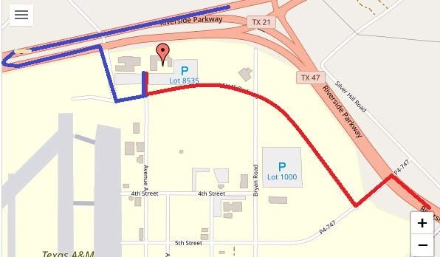

# Parking at TTI Headquarters

You may park in any spot in Lot 8535. **IF** you are in a DOT marked vehicle you **do not** need to worry about a day pass for the lot. If you are in a personal or rental vehicle you will need to take the following steps to obtain a parking pass **each day.**

# *This must be done each morning as the pass is only good for one day*

* Take a photo or notate your license plate number
* Stop at the front desk of the TTI Headquarters building with your license plate number and $5.00 payment.

# Map and Directions from The George Hotel to Casa Do Brasil

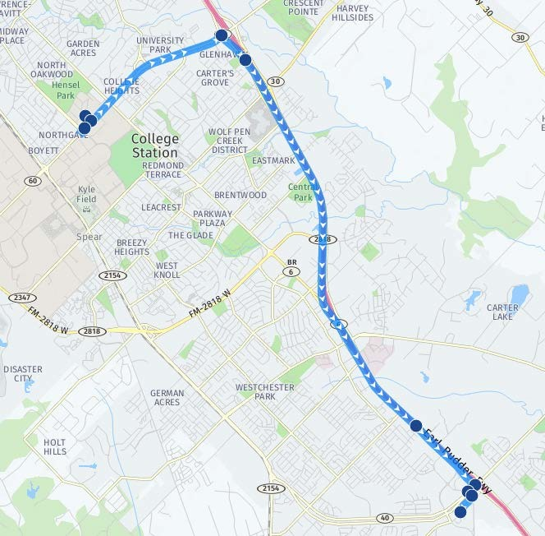180 Century Ct College Station, TX 77840 to - Greens Prairie Rd W College Station, TX 77845 Total distance: 10 miles

1. Turn right onto University Dr. (FM-60). Go for 0.1 mi.
2. Make a U-Turn onto University Dr. (FM-60). Go for 2.2 mi.
3. Turn right onto S Earl Rudder Fwy. Go for

0.4 mi.

1. Take left ramp onto TX-6 S (S Earl Rudder Fwy). Go for 5.2 mi.
2. Take the exit toward TX-40/WM D Fitch Pkwy/Hospital onto Frontage Rd W. Go for

1.0 mi. (Continuing straight through 4 way intersection)

1. Turn right on to Greens Prairie Rd W. Go for

.5 mi.

1. Take left at Casa do Brasil.

Roadside Safety MASH Implementation -- **DRAFT**

TPF (5)343

**Committee Charter**

**A proposed update to be submitted for approval at the 2019 Annual Meeting**

**Purpose**: The purpose of the MASH Implementation Pooled Fund is to improve the understanding and exchange of information concerning MASH (Manual for Assessing Safety Hardware) implementation, and to develop and conduct research inquiries to comply with the new requirements for MASH and the AASHTO/FHWA Joint Implementation Agreement.. The purpose of the MASH Implementation Pooled Fund Committee (hereinafter Committee) is to provide for meaningful input, feedback, and decision making that supports the pooled fund’s purpose. The Committee’s work is funded through the Transportation Pooled Fund program which allows states to combine their funding resources for research.

**Membership:** The Committee is comprised of one member from each State that provides funding contributions. Voting privileges are assessed by the lead state on April 1 of each year, and are rescinded for states not current with their required annual contribution (see Funding). States that are current within 12 months of any vote can designate a voting member and participate in voting. Each participating agency informs the lead state who on their staff will serve as the voting member, and a voting member may only be an employee of that agency. In advance of a meeting in which voting will take place, the voting member may delegate their vote to another agency employee.. Although other agency staff, including those who are employed by member states, TTI, and FHWA do not vote, they are welcome to participate in all pooled fund meetings, conference calls, and other events.

**Decisions:** Voting on all matters before the committee, including the work plan, research priorities, or questions posed by or to the committee, will be decided by a majority of the committee voting members present. The lead state will be responsible for tallying and reporting out vote results. The lead state is also responsible for determining the voting method that will be used for any particular vote, announcing the voting method before the vote is taken, and may solicit advice from voting members or other participants. This includes decisions related to the confidentiality of any particular vote. Votes may be taken either live, or using an electronic tool such as a web-based survey software, at the lead state’s discretion.

**Meetings:** The annual meeting is a face to face meeting that is held annually and is normally scheduled to take place over two consecutive days. Members are welcome to attend and participate as described in “Membership” above. Travel for the voting member representing each agency is sponsored by the transportation pooled fund. The location of the meeting is decided by a vote of the Committee members, with members volunteering to host the meetings. Normally, every other meeting is held at TTI in College Station TX, in order to provide an opportunity for onsite observation of various ongoing research and testing efforts.

**Chairman:** The Chair of the Committee will be the Washington State voting member. The Chairman participates in the development of the meeting agenda, facilitates the meeting discussion and decision making, and provides direction and oversight of the administration of the pooled fund.

**Lead State:** WSDOT is the lead state for the pooled fund program. As the lead, it is responsible for the following:

1. Collecting the financial transfers from participating states into the pooled fund.
2. Developing and executing work under the master research agreement with TTI.
3. Reviewing and processing invoices on task orders. It is also responsible for fulfilling bookkeeping, reporting, and other requirements imposed by FHWA on pooled fund operations.
4. Reimbursing travel for the Committee members.
5. Making arrangements for meetings and events, or arranging for that work to be done by others, coordinating with the TTI on products such as agendas, information materials, presentations, and other details about the program necessary for conducting meetings as required.

**Texas Transportation Institute:** TTI is the contractor with WSDOT which is established to perform research on MASH implementation research. TTI is responsible for the Committee work plan, research reports and products, internal and external website, letters of acceptance and other documentation necessary to serve the Committee needs,. Work is described in individual task orders that are applied to the master agreement, and work proceeds upon approval of these task orders by TTI and WSDOT. Task orders may also be written to benefit individual member states (at their option) under the master agreement, and these bilateral, reimbursable task orders are organized by WSDOT and the interested state with the cooperation of TTI. Note that processing task orders for individual states may be limited by the capacity of lead state staff, and/or various contractual or funding ceiling issues that may arise. .

**Research projects:** Projects are assigned a lead researcher by TTI, and that person is responsible for conducting the research and providing quarterly reports on progress. The researcher may occasionally be called upon to present the progress to the membership during a meeting or conference call. When the researcher determines that it is in the best interest of the states that the project be modified, the terms of that modification are brought to the lead state for action. In the case of a no cost scope or schedule change, the lead state may, at their option approve the change with or without a vote of the membership. In the case of a budget change, that decision must be brought to the membership for a vote, either during a regular or special conference call or face to face meeting, and the voting is conducted as described above.

**Research proposals:**  Proposals for research are prepared by individual members prior to the meeting. A staff person from one member state is expected to be the lead author and representative for each proposal. That lead author is encouraged to solicit help from other pooled fund participants during the development of the proposal, in order to benefit from subject matter expertise and experience, and in order to generate interest and ultimately support for the proposal. The lead author is required to coordinate with TTI staff during proposal develop so that an opportunity is provided to review and/or participate the development of the scope and estimate, which are both required before the proposal can be voted on.

**Technical Monitor/Representative:** Once it’s determined at the annual meeting that a project will likely be funded in the upcoming fiscal year, a technical monitor is selected who will act on behalf of the membership in consulting with the researchers about questions that may arise during the course of the work.

**Communications:** The lead state keeps a list of the voting member from each state who serves as the primary point of contact. Other names of agency staff may be submitted by the voting member to be included on that roster for routine communications. Occasionally, information about ongoing projects is requested by voting members or others, including outside parties. Information about ongoing projects may be shared by TTI or the technical monitor with one or all voting members (one per state) who request it.

**Funding:**  Member states post yearly commitments to the Transportation Pooled Fund website, which is a promise to transfer federal (or state) funds to WSDOT through the obligation transfer process. WSDOT may ONLY contract with TTI for work in which sufficient obligations have been received. Therefore, states will transfer, at a minimum, annual contributions within the federal fiscal year. Multiple year transfers can also be accepted, depending on individual state research funding program processes. The accepted annual contribution is $50,000, which must be applied on or before March 31 of each year to be credited to the current federal fiscal year (ending September 30), and to maintain voting privileges (see Membership). Extensions are not allowed. The exception is the contribution of the lead state which is $25,000 annually, in recognition of the staff time and resources required to organize the pooled fund. Any other exceptions or extensions may be granted only by action taken by the voting members at the annual meeting.

**Travel:** Membership travel will be reimbursed with transportation pooled funds. Travel reimbursement rules and rates are dictated by WSDOT travel rules and regulations which are consistent with GSA travel per diem rates. Travel may only be reimbursed if prior travel authorization is obtained by WSDOT.

**Responsibilities or functions not otherwise described:** The lead state is responsible for making decisions and addressing questions that may arise and are not otherwise described in the charter, but may at their discretion seek advice on such decisions from the Committee in formal or informal communications

.



**2019-01-BD**

**Research Problem Statement**

|  |  |
| --- | --- |
| **Project Title:** | Wood Sign Supports MASH Compliance |
| **Project Synopsis:** | *Please describe the proposed project synopsis within 200 words.*  Develop criteria for single and multiple wood post sign supports for small to medium sign sizes used for permanent and temporary installations. The project will review existing literature, determine applicable wood species and grades, determine installation details, and perform MASH crash testing. |
| **Project Goal(s):** | Identify and evaluate the crash performance of breakaway wood sign supports. The evaluation should address in-service safety performance, previous crash testing, potential failure modes, and the likelihood of wood supports to comply with the MASH crash test criteria.  Evaluate wood post species, grades, and drilled weakening holes for 4”x4”, 4”x6”, 6”x6”, and 6”x8” post sizes. Consider Douglas Fir, Western Hemlock, or other wood species that can be acceptable alternatives to Southern Yellow Pine. Design modifications that address failure modes.  Identify installation criteria for direct burial wood posts that accounts for acceptable breakaway performance and adequate soil resistance to support the full bending strength of the post. The details shall include post dimensions, drilled weakening hole sizes, location of drilled weakening holes, minimum post embedment’s, number of posts allowed within a 7-foot swath, upper hinge details for multi-post installations, and ranges of sign heights and widths for each post size. |
| **Project Background:** | *Please describe the problem you would like to address.*  Wood sign support 4”x4”, 4”x6”, 6”x6”, and 6”x8” posts have been successfully used for many years that include drilled weakening holes to promote controlled fracture on impact. Wood posts were successfully tested under NCHRP 350 conditions in 1991 (FHWA Eligibility Letter SS-25).  Wood posts are a useful non-proprietary alternative to steel posts and are used for temporary sign supports in work zones and for permanent installations. States prefer to retain the option of using wood posts that satisfy MASH crash testing criteria.  Recent MASH testing of single 4”x4” signpost and closely-spaced multiple 4”x4” sign posts failed due to penetration of the occupant compartment by the sign or post fragments. Evaluation of 4”x4” wood posts with drilled weakening holes or the use of different wood species and grades has not been performed.  Evaluation of larger 4”x6”, 6”x6”, and 6”x8” wood posts using alternative wood species and grades is necessary to provide states information for MASH compliance. Successful testing of larger dimension wood posts with drilled weakening holes will provide states an option to install wood posts in a variety of signing conditions. |
| **Proposed Work Plan:** | *Please describe what work or test will be done and what the result will be.*    The proposed work plan includes the following tasks:   * Literature Review * Engineering analysis of post options * Pendulum Testing * MASH TL-3 Crash Testing * Final Report |
| **Deliverables:** | Summary table of successful results, including post dimension, drilled hole dimension/placement, wood species, wood grades, minimum embedment requirements, number of posts allowed in a 7-foot swath, min/max sign height.  Crash test report, photos, videos, summary of results and performance evaluation summary, support for submitting completed results/materials to FHWA for eligibility letter. |
| **Urgency and Expected Benefit:** | *Please describe the expected benefits of the research.*  MASH implementation milestone for sign supports is December 31, 2019. To date, information is not available whether wood post sign supports are being evaluated by NCHRP 3-119.  Wood post material is a common, available material for sign supports. Maintenance crews can replace damaged wood sign posts with minimal engineering support. Cost of wood posts is competitive with other sign post options for small to medium-sized signs. |
| **Problem Funding and Research Period:** | *Please describe what are the estimated costs and time to complete the project*  The estimated costs to complete the proposed project is $240,000.Estimated time to complete the project is 18 months. |
| **Developer(s) of the Problem Statement:** | Name: Scott Jollo, Oregon DOT  Email: scott.u.jollo@odot.state.or.us  Phone: (503)-986-3069  Name: Jeff. Jeffers, Alaska DOT&PF  Email: jeff.jeffers@alaska.gov  Phone: (907)-465-8962  Name: Rodney Wynn, Maryland DOT  Email: [rwynn@mdot.maryland.gov](mailto:rwynn@mdot.maryland.gov)  Phone: (410)-787-7662 |



**Research Problem Statement**

**2019-02-BD**

|  |  |
| --- | --- |
| **Project Title:** | Steel Luminaire Supports MASH Compliance |
| **Project Synopsis:** | *Please describe the proposed project synopsis within 200 words.*  Develop criteria for non-proprietary steel luminaire supports that satisfies MASH requirements. The project will review existing literature, determine arm and height configurations, determine installation details, perform computer simulations, and perform MASH crash testing. |
| **Project Goal(s):** | Identify and evaluate the crash performance of breakaway steel luminaire supports. The evaluation should include a survey of the Pooled Fund members, in-service safety performance, previous crash testing, potential failure modes, and the likelihood of luminaire supports to comply with the MASH crash test criteria.  Coordinate with researchers that are working on the NCHRP 03-119 project about the parameters they are using, computer simulations they have ran, and the luminaire support they are going to crash test.  Determine the configurations to do computer simulations and verification crash testing to move towards an approved non-proprietary luminaire breakaway support that satisfies MASH. Items to consider are arm lengths, luminaire mounting heights, base type, pole sizes, and maximum weights. |
| **Project Background:** | *Please describe the problem you would like to address.*  Lighting for the State Highways requires installing many installations closed to the traveled way that require breakaway functionality.  Slip base non-proprietary steel luminaire supports are shown on TM629 and TM630 of the Oregon DOT standards and ES-6F of the CALTRANS standards drawings that have provided a high level of safety for many years. Frangible base luminaire supports have been successfully used across the country with a high level of safety with castings forged by Akron that may be considered a proprietary item.  Changes in MASH for the roof crush has raised concerns about whether or not the current maximum total weight of 1000# is acceptable.  The current NCHRP 03-119 project is including luminaire breakaway supports in the research, but the extent of the luminaire breakaway supports investigation is not known. It is cost effective to make sure the work performed for the Pooled Fund does not duplicate the computer simulations, design modifications, and full-scale crash testing already performed by the NCHRP 03-119 project. |
| **Proposed Work Plan:** | *Please describe what work or test will be done and what the result will be.*  The proposed work plan includes the following tasks:   * Literature Review and Survey of States * Computer Simulations * MASH TL-3 Crash Testing * Final Report |
| **Deliverables:** | Summary table of results including breakaway base dimensions, ranges of arm lengths, range of luminaire mounting heights, base types, pole sizes, and maximum weights.  Computer simulation and verification crash test reports, photos, videos, and performance evaluation summaries to use for submitting completed results/materials to the FHWA for an eligibility letter. |
| **Urgency and Expected Benefit:** | *Please describe the expected benefits of the research.*  MASH implementation milestone for luminaire supports is December 31, 2019.  Steel luminaire breakaway supports are very common and maintenance crews have had satisfactory historical performance.  The results of this research can move States towards MASH compliant breakaway luminaire supports. |
| **Problem Funding and Research Period:** | *Please describe what are the estimated costs and time to complete the project*  The estimated costs to complete the proposed project is $120,000.Estimated time to complete the project is 18 months. |
| **Developer(s) of the Problem Statement:** | Name: Erik Emerson, Wisconsin DOT  Email: Erik.Emerson@wi.gov  Phone: (608)-266-2842  Name: Scott Jollo, Oregon DOT  Email: scott.u.jollo@odot.state.or.us  Phone: (503)-986-3069  Name: Ethan Peterson, Minnesota DOT  Email: ethan.peterson@state.mn.us  Phone: (651)-234-7380 |



**2019-03-BD**

**Research Problem Statement**

|  |  |
| --- | --- |
| **Project Title:** | Non-proprietary Large Sign Supports |
| **Project Synopsis:** | *DOT’s are using non-proprietary wood and steel-I-beam supports with slip bases to support large ground mounted guide signs and need assistance in determining if these designs may continue to be used and in evaluating if they will meet the new MASH testing requirements. Sign supports of different shapes, materials and spacing should be considered. It is specifically requested that closely spaced sign supports (< 6’ spacing) are tested.* |
| **Project Goal(s):** | 1. Provide clarification to state DOT’s regarding the limits of the continued use of sign supports which meet NCHRP 350 after December 31st, 2019 and what analysis is needed to justify their continued use. 2. Determine if large sign supports of different shapes, materials and spacing can meet MASH test requirements. It is specifically requested that closely spaced sign supports (< 6’ spacing) are tested |
| **Project Background:** | *Many DOTs use a non-proprietary steel-I-beam support design for all large ground mounted extruded panel type signs. It is assumed these designs meet NCHRP 350 test criteria but not MASH.*  *Per FHWA (Federal Register)* *Docket No. FHWA-2015-0008:*  *The NCHRP 350-tested devices remain eligible for Federal-aid funding. The FHWA will not withdraw an existing Federal-aid eligibility letter for a product that currently meets NCHRP Report 350 criteria. The proposed deadline does not prevent a manufacturer from modifying a device, does not impose any requirements for the installation of MASH-tested devices, nor does it prevent a State DOT from installing a device previously tested to the NCHRP 350 criteria. The proposed deadline only applies to those seeking a Federal-aid eligibility letter for a modified device previously tested to NCHRP 350 criteria. It will be the States' responsibility to determine if all future proposed modifications made to existing 350 devices comply with NCHRP Report 350 criteria.*  *DOT’s request clarification on the above statement RE: Can DOT’s continue to use current NCHRP 350 compliant non-proprietary steel-I-beam supports and if not what steps need to be taken to continue their use?*  *If the use of the subject sign supports cannot be continued staring in January of 2020, will the subject post be considered non-crashworthy and if yes, will projects already let and bid have to be changed to MASH compliant sign supports?*  *Either way, large ground mounted sign supports have not been crash tested under the MASH criteria and it is requested that the performance of such supports is researched acknowledging the MASH criteria.*  *In addition, it is desired to test the effects of two closely spaced supports under the MASH criteria. Situations exist where multiple closely spaced (< 6’) supports support a single sign. By having the supports spaced less than 6’ apart, there is a chance that a vehicle may strike both posts during a collision; therefore, it is desired to test a vehicle striking two supports.* |
| **Proposed Work Plan:** | The proposed work plan includes the following tasks:   * Literature Review * Engineering Analysis * MASH TL-3 Crash Testing * Final Report |
| **Deliverables:** | Provide clarification on limits of DOT’s to continue to use NCHRP 350 compliant non-proprietary steel-I-beam supports.  Provide analysis and any needed testing on the subject designs. |
| **Urgency and Expected Benefit:** | *Based on guidance from FHWA all sign supports must meet MASH after December 31st, 2019. The inability to continue use of NCHRP 350 compliant supports will have significant adverse impacts to numerous let contracts and substantial cost to the DOT.* |
| **Problem Funding and Research Period:** | *Please describe what are the estimated costs and time to complete the project*  The estimated costs to complete the proposed project is $100,000.Estimated time to complete the project is 12 months. |
| **Developer(s) of the Problem Statement:** | **TN DOT:**  Name: Joseph Sweat / Eric Jackson / Ali Hangul  Email: [Joseph.Sweat@tn.gov](mailto:Joseph.Sweat@tn.gov) / [Eric.Jackson@tn.gov](mailto:Eric.Jackson@tn.gov) / [Ali.Hangul@tn.gov](mailto:Ali.Hangul@tn.gov)  Phone: 615-532-3431 / 615-741-0802 / 615-741-0804  **MassDOT:**  Name: Corey O’Connor / James Danila  Email: [Corey.OConnor@dot.state.ma.us](mailto:Corey.OConnor@dot.state.ma.us) / [James.Danila@dot.state.ma.us](mailto:James.Danila@dot.state.ma.us)  Phone: 857-368-9638 / 857-368-9640 |



**2019-04-BD**

**Research Problem Statement**

|  |  |
| --- | --- |
| **Project Title:** | Crashworthy Pedestrian/Traffic Signals and Detector Assemblies |
| **Project Synopsis:** | *MASH Crashworthiness evaluation of Pedestrian and Small Traffic Signals installed on Transformer Bases and Pedestrian Detector/Actuator Assemblies.* |
| **Project Goal(s):** | Provide MASH Crashworthy designs of breakaway Pedestrian Signals/Actuators and Small Traffic Signals. |
| **Project Background:** | *Pedestrian Signals are needed at many intersections/pedestrian crossings where there is no other post or poles fore which to attach. Additionally, current ADA Guidance recommends separated Pedestrian detector/actuators, which require separate posts. These assemblies need to the evaluated for MASH compliance. Additionally, similar to the Pedestrian Signals, small traffic signals are often mounted to above transformer bases to a have a breakaway system in locations such as medians and traffic islands.*  *Examples of the Pedestrian Assemblies can be viewed on FDOT Standard Plans, Index* [***653-001***](https://fdotwww.blob.core.windows.net/sitefinity/docs/default-source/design/standardplans/2020/idx/653-001.pdf?sfvrsn=d8fdedf8_2) *(Pedestal Mounted Signal) and Index* [***665-001***](https://fdotwww.blob.core.windows.net/sitefinity/docs/default-source/design/standardplans/2020/idx/665-001.pdf?sfvrsn=1026897b_4)*.*  cid:image003.jpg@01D526A5.13A027A0 *Pictured is an example of a Small Traffic Signal Assembly.* |
| **Proposed Work Plan:** | *Crash test worse-case assembly details based on information gathered from the member states and establish guidelines for acceptable mounting hardware (i.e., heights, size, and mass of signal heads). Additionally, bogie test or pendulum test pedestrian detector/actuator posts to establish equivalent breakaway design. Some testing has been done by TTI for TxDOT (Report 0-6946-1) for crash testing Flashing Beacons and Controller Cabinets on post supports mounted on transformer bases.*    **Task 1. Information Gathering through Members Survey.**  Develop design details.  Conduct finite element simulation as design aid and vehicle impact behavior prediction.  **Task 2. Component Testing.**  Conduct component testing to investigate worse-case conditions.  **Task 3. System Construction & Full-Scale Crash Testing.**  Build /Purchase test articles.  Conduct full-scale crash testing of worse case(s) (TL-3).  **Task 4. Guidelines.**  Define guidelines and summarize recommendations for implementation based on crash testing and engineering investigation. |
| **Deliverables:** | Guidelines (i.e., minimum maximum design parameters) for establishing MASH Compliant Pedestrian Signal Assemblies, Small Traffic Signal Supports, and Pedestrian Detector/Actuator Posts. |
| **Urgency and Expected Benefit:** | *Needed for MASH Implementation of Breakaway Devices. Provide MASH Compliant Pedestrian Signal and Detector/Actuator Assemblies, as well as MASH Compliant Small Signal Assemblies.* |
| **Problem Funding and Research Period:** | *Please describe what are the estimated costs and time to complete the project*  Problem Anticipated Funding: $120,000  Research Period: 1 year |
| **Developer(s) of the Problem Statement:** | Name: Derwood Sheppard  Email: [derwood.sheppard@dot.state.fl.us](mailto:derwood.sheppard@dot.state.fl.us)  Phone: 850-414-4334 |



**2019-05-BD**

**Research Problem Statement**

|  |  |
| --- | --- |
| **Project Title:** | Crashworthy Enhanced Highway Sign Assemblies |
| **Project Synopsis:** | *MASH Crashworthiness evaluation of Various Enhanced Highway Signing Options (i.e., RRFB’s, Highlighted Signs, Flashing Beacons, Speed-Feedback Signs, etc.) installed on Transformer Bases.* |
| **Project Goal(s):** | Provide MASH Crashworthy designs of breakaway Enhanced Highway Sign Assemblies. |
| **Project Background:** | *There are many options for enhancing highway signs as outlined in the MUTCD, and in some cases through FHWA Interim Approvals (i.e., RRFB’s). All of these options require different sign panels of varying weights and sizes, can be powered using solar panels or conventional service points, and have controller/battery cabinets. To-date there has been no comprehensive crash testing or evaluation completed to provide guidance on the crashworthy design of these systems.*  *Examples of these assemblies can be viewed on FDOT Standard Plans, Indexes* [***700-120***](https://fdotwww.blob.core.windows.net/sitefinity/docs/default-source/design/standardplans/2020/idx/700-120.pdf?sfvrsn=e234384e_4) *and* [***654-001***](https://fdotwww.blob.core.windows.net/sitefinity/docs/default-source/design/standardplans/2020/idx/654-001.pdf?sfvrsn=dbc3de32_2)*.* |
| **Proposed Work Plan:** | *Crash test worse-case assembly details based on information gathered from the member states and establish guidelines for acceptable mounting hardware (i.e., heights, size, and mass of sign panels and associated equipment). Some testing has been done by TTI for TxDOT (Report 0-6946-1) for crash testing Flashing Beacons and Controller Cabinets on post supports mounted on transformer bases.*  The proposed work plan includes the following tasks:   * Literature Review * Engineering Analysis * MASH TL-3 Crash Testing * Final Report |
| **Deliverables:** | Guidelines (i.e., minimum maximum design parameters) for establishing MASH Compliant Enhanced Highway Assemblies. |
| **Urgency and Expected Benefit:** | *Needed for MASH Implementation of Breakaway Devices. Provide MASH Compliant Pedestrian Enhanced Highway Assemblies.* |
| **Problem Funding and Research Period:** | The estimated costs to complete the proposed project is $150,000.Estimated time to complete the project is 12 months. |
| **Developer(s) of the Problem Statement:** | Name: Derwood Sheppard  Email: [derwood.sheppard@dot.state.fl.us](mailto:derwood.sheppard@dot.state.fl.us)  Phone: 850-414-4334 |



**2019-38-BD**

**Research Problem Statement**

|  |  |
| --- | --- |
| **Project Title:** | Galvanized Steel “Goal Post” Type Pipe Post Sign Supports MASH Compliance |
| **Project Synopsis:** | The project will review existing literature, analyze current design and propose modifications, evaluate final design through computer simulations, and perform MASH crash testing. |
| **Project Goal(s):** | Evaluate crashworthiness of breakaway steel “goal post” type sign supports according to MASH. In addition, evaluate design modification for omni-directional impacts. |
| **Project Background:** | *These support systems are typically used in relatively low speed, urban environments where available right of way is highly restricted and/or available sidewalk width for pedestrians would be too restricted by using a multiple support system.*  *Breakaway steel supports were previously approved under NCHRP Report 350. To date, no MASH crash testing has been performed on these types of sign support systems.* |
| **Proposed Work Plan:** | The proposed work plan includes the following tasks:   * Literature Review * Engineering Analysis and Design Modifications * Computer Simulations * MASH TL-3 Crash Testing * Final Report |
| **Deliverables:** | Crash test report, photos, videos, summary of results and performance evaluation summary. |
| **Urgency and Expected Benefit:** | Successful completion of this project will result in the availability of a non-proprietary support system for use typically in relatively low speed, urban environments where available right of way is highly restricted and/or available sidewalk width for pedestrians would be too restricted by using a multiple support system. |
| **Problem Funding and Research Period:** | The estimated costs to complete the proposed project is $200,000.Estimated time to complete the project is 18 months. |
| **Developer(s) of the Problem Statement:** | Name: Ted Whitmore  Email: ted.j.whitmore@wv.gov  Phone: 304-558-9468 |

**Notes**



**2019-06-LCB**

**Research Problem Statement**

|  |  |
| --- | --- |
| **Project Title:** | MASH TL-4 Testing and Evaluation of Free-Standing F-shape Portable Concrete Barrier |
| **Project Synopsis:** | Evaluate and test a 42-inch tall, F-shape profile, pin-and-loop connection, free-standing Portable Concrete Barrier (PCB) in accordance with MASH. Perform the necessary steps to certify MASH compliance at Test Level 4 (TL-4), or TL-3, if TL-4 is not feasible. |
| **Project Goal(s):** | A Free-Standing Portable Concrete Barrier that is MASH TL-4 compliant |
| **Project Background:** | Oregon Department of Transportation designed a 42-inch PCB that met NCHRP Report 350 TL-4 criteria. Several states use this design, or a similar design, and many miles are in-service today. This project would certify that this design or a similar design meets MASH TL-4 criteria.  Under a PennDOT funded project, TTI is currently designing F-Shape PCB systems using a pin-and-loop connection keyed into asphalt to satisfy MASH TL-4 and TL-3 criteria. While the 42-inch barrier will be the most commonly used, PennDOT also is seeking similar MASH compliant barriers at 32-inch and 50-inch heights for MASH TL-3 and TL-4 compliance, respectively. PennDOT would like to use the same barriers in freestanding conditions for use in temporary conditions. Temporary conditions typically do not lend themselves to embedment, but pinning the barriers could work if traffic is allowed on both sides of the barrier. It would be beneficial for PennDOT to have MASH TL-4 and/or TL-3 compliant temporary PCB systems. |
| **Proposed Work Plan:** | **Tasks:**   1. **Literature Review and Engineering Analysis:** 2. Evaluate various current PCB designs from several states and determine which F-shape MASH design would likely to be used by most states. 3. Determine if MASH TL-4 is feasible. If TL-4 is not feasible, evaluate the barrier for TL-3 compliance. 4. Determine the most critical PCB design (minimum segment length, reinforcement, and critical height, etc.) 5. Evaluate what is needed for MASH determination (i.e., professional opinion, simulation, and/or crash tests) 6. If crash tests are needed, determine which crash tests are critical for MASH compliance. 7. **Construction and Demolition** 8. **Full-Scale Crash Testing and Reporting:** 9. Perform critical full-scale crash tests determined in Task 1. (Budgeting for two crash tests) 10. Provide final report summarizing the details of the test installation, final drawings, and our finding and conclusions. 11. Provide a professional opinion that indicates that tests not conducted are not critical due to successfully performed tests on similar systems in the past. 12. Provide a professional opinion for MASH compliance of the other designs not selected for crash testing. |
| **Deliverables:** | A report providing details of the free-standing PCB, documentation of the evaluation and crash tests performed, the results of each crash test, and the assessment of the performance of the PCB according to MASH specifications. Professional opinion for MASH compliance for similar, less critical, designs from various states which were not crash tested. |
| **Urgency and Expected Benefit:** | Several states use portable concrete barrier in a permanent installation. The major advantage of PCB is that, when used on a paved shoulder, or paved median with no embedment, it can be easily removed to accommodate pavement overlays and then replaced without damage. In Oregon, for example, PCB has been used as the standard barrier for narrow, paved medians. On facilities with high volumes and a high percentage of trucks, it is desirable to provide the additional protection of a TL-4 barrier.  Freestanding PCB systems are oftenly used in temporary conditions. PennDOT has used their NCHRP Report 350 compliant PCB in both temporary and permanent conditions. The permanent PCB systems have been embedded, whereas the temporary PCB systems have been freestanding. PennDOT would like to do the same for its MASH PCB systems. |
| **Problem Funding and Research Period:** | **Total Estimated Cost = $245,000**  **Work Schedule:** (Estimated Project Duration = 10 months from initiation of the project)   * Task 1 = 3 months * Task 2 = 3 months * Task 3 = 4 months |
| **Developer(s) of the Problem Statement:** | Name: Christopher Henson, Oregon DOT; Nina Ertel, P.E, PennDOT.; Josh Palmer, Colorado DOT; Josh Keith, Colorado DOT  Email: [christopher.s.henson@odot.state.or.us](mailto:christopher.s.henson@odot.state.or.us)  Phone: 503-986-3561 |



**2019-08-LCB**

**Research Problem Statement**

|  |  |
| --- | --- |
| **Project Title:** | Investigation and Testing of the Shallowest Embedment or Footing Required for a Cast-In-Place Concrete Median Barrier at MASH TL-5 Conditions |
| **Project Synopsis:** | *Using the results of past successful MASH TL-4 tests, this project will develop a design for a minimum embedment depth in ACP and/or the minimum footing dimensions required for a TL-5 concrete median barrier.* |
| **Project Goal(s):** | *Through testing or engineering analysis, identify minimum embedment depth in ACP and/or footing depth required to satisfy MASH TL-5 testing on a concrete median barrier, including the minimum barrier length required.* |
| **Project Background:** | *MASH TL-5 designs for single-slope concrete median barriers typically have a moment slab, a continuous shallow footing, and/or deep footings located at the ends of the barrier. Construction constraints, such as buried utilities or bridge pier footings, can make some footing designs impractical. TTI has successfully tested a MASH TL-4, single-slope, cast-in-place concrete median barrier with a 1” ACP embedment depth for both 75’ and 40’ long segments. TTI has also completed simulation analysis for the design of structurally independent foundations for a 54” barrier as part of TxDOT Project 0-6948, but the designs developed in that project have drilled shaft footing, a continuous moment slab footing, and a continuous concrete beam footing.*  *Data from these past tests can be used to determine what the minimum embedment depth and/or footing size that would be required to accommodate the lateral impact loads that need to be contained in order to satisfy a TL-5 test. However, full-scale simulation and crash testing may be required to arrive at the new design since previous designs for MASH TL-5 did not have the asphalt key-in. Furthermore, the recent TxDOT Project 0-6948, which was more restrictive in terms of barrier deflection, required larger footing than the simpler ACP constraint desired.* |
| **Proposed Work Plan:** | *Following work plan is expected to meet the objectives of this project.*  *Task 1: Simulation Analysis – In this task, full scale model of the barrier keyed into asphalt will be developed and impact simulations with MASH Test 5-12 with tractor-van trailer vehicle will be performed to determine the acceptable minimum barrier segment length and ACP embedment depth.*  *Task 2: Construction – In this task a full scale test installation of the concrete barrier embedded in ACP will be constructed*  *Task 3: Testing and Reporting – In this task MASH Test 5-12 of the test installation will be performed and a final report will be prepared for the project.* |
| **Deliverables:** | *Design drawings for minimum embedment depth and/or footing size to accommodate a MASH TL-5 concrete median barrier.* |
| **Urgency and Expected Benefit:** | *With the release of NCHRP Report 892, TL-5 pier protection is likely to be a more commonly used design component. Reducing or eliminating some or all of the footing required for a TL-5 concrete barrier design will have an immediate cost reduction benefit.* |
| **Problem Funding and Research Period:** | *Estimated Costs:*  *Task 1 – $35,000*  *Task 2 – $78,000*  *Task 3 – $57,000*  *Estimated Project Period: 12 months* |
| **Developer(s) of the Problem Statement:** | Name: Jim Danila, MassDOT  Email: james.danila@dot.state.ma.us  Phone: 857-368-9640 |



**2019-09-LCB**

**Research Problem Statement**

|  |  |
| --- | --- |
| **Project Title:** | Transition Between Guardrail and Tangent Anchored Portable Concrete Barriers |
| **Project Synopsis:** | Utah and other states install portable concrete barrier in permanent applications that require the last 3 barrier to be anchored before installing a crash cushion or w-beam transition and narrow  shoulders that require tangent anchored barrier. At this time there are no transitions between w-beam  or thrie-beam to anchored temporary concrete barrier tested to MASH criteria. Having one transition design for both anchored and free standing PCB’s would simplify the design and construction process. |
| **Project Goal(s):** | Design a transition between guardrail and tangent anchored portable concrete barrier meeting  MASH criteria. |
| **Project Background:** | The majority of highways that are constructed through mountainous areas are constructed with narrow shoulders. Anchored PCBs are used in these locations due to slopes steeper than 2:1, within rock fall areas or it is the local maintenance shed’s preferred barrier system. See figure 1 & 2 for example.  Test no. TRP-03-335 Midwest Guardrail System to PCB Transition is designed with free standing PCBs placed at a 15H:1V flare. This concept was designed to move the barrier end further way from the backside of the w-beam transition. Due to narrow shoulders there is insufficient room for flared anchored design to be installed. |
| **Proposed Work Plan:** | *Following work plan is expected to meet the objectives of this project.*  *Task 1: Conceptual Design – In this task, various concepts of the transition from the W-beam to anchored PCB will be developed. The concepts will be presented to the Technical Representative for selection of one concept for further development through simulation and full-scale testing.*  *Task 2: Simulation Analysis – In this task, full scale model of the transition concept will be developed and impact simulations with MASH Test Level 3 criteria will be performed to determine the performance of the design. Results of the simulation will be used to make relatively small modifications to the design to improve its performance.*  *Task 3: Construction – In this task a full scale test installation of the anchored concrete barrier and the transition will be constructed. The budget for this task does not include construction of concrete barriers. It is assumed that 50-ft length of the concrete barriers can be provided by one of the states. The cost of shipping the barriers will be covered through this project.*  *Task 4: Testing and Reporting – In this task MASH Test 3-11 and Test 3-10 will be performed at the downstream end of the transition. It is assumed that the upstream end of the transition can be kept the same as one of the existing transitions that have been previously crash tested. Doing this will not require testing at the upstream end of the transition. However, if this cannot be achieved, additional testing may be required at the upstream end, which can be performed by either allocating more resources to the project, or by completing the testing in a second phase. A final project report will be prepared after completion of the crash testing.* |
| **Deliverables:** | Compile summary report to document research effort, including literature review, CAD details, crash testing, and recommendations for further research in the event the of the system failing testing criteria. |
| **Urgency and Expected Benefit:** | *One transition design to be used for anchored temporary concrete barrier and if possible use for bridge rails and cast-in-place concrete barrier.* |
| **Problem Funding and Research Period:** | *Estimated Costs:*  *Task 1 – $10,000*  *Task 2 – $35,000*  *Task 3 – $20,000 (includes cost for shipping concrete barriers to TTI)*  *Task 4\**  *Test 3-10 – $40,000*  *Test 3-11 – $45,000*  *\*Assuming*  *- Testing at upstream end of the transition will not be required, or will be done in a 2nd phase*  *- Concrete barriers (50-ft) will be donated by one of the states*  *Estimated Project Period: 12 months* |
| **Developer(s) of the Problem Statement:** | Name: Shawn Debenham (Utah Department of Transportation)  Email: Sdebenham@utah.gov  Phone:801-971-9575 |

**Figure 1:**

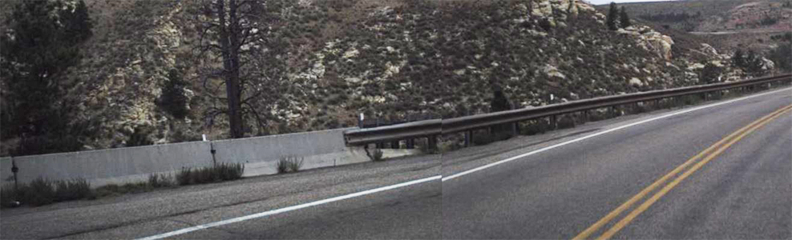

**Figure 2:**

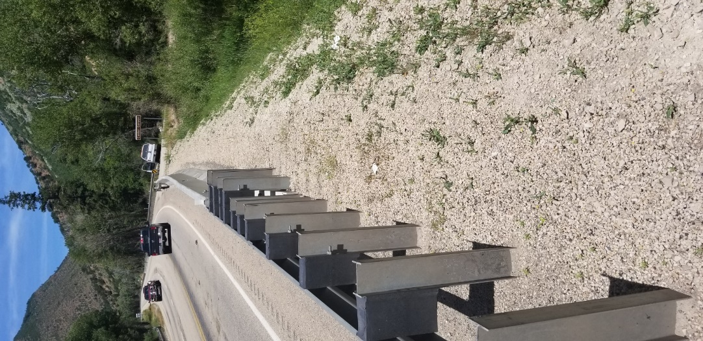



**2019-10-LCB**

**Research Problem Statement**

|  |  |
| --- | --- |
| **Project Title:** | Transition from Pinned-Down to Rigid Barrier Median Application |
| **Project Synopsis:** | States that use portable concrete barrier in permanent and temporary applications require a transition from pinned-down PCB’s to ridged barrier in median applications. See figure 1 & 2 for example of the need for permanent application.  The current transition from pinned-down to ridged barrier design has been successfully tested for right shoulder applications only. It is desired to modify this design for median application for both asphalt and concrete pavements meeting MASH testing criteria. |
| **Project Goal(s):** | The objective of this research effort is to modify the transition for median applications to meet MASH testing criteria. |
| **Project Background:** | A transition from pinned-down anchored F-shape temporary concrete barrier to rigid single-slope concrete barrier for both asphalt and concrete pavement was successfully tested to MASH criteria, see Test nos. 405160-34 and 405160-36. However, these designs are for right shoulder applications only. |
| **Proposed Work Plan:** | *Following work plan is expected to meet the objectives of this project.*  *Task 1: Transition Design – In this task, previously developed roadside version of the transition design (from TTI projects 40516-34 and 405160-36) will be used as basis to develop a median transition design. This design effort will not include simulation.*  *If the pinned barrier system desired in the median transition design is the same as the one used in TTI projects 405161-34 and 405160-36, a new crash test is not needed. This is because a median version of the transition design is not expected to deteriorate the crash performance compared to the roadside version.* |
| **Deliverables:** | Develop engineering drawings of the transition system. |
| **Urgency and Expected Benefit:** | Development of a crashworthy transition from pinned-down anchored F-shape temporary concrete barrier to rigid single-slope barrier would provide states with a safe median barrier connection design. |
| **Problem Funding and Research Period:** | *Estimated Costs:*  *Task 1 – $15,000*  *Estimated Project Period: 5 months* |
| **Developer(s) of the Problem Statement:** | Name: Shawn Debenham (Utah Department of Transportation)  Email: Sdebenham@utah.gov  Phone:801-971-9575 |

**Figure 1:**

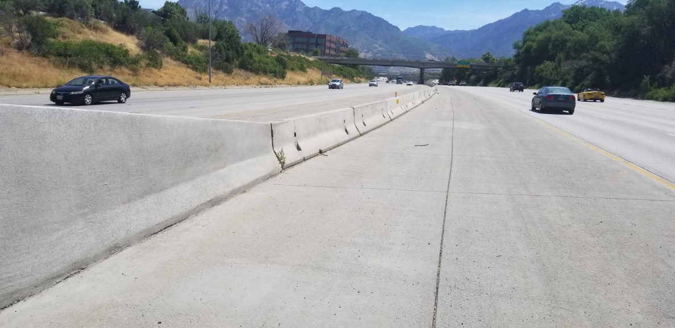

**Figure 2:**

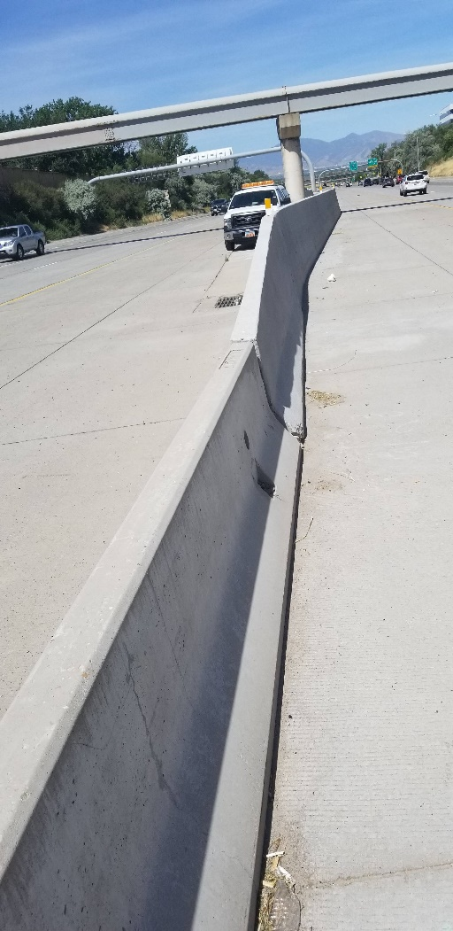



**Research Problem Statement**

**2019-11-LCB**

|  |  |
| --- | --- |
| **Project Title:** | Transition from W-Beam Guardrail to Concrete Barrier |
| **Project Synopsis:** | Develop and evaluate a MASH TL-3 compliant W-Beam transition to various types of concrete barriers using engineering analysis, simulation, and/or crash testing. The concrete barriers for consideration include a 32-inch and 42-inch Vertical Wall, F-shape, NJ shape, and single slope with/without flare. |
| **Project Goal(s):** | 1. (a) To develop a MASH TL-3 compliant W-Beam Guide Rail Transition to Vertical Wall Bridge Barrier.   *- TTI Comment: This type of transition is being evaluated under PennDOT MASH Implementation project WO1-TA027 (TTI Project No. 608221)*  (b) To develop a MASH TL-3 compliant W-Beam Guide Rail Transition to single slope, F-shape cast-in-place and precast barriers, and NJ shape barrier  *- TTI Comment: The F-Shape CIP barrier transition is being evaluated under PennDOT MASH Implementation project WO1-TA027 (TTI Project No. 608221)*   1. (a) To develop a MASH TL-3 compliant stacked W-Beam transition to vertical wall bridge barrier   *- TTI Comment: TTI will be conducting a TxDOT sponsored project in the future to develop and test a MASH TL-3 compliant stacked W-Beam transition to a median Single Slope barrier.*  (b) To develop a MASH TL-3 compliant stacked W-Beam transition to F-shape concrete barrier   1. Evaluate MI thrie beam transition or other thrie beam transitions to Vertical wall, F-shaped, and single slope barriers.     *- TTI Comment: Problem Statement No. 2019-19-LSRB already addresses this project goal.* |
| **Project Background:** | Pennsylvania - PA uses F-shape, vertical wall, and structure mounted guiderail as common bridge railings. W-beam transitions to F-shape bridge barrier with a 10-degree flared wing was crash tested by TTI in 2000 and 2005 for NCHRP 350 TL-3 and TL-4 respectively. These W-Beam transitions need to be re-tested for MASH 2016 TL-3.  PA is quite interested in W-Beam transition to vertical wall bridge barrier.  Michigan - MI uses transitions containing thrie-beam panels, and these transitions are MASH compliant. However, theses transitions may only be attached to a vertical concrete wall. Therefore, MI is interested in a transition (containing thrie-beam panels, w-beam panels, or a combination of both) that can be attached directly to a single-slope concrete barrier or NJ/F-Shape concrete barrier.  Alabama - *In order to assist in the problem statement development for the transition from the W-Beam to concrete barrier, would it be possible to get a better understanding of the failure of the MASH test for the Stacked W-Beam Transition – Test Report No. 604581-1, May 11, 2016? The report is* [*https://www.roadsidepooledfund.org/wp-content/uploads/2017/04/TMNo604581-1-Final.pdf*](https://gcc01.safelinks.protection.outlook.com/?url=https%3A%2F%2Furldefense.proofpoint.com%2Fv2%2Furl%3Fu%3Dhttps-3A__www.roadsidepooledfund.org_wp-2Dcontent_uploads_2017_04_TMNo604581-2D1-2DFinal.pdf%26d%3DDwMFAg%26c%3DlSeynXUFlYj-tdeX6gNnztbCom1Kz3WIsk-7BcsdgdY%26r%3DtFyMK5_LbW2md7SIbwKYT57o6AHjZCr7k67ChMT0lrQ%26m%3DrNMOXwxXu9M05eTafaJFviy3I-hlNwJrfFuTxLU5M3I%26s%3D7ddejCpcJvQvpjRR6Rd9ftq-WadaYUTfScG2B7wEV-0%26e%3D&data=02%7C01%7Chraza%40pa.gov%7Ca76c8a7cabb94f28348b08d70ab9e90e%7C418e284101284dd59b6c47fc5a9a1bde%7C0%7C0%7C636989665920607559&sdata=TkjVsFwhO2eFx0gKivmuJeGD4QWdD%2B1ywKFwmmUa3I4%3D&reserved=0) *.*  *Our state uses a stacked w-beam to a vertical face, and based on what was learned from the crash test, are there tweaks that are suspected could be made and this become a passing system? Things such as revised post spacing, a longer vertical face on the bridge rail, etc…   Or are there fatal flaws with a stacked w-beam such that there is nothing perceived that will fix it?*    Delaware - DE has a similar detail with an attachment to F-Shaped barrier.  If this detail does not pass, it will create an issue with us. The only thought that I had was to use a 42” barrier as the truck seems to rotate over the wall slightly but I don’t know if the extra 10” would make a difference.  I am not sure how many other states use this detail but it does seem popular.  TTI can point out if a W-Beam transition is available or which transition could be useful to majority of States. |
| **Proposed Work Plan:** | **Tasks:**  - Note: This proposed work plan is only considering one type of transition (i.e., W-Beam, stacked, or Thrie-Beam). Each type of transition should be considered under separate projects.   1. **Literature Review and Engineering Analysis:** 2. Evaluate various current W-Beam transition designs from states and determine which design is most commonly used by states. 3. Determine the critical transition design. 4. Evaluate what is necessary for MASH determination (i.e., professional opinion, simulation, and/or crash testing). 5. If crash testing is necessary, determine which crash tests are critical for MASH compliance. 6. **Construction and Demolition** 7. **Full-Scale Crash Testing and Reporting:** 8. Perform critical full-scale crash tests determined in Task 1. (Budgeting for two crash tests) 9. Provide final report summarizing the details of the test installation, final drawings, and our finding and conclusions. 10. Provide a professional opinion that indicates that tests not conducted are not critical due to successfully performed tests on similar systems in the past. 11. Provide a professional opinion for MASH compliance of the other designs not selected for crash testing. |
| **Deliverables:** | A report providing details of the transition, documentation of the evaluation, the results of each crash test if performed, and the assessment of the performance of the transition according to MASH TL-3 criteria. |
| **Urgency and Expected Benefit:** | Several states connect W-Beam guardrail to various concrete barriers. MASH compliant transitions are urgently needed to meet MASH compliance dates. |
| **Problem Funding and Research Period:** | **Total Cost Estimate = $130,000**  **Work Schedule:** (Estimated Project Duration = 10 months from initiation of the project)  - Note: This proposed work schedule is only considering one type of transition (i.e., W-Beam, stacked, or Thrie-Beam). Each type of transition should be considered under separate projects.   * Task 1 = 3 months * Task 2 = 3 months * Task 3 = 4 months |
| **Developer(s) of the Problem Statement:** | Name: Hassan Raza, Mark Buckalew, Steve Walker, Carlos Torres  Email: [hraza@pa.gov](mailto:hraza@pa.gov); [Mark.Buckalew@delaware.gov](mailto:Mark.Buckalew@delaware.gov); [walkers@dot.state.al.us](mailto:walkers@dot.state.al.us); TorresC@michigan.gov  Phone: 717-783-5110 |



**2019-12-LCB**

**Research Problem Statement**

|  |  |
| --- | --- |
| **Project Title:** | MASH TL-2 Compliant Permanent Concrete Low-Profile Barrier (Barrier Curb) |
| **Project Synopsis:** | *Develop a MASH TL-2 Compliant Permanent Concrete Low-Profile Barrier* |
| **Project Goal(s):** | Provide design details for a MASH TL-2 Compliant Permanent Concrete Low-Profile Barrier |
| **Project Background:** | *From AASHTO RDG, 4th Edition 2011, Chapter 5;*  *“…developed for typically urban environments or where a TL-2 system is appropriate is the low profile barrier. These barriers typically range from 457 mm to 510 mm [18 in. to 20 in.]. The low profile barrier was developed to provide a barrier that provides additional design options for site-specific applications. These barriers can be used in permanent or temporary applications. Several different barrier cross-section configurations have been approved for TL-2 applications. Many of these barriers are available as cast-in-place or precast construction. The lower barrier height improves sight distance as well as provides another option to tie in with the adjacent surroundings. This low profile barrier shown in Figure 5-19 has been used in urban settings to shield trees in a raised median.”*      *Figure 5-19. Low Profile Barrier* |
| **Proposed Work Plan:** | *Design and Crash Test a Length of Need segment of MASH TL-2 Compliant Permanent Concrete Barrier (Barrier Curb). The project should look to optimize the system while allowing for potential future asphalt overlays, but not exceed 24-inches of height to avoid sight distance issues.*  **Task 1. Design Detail Development and Finite Element Investigation.**  Develop design details.  Conduct finite element simulation as design aid and vehicle impact behavior prediction.  **Task 2. System Construction & Full-Scale Crash Testing.**  Build test article.  Conduct full-scale crash testing (TL-2).  **Task 3. Implementation.**  Summarize recommendations for implementation based on crash testing and engineering investigation. |
| **Deliverables:** | MASH TL-2 Compliant Permanent Concrete Low-Profile Barrier |
| **Urgency and Expected Benefit:** | *A MASH Compliant design for permanent design is currently not available.*  *Benefits include:*   * *Having a MASH option for urban areas where visibility of pedestrians, bicyclists, and businesses is paramount, in addition to providing sufficient stopping sight distance.* * *provide a great crashworthy alternative for separated ped./bicycle facilities (i.e. Barrier Curb).* * *Aesthetically mitigate items like; trees, street furniture, parklets, etc. in context sensitive areas (i.e., urban areas with speeds between 35 and 45 MPH).* |
| **Problem Funding and Research Period:** | *Please describe what are the estimated costs and time to complete the project*  Problem Anticipated Funding: $180,000  Research Period: 1 year |
| **Developer(s) of the Problem Statement:** | Name: Derwood Sheppard  Email: [derwood.sheppard@dot.state.fl.us](mailto:derwood.sheppard@dot.state.fl.us)  Phone: 850-414-4334 |



**2019-35-LCB**

**Research Problem Statement**

|  |  |
| --- | --- |
| **Project Title:** | Vehicle Collision Forces on a Soundwall |
| **Project Synopsis:** | *The AASHTO LFRD Bridge Design Specifications provides vehicle collision forces in Section 15.8.4. There are 4 different cases that have been developed based on the wall offset. These loads were based on limited data and engineering judgement. This research would be to use computer simulations to update the loads and heights of applications in this section. Also, to base loading on the height of the rail in front of the soudnwall.*  *In some cases, the soundwall starts and ends behind the wall, so if the rail is impacted prior to the beginning of the wall, the lean of the vehicle could cause the upper portion to impact the end post of the wall creating a lateral load instead of the transverse loads covered by the specification (as shown below). This loading information could also be used for other objects located behind the rail such as bridge columns.* |
| **Project Goal(s):** | 1. Update Section 15.8.4 of the *AASHTO LFRD Bridge Design Specifications* 2. *Provide loading for objects within the Zone of Influence but behind the wall.* |
| **Project Background:** | *Background is covered in the project synopsis.* |
| **Proposed Work Plan:** | 1. Build a confidence level (validation) of the simulation model of the of heavy vehicles into soundawalls by simulating updated versions of TL-5 and TL-4 vehicle models into tested systems with a relatively tall barrier 2. Conduct literature review to define the state of practice of common soundwalls configurations and installations details. 3. Define critical configurations for evaluation such as offset distance from the barrier or exposed end dimensions 4. Conduct impact simulations of the selected configuration to determine the impact force 5. Process the impact force profile into a design table format |
| **Deliverables:** | 1/ A report describing the process and the results of the project  2/ A table describe loading profile for both vertical and longitudinal directions and the selected critical impact conditions  3/ Equivalent static force of these profiles |
| **Urgency and Expected Benefit:** | *The expansion of highways and high speed roadways into more residential areas resulted into more soundwall applications that are not designed to withstand vehicular impact. This trend is not going to stop and there is a benefit to user agencies to identify design load so that they can ensure the integrity of these sound walls. The urgency stems from the risk of having these wall exposed to impact loads that they cannot withstand. Hence, there is a safety and labiality risk by having these under designed walls next to the driving public and the residential population .* |
| **Problem Funding and Research Period:** | *The cost of conducting the research is $89,559, it is expected to span over 12 months duration* |
| **Developer(s) of the Problem Statement:** | Name: Taya Retterer, P.E.  Email: [taya.retterer@txdot.gov](mailto:taya.retterer@txdot.gov)  Phone: 512-416-2719 |

**Notes**



**2019-22-BR**

**Research Problem Statement**

|  |  |
| --- | --- |
| **Project Title:** | Investigation of MASH, TL-5 TBTA Bridge Railing Mounted on Traditional Concrete Deck |
| **Project Synopsis:** | The TBTA bridge railing was successfully crash tested under MASH, TL-5 criteria, and an FHWA eligibility letter (B-274) was issued for this bridge railing. However, the TBTA railing was tested on a surrogate composite bridge span, and transportation agencies may wish to use this railing type on a traditional concrete bridge deck. |
| **Project Goal(s):** | 1. Evaluate the TBTA bridge railing mounted on a traditional concrete bridge deck. 2. Establish design criteria for mounting the TBTA bridge railing on a traditional concrete deck. 3. Determine if the TBTA bridge railing can be mounted on top of a concrete brush block. |
| **Project Background:** | The TBTA bridge railing was successfully crash tested under MASH, TL-5 criteria, and an FHWA eligibility letter (B-274) was issued for this bridge railing. However, the TBTA railing was tested on a surrogate composite bridge span, and transportation agencies may wish to use this railing type on a traditional concrete bridge deck.  It may be possible to use this railing on a concrete deck, but a design of the post to deck connection is needed. |
| **Proposed Work Plan:** | *Following work plan is expected to meet the objectives of this project.*  *Task 1: Post-to-Deck Design – In this task, a design of the post attached to the concrete deck using adhesive or screw-in anchors will be developed. The design criteria for this post-to-concrete deck attachment will be to meet the design capacity of the post-to-steel orthotropic deck connection used in the TBTA crash testing.*  *Task 2: Dynamic Bogie Testing – In this task, dynamic impacts using a surrogate bogie vehicle will be performed to evaluate the performance of the post connection design for concrete and steel. Four bogie tests will be performed, two with post installed on concrete and two on steel deck similar to the orthotropic deck used in the TBTA testing. Force-deflection response will be measured and compared for the two types of posts. If they exhibit similar post-deflection response, if would imply that the new concrete post and the one used in TBTA testing are interchangeable.* |
| **Deliverables:** | * Final report containing details of the new post attachment design and the full-scale bogie impact testing. * Movie files and photos from testing |
| **Urgency and Expected Benefit:** | *Successful design will allow user agencies to use the TBTA bridge on concrete decks.* |
| **Problem Funding and Research Period:** | *Estimated Costs:*  *Task 1 – $20,000*  *Task 2 – $20,000*  *Estimated Project Period: 10 months* |
| **Developer(s) of the Problem Statement:** | Name: Carlos Torres  Email:TorresC@michigan.gov  Phone: (517) 335-2852 |



**2019-23-BR**

**Research Problem Statement**

|  |  |
| --- | --- |
| **Project Title:** | Development of a Thrie-Beam Retrofit for Upgrading Obsolete Bridge Railings |
| **Project Synopsis:** | State transportation agencies may need to resort to a thrie-beam retrofit design when an obsolete bridge railing needs to be brought up to acceptable performance levels, and complete bridge railing replacement is impractical or impossible. Furthermore, an ideal retrofit design should allow for the existing bridge railing to remain in place for historical purposes and/or safety reasons. |
| **Project Goal(s):** | 1. Develop a post-mounted, thrie-beam retrofit design meeting the requirements of MASH, TL-3. 2. Develop thrie-beam retrofit options acceptable for use with a wide variety of bridge railing designs (e.g., concrete parapet bridge railings, composite (concrete and steel) bridge railings, concrete post-and-beam, metal post-and-beam, etc.). 3. Develop guidelines for transitioning from traditional steel beam guardrail (e.g., 31” tall w-beam guardrail with 8” offset blocks) to thrie-beam retrofit. 4. Establish minimum requirements for proper use and installation of thrie-beam retrofit options (e.g., minimum bridge deck thickness, minimum brush block thickness, minimum concrete strength requirements, anchoring requirements, minimum offset requirements between thrie-beam retrofit and existing bridge railing, lateral offset requirements between thrie-beam retrofit and face of brush block, minimum length of thrie-beam retrofit, etc.). 5. Develop guidelines for different anchoring options (e.g., adhesive-anchored bolts to curb/deck, bolt-through anchors to curb/deck, and anchoring to bridge railing), and provide recommended design impact loads at anchors for the different anchoring options (i.e., propose recommended minimum design loads for anchors for use when it is necessary for designers to make minor modifications to thrie-beam retrofit anchorages). Recommended design impact loads for anchors should be based on actual crash test data, so strain gauges should be installed as part of any crash test to measure the impact load at each anchor. |
| **Project Background:** | Michigan – Michigan currently uses thrie-beam retrofit designs attached to the face of a substandard bridge railing by driving bolts through the substandard bridge railing. However, Michigan is willing to consider adopting other thrie-beam retrofit options.  Florida and Oregon – both states currently use thrie-beam retrofit designs where the thrie-beam guardrail is mounted on posts which are secured to an existing curb (brush block) with epoxy/resin bonded anchors. |
| **Proposed Work Plan:** | TTI will design, build and test a new thrie beam retrofit bridge railing consisting of 10-gauge thrie beam guardrail element attached to steel posts that are placed on top of and epoxy anchored into a 9-inch high curb that is on top of a concrete deck. The 9-inch high curb will be cast separately from the concrete deck, and the curb will contain steel reinforcement epoxy anchored into the concrete deck. The posts will likely be on 3’ - 1 ½” centers with wood blockouts.  The project will have the following tasks.   1. Task 1 - Literature Review – Look at systems that have already been tested. 2. Task 2 – Engineering Design and detailing 3. Task 3 – Construction of full scale test installation 4. Task 4 – Full-scale crash testing – MASH Tests 3-10 & 3-11. |
| **Deliverables:** | 1. A comprehensive report, including design details of the tested thrie-beam retrofit design(s). 2. The results of all crash tests performed, including pictures and videos of all crash tests performed. 3. Establishing whether the tested design meets the requirements of MASH, TL-3. 4. Developing and providing guidelines for transitioning from traditional steel beam guardrail (e.g., 31” tall w-beam guardrail with 8” offset blocks) to thrie-beam retrofit, establish minimum requirements for proper use and installation of thrie-beam retrofit options (e.g., minimum bridge deck thickness, minimum brush block/curb thickness, minimum concrete strength requirements, anchoring requirements, minimum offset requirements between thrie-beam retrofit and existing bridge railing, lateral offset requirements between face of thrie-beam retrofit and face of brush block, minimum length of thrie-beam retrofit, etc.). 5. Developing and providing guidelines for different anchoring options (e.g., adhesive-anchored bolts to curb/deck, bolt-through anchors to curb/deck, etc.), and provide recommended design impact loads at anchors for the different anchoring options (i.e., propose recommended minimum design loads for anchors for use when it is necessary for designers to make minor modifications to thrie-beam retrofit anchorages). |
| **Urgency and Expected Benefit:** | A thrie-beam retrofit option is beneficial in cases where complete bridge railing replacement is not viable for economical or historical reasons. Therefore, the urgency for a MASH-compliant retrofit option is high for transportation agencies relying on this type of design. |
| **Problem Funding and Research Period:** | The estimated cost for the project is approximately $225,000. The breakdown of costs is listed below:   |  |  | | --- | --- | | 1-Lit Review | $5,750 | | 2 - Engineering Design & Detail | $26,300 | | 3- Construction | $110,200 | | Test 3-10 | $37,000 | | Test 3-11 | $44,000 | | 3- Demo | $2,200 | | ***Total Estimated Cost - All Tasks*** | ***$225,450*** | |
| **Developer(s) of the Problem Statement:** | Name: Carlos Torres, Derwood Sheppard, Alex Lim, Alexander Bardow, William Williams  Email: [torresc@michigan.gov](mailto:torresc@michigan.gov) [Derwood.Sheppard@dot.state.fl.us](mailto:Derwood.Sheppard@dot.state.fl.us)  [Alex.K.LIM@odot.state.or.us](mailto:Alex.K.LIM@odot.state.or.us) [alexander.bardow@state.ma.us](mailto:alexander.bardow@state.ma.us)  Phone: (517) 335-2852, (850) 414-4334, (503) 986-3402, 979-317-2707 (Williams) |



**2019-24-BR**

**Research Problem Statement**

|  |  |
| --- | --- |
| **Project Title:** | MASH TL-4 Crash Testing of Bicycle Railing on Constant Slope Parapet |
| **Project Synopsis:** | The purpose of this project is to evaluate and test a combination barrier system that consists of a bicycle railing mounted on top of a standard Illinois Department of Transportation (IDOT) concrete parapet. The total height of the system is 54 inches including a 15-inch tall bicycle railing mounted on top of a 39-inch tall constant slope parapet (see attached figure). The testing is to be performed in accordance with MASH TL-4 criteria. |
| **Project Goal:** | The objective of this project is to evaluate the performance of a railing mounted on top of a standard IDOT constant slope parapet under MASH TL-4 criteria by performing MASH Test 4-12 and providing professional opinions for MASH Test 4-10 and MASH Test 4-11. |
| **Project Background:** | IDOT has a significant number of bridges that accommodate bicyclists throughout the state. The department utilizes a railing height of 54 inches as recommended in the early editions of the LRFD Bridge Design Specifications. MASH TL-4 compliant barrier systems are recommended on IDOT bridges whenever possible. Therefore, IDOT desires to develop and test a 15-inch tall railing mounted on top of a 39-inch tall standard IDOT parapet to accommodate bicyclist and traffic safety. |
| **Proposed Work Plan:** | **Tasks:**   1. **Engineering Analysis and Drafting:** 2. Evaluate the railing design details and make recommendations for modifications based on past crash testing of similar combination barrier systems. 3. Develop detailed drawings of the combination barrier system with the suggested modifications and submit to the state representative for approval. 4. Once approved, the research team will develop full-scale test installation drawings of the combination barrier system for construction and full-scale testing. 5. **Construction and Demolition** 6. **Full-Scale Crash Testing and Reporting:** 7. Perform critical full-scale crash tests. (Budgeting for MASH Test 4-12) 8. Provide final report summarizing the details of the test installation, final drawings, and our finding and conclusions 9. Provide a professional opinion that indicates that tests not conducted are not critical due to successfully performed tests on similar systems in the past. |
| **Deliverables:** | A report providing details of the combination barrier system, documentation of the evaluation and crash tests performed, the crash test results, and the assessment of the performance of the combination barrier system according to MASH TL-4 specifications. Professional opinion for MASH crash tests not performed. |
| **Urgency and Expected Benefit:** | This project will benefit the member states by implementing MASH TL-4 compliant barrier systems that accommodate bicyclists while providing higher safety for the motoring public and meet the most recent barrier testing criteria. |
| **Problem Funding and Research Period:** | **Total Estimated Cost = $250,000**  **Work Schedule:** (Expected Project Duration = 10 months from initiation of the project)   * Task 1 = 3 months * Task 2 = 3 months * Task 3 = 4 months |
| **Developer(s) of the Problem Statement:** | Name: Kevin Riechers, IDOT; Carlos Torres, MDOT; Kenneth Shannon, MTO  Email: [Kevin.Riechers@illinois.gov](mailto:Kevin.Riechers@illinois.gov)  Phone: 217-782-9109 |

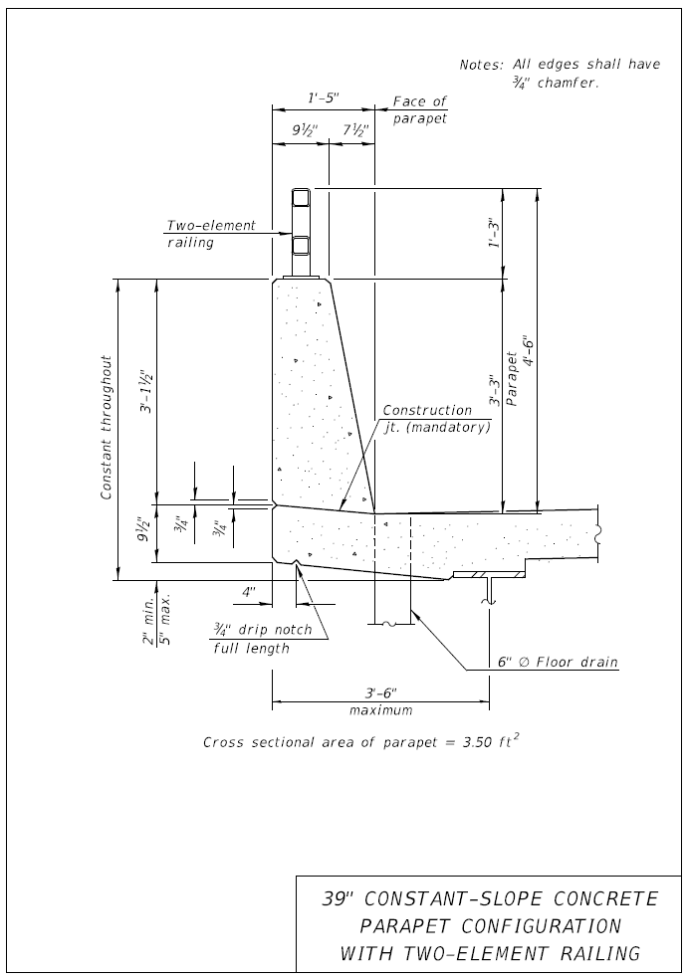



**2019-34-BR**

**Research Problem Statement**

|  |  |
| --- | --- |
| **Project Title:** | Resistance of Bolt-through anchor to Repeated Impact Loading |
| **Project Synopsis:** | State transportation agencies will need bridge rail retrofit option, bolt through connection, to attach tested concrete rail to existing bridge deck to bring the railing to acceptable performance level, MASH TL-4.  However, after the 1985, Research Report 382-2F Response of Highway Barriers to Repeated Impact Loading: Concrete Barriers (<https://library.ctr.utexas.edu/digitized/texasarchive/phase2/382-2f-ctr.pdf>), there is no further study to conclude the proper detailing, size and grade of anchor bolt to be used to connect concrete rail to deck.  When bolt-through connection is used, the yield line theory per AASHTO LRFD Section 13 is probably invalid, since the bridge rail is not rigidly connected to the deck (in order to achieve absolute rigid connection, there will be too many anchor bolts and not practical to construct). If rigid connection is not a guarantee, it is important to determine the actual load transfer from the bridge rail to the bolt-through connection to properly design bolt connection and the deck overhang.  Furthermore, with the increase of the MASH TL-4 design impact load, if actual load observed in the anchor bolt is not determined from testing, the design for the bolt-through anchor or resin bonded anchor per ACI for concrete anchor will not work. |
| **Project Goal(s):** | 1. Provide an easy option to attach tested concrete rail to bridge deck shown below 2. Provide a connection option when the resin bonded anchor does not work on thin existing deck (<8in) with 3300psi concrete and poor reinforcing. 3. Determine the appropriate grade and size of anchor bolt to be used to avoid brittle failure. 4. Determine the actual load transfer to bolt connection. The yield line theory and design deck overhang for rail resistance shown is AASHTO LRFD Section 13 is not appropriate to be used for bolt connection where the rigid connection assumption is invalid. 5. Determine the limit of allowable bolt spacing, at/near joint, at mid wall, at end where concrete barrier is taper in width, to ensure load transfer to deck is achieve at any section (see sketch below). As shown, depend on the location and spacing, the load distribution could be over 3, or 4 or 5 bolts. If design by per ft basis, it will be overkill. |
| **Project Background:** | Allow designer to design and attach concrete tested rail to concrete bridge decks. Oftentimes, the use of resin bonded anchors is not an option for retrofits on thin (< 8-inch) existing deck with lower concrete strength and poor reinforcing. |
| **Proposed Work Plan:** | **Tasks:**   1. **Engineering Analysis** 2. **Construction and Demolition** 3. **Testing and Reporting** |
| **Deliverables:** | A report providing details of the test installation, documentation of the evaluation, the results of the tests performed, and the assessment of the results. |
| **Urgency and Expected Benefit:** | Allow for designers to use resin bonded anchors to attach tested rails to thin (< 8-inch) existing concrete bridge decks with low concrete strength and poor reinforcing. |
| **Problem Funding and Research Period:** | **Total Estimated Cost = $230,000**  **Work Schedule:** (Estimated Project Duration = 10 months from initiation of the project)  • Task 1 = 3 months  • Task 2 = 3 months  • Task 3 = 4 months |
| **Developer(s) of the Problem Statement:** | Name: Alex Lim (OR)  Email: [Alex.K.LIM@odot.state.or.us](mailto:Alex.K.LIM@odot.state.or.us)  Phone: (503) 986-3402 |

**Notes**



**2019-13-LSRB**

**Research Problem Statement**

|  |  |
| --- | --- |
| **Project Title:** | Design and Testing of a MASH TL-3 Thrie-Beam System for Roadside and Median Applications |
| **Project Synopsis:** | *Develop and crash test a thrie-beam roadside and a median system that will meet MASH TL-3. Additionally, develop a transition between w-beam MGS and the newly developed thrie-beam system through computer simulation.* |
| **Project Goal(s):** | *-Develop designs for a MASH TL-3 thrie-beam roadside system and a median system*  *-MASH crash test the newly developed thrie-beam designs*  *-Develop transition from w-beam to thrie-beam system through computer simulation* |
| **Project Background:** | *NCHRP Project 22-14(03) tested and evaluated existing NCHRP 350 crash tested roadside hardware to MASH standards. Included in that study was a MASH TL-3 test on G9 Thrie Beam, which did not perform acceptably during 3-11.* |
| **Proposed Work Plan:** | *Task 1: Literature and Engineering Review*  This task will review the current literature and previous research related to thrie-beam guardrail systems and transitions between w-beam and thrie-beam sections. This task will also complete a preliminary analysis of the roadside, median, and transition systems in preparation for the computer simulation  *Task 2: Computer Modeling and Simulation*  This task will develop the roadside, median, and transitions systems through computer simulation.  *Task 3: MASH Crash Testing*  This task will crash test the roadside and median systems to MASH TL-3.  *Task 4: Reporting*  This task will complete the final technical report documenting all of the work completed in this project. |
| **Deliverables:** | *-Designs for a roadside and a median thrie-beam barrier that will conform to MASH TL-3 that have been crash tested*  *-Design for a transition between w-beam and thrie-beam guardrail that was computer simulated*  *-Technical report documenting all of the work completed in this project* |
| **Urgency and Expected Benefit:** | *There are currently limited options for reducing deflection while conforming to MASH TL-3. The development of a thrie beam option would have an immediate benefit to safety by reducing impact severity and financially by having an alternative to concrete barrier.* |
| **Problem Funding and Research Period:** | *$300,000*  *18 month project* |
| **Developer(s) of the Problem Statement:** | Name: Jim Danila, MassDOT  Email: james.danila@dot.state.ma.us  Phone: 857-368-9640 |



**2019-15-LSRB**

**Research Problem Statement**

|  |  |
| --- | --- |
| **Project Title:** | 31” Rectangular Wood Post W-Beam Guardrail in Concrete Mow Strips |
| **Project Synopsis:** | To develop a leave-out and grout backfill detail around a wood post within a concrete mow strip that will allow the post to function as part of a MASH TL-3 guard rail barrier. |
| **Project Goal(s):** | To develop and analyze various options that will allow a wood post used in a concrete mow strip to perform properly when used as part of MASH TL-3 guard rail barrier. A preferred detail would be selected for full scale or pendulum testing. |
| **Project Background:** | Previous MASH tests were run on this concept by TTI but two of the tests failed.  (TTI Report 608551-01-1-5 ; April 2019)  Previous research into posts in mow strips was conducted by TTI using NCHRP 350 (TTI Report 405160-14-1 ; May 2009) and may have details or information that could be useful for this project. |
| **Proposed Work Plan:** | This project would examine the failures from the original testing and use the lessons learned to develop new, potential options. These proposed options would be evaluated and a preferred detail would be selected for testing.  Assuming a successful test, the applicability of the new detail would be analyzed for use with steel posts as well as for posts (both wood and steel) in asphalt mow strips. |
| **Deliverables:** | An engineering drawing of the leave out and post along with specifications for the grout / backfill material. A crash test report or summary of the analysis performed should also be delivered. |
| **Urgency and Expected Benefit:** | Louisiana primarily uses timber posts and includes mow strips on almost all of their guard rail installations. Having an approved MASH detail for most strips is essential and would see immediate implementation. |
| **Problem Funding and Research Period:** | *Task 1 – Redesign: $5,000*  *Task 2 – Construction, Testing, & Reporting: $55,000*  *Total Estimated Cost: $60,000*  *Research Period: 6 months* |
| **Developer(s) of the Problem Statement:** | Name: Kurt Brauner  Email: kurt.brauner@la.gov  Phone: 225-379-1933 |



**2019-17-LSRB-2**

**Research Problem Statement**

|  |  |
| --- | --- |
| **Project Title:** | BIB Terminal Variations in Foreslope/Backslope/Ditch Configurations |
| **Project Synopsis:** | *Please describe the proposed project synopsis within 200 words.*  Evaluate range of foreslope/backslope/ditch configurations, i.e. site variations from crash tested conditions, producing acceptable results under MASH conditions.  Project will use analysis, simulation, and physical testing, as required, to evaluate acceptable range(s) of variation. |
| **Project Goal(s):** | Consider variations from crash tested configuration (4:1 Foreslope/ 2:1 Backslope/ V-Ditch, under TTI project 608431, tests 3-34, 3-35) to address the following:   * Establish the BIB terminal may be installed on foreslopes of 4:1 or flatter. * Establish a flattest effective backslope; a threshold backslope for requiring area free of fixed objects behind the terminal; and investigate whether there is a limit for backslope steepness. * Establish the BIB terminal may be installed in flat-bottomed ditches. * Establish necessary design alterations from previous tested configuration, if any, when: the foreslope is flatter than 4:1; foreslope of the ditch is wider than 6 feet; the backslope varies from 2:1; or the ditch is flat-bottomed. |
| **Project Background:** | *Please describe the problem you would like to address.*  The Buried-in-Backslope (BIB) Terminal project (TTI project 608431) demonstrated the BIB system performs effectively under MASH conditions. Because testing was conducted for just one configuration, applicability of the terminal to other site conditions should be investigated. Ideally, the system could be installed where site conditions vary from the tested configuration.  The MASH BIB was tested to the same configuration used under NCHRP 350 in the early 2000s. Successive NCHRP 350 tests varied conditions of foreslope and backslope over three tests. The sequence of testing gave credibility to some acceptable site variability for the installation. The most of extreme configuration was matched for the MASH test: 4:1 foreslope, 2:1 backslope, and V-ditch.  The problem for this project is to show that the BIB is adaptable to variations in ditch slope, depth, and shape, because field conditions may not match the previous MASH-tested configuration of 4:1 foreslope, 2:1 backslope, and V-ditch. It would be important for the project to establish limits for variability, and any changes to the design to adjust for site variations |
| **Proposed Work Plan:** | *Please describe what work or test will be done and what the result will be.*  **Task 1. DOT Members Survey.**  Identify the most common applicable ranges with respect to the research parameters that are in use (and needed) by the DOT Members: examples are degree of backslope, type of ditch configuration, ditch width, rubrail /no rubrail.  **Task 2. Engineering Analysis and Finite Element Investigation.**  Conduct engineering analysis to identify most critical cases based on Task 1 results.  Conduct finite element computer simulations to investigate the critical cases in terms of system crashworthiness.  **Task 3. Recommendations.**  Summarize recommendations based on engineering analysis (and FEA). |
| **Deliverables:** | Acceptable limits for foreslope (flatter than 4:1), and backslope (range of variation from 2:1 and critical slope), offset to ditch bottom or width of foreslope, and width of flat-bottomed ditch. Necessary changes to the design for variations, if any, including threshold for backslope which requires clearing and grading of area free of fixed objects behind the terminal. |
| **Urgency and Expected Benefit:** | *Please describe the expected benefits of the research.*  MASH tests have been successfully completed (3-34, 3-35) for one site configuration. States have variable design standards for ditches and adapting the device for site variability would increase the number of locations this device could be installed.  BIB Terminal eliminates the potential for terminal end strike. Because of the slopes involved, other issues need to be considered. If acceptable limits for site variability can be shown, wider installation may reduce risk to the traveling public. |
| **Problem Funding and Research Period:** | *Please describe what are the estimated costs and time to complete the project*  Problem Anticipated Funding: $90,000  Research Period: 1 year |
| **Developer(s) of the Problem Statement:** | Name: Christopher Henson, Oregon DOT;  Email: Christopher.S.HENSON@odot.state.or.us  Phone: (503) 986-3561  Name: Josh Palmer, Colorado DOT;  Email: Joshua.j.palmer@state.co.us  Phone: (303) 757-9229  Name: Fil Sotelo, Illinois DOT;  Email: Filiberto.Sotelo@Illinois.gov  Phone: ( 217) 557-2563  Name: Jeff. Jeffers, Alaska DOT&PF  Email: jeff.jeffers@alaska.gov  Phone: (907) 465-8962 |



**2019-18-LSRB**

**Research Problem Statement**

|  |  |
| --- | --- |
| **Project Title:** | MASH TL-2 Evaluation and MASH determination of 8-inch vertical curb with MGS traffic barrier |
| **Project Synopsis:** | *.*  Evaluate and potentially crash test a 8-inch tall vertical curb with MGS traffic barrier in accordance with MASH Test Level 2 (TL-2). Perform the necessary steps to certify MASH compliance at TL-2. |
| **Project Goal(s):** | A 8-inch vertical curb flush with MGS traffic barrier that is MASH TL-2 compliant. |
| **Project Background:** | MDOT has been using curb combination and traffic barrier (attached standard *17_12_21_MD-605.31*) for many years with the face of barrier rail flush with the face of the curb. For design speed equal and less than 45 mph, Type A curb (8-inch) is used (attached standard *MD-602.02*).  MDOT also uses traffic barrier with curb and sidewalk, which is basically having the barrier offset from the curb*.*  Due to lack of crash testing for 8-inch curb with barrier aligned up with face of curb, MDOT has difficulty to meet the criteria of MASH 2016.    PennDOT also uses 8-inch curb for roadways typically (see attached *PennDOT typical curb detail*). A 4-inch curb is used with traffic barrier (see attached *PennDOT Guide rail with curb detail*). However, 4-inch curb often cannot be used on projects, and then 8-inch curb is allowed with stiffened traffic barrier. For example, 4-inch curb is problematic for drainage, so 8-inch curb is used with drainage inlet (see attached *PennDOT inlet profile detail*). |
| **Proposed Work Plan:** | 1. Build a confidence level (validation) of the simulation model of the of guardrail with a curb by simulating MASH tested designs such the ones conducted at the MwRSF      1. Evaluate MGS traffic barrier installed along a 8-inch curb using LS-DYNA simulation. The face of the barrier rail should flush with the face of the curb for MASH TL-2. 2. Evaluate if the barrier be pushed back, how much offset from the face of curb is acceptable. 3. Identify the most critical successful configuration based on the simulation 4. Evaluate and perform MASH compliance via crash testing. 5. Provide final report, including engineering opinion for MASH compliance for crash testing. 6. Provide engineering opinion on any acceptable variations such as variations of shape of curb, (acceptable offset from curb, etc?). All states may not have the exact same shape of vertical curb, so engineering opinion needs to consider potential MASH compliant variations. |
| **Deliverables:** | A report providing details of traffic barrier face flushed with face of 8-inch curb, and variation of barrier offset from curb documentation of the evaluation and crash tests performed, the results of each crash test, and the assessment of the performance according to MASH Test Level 2 (or TL-2) specifications. Engineering opinion for MASH compliance for similar, less critical, designs which were not crash tested. |
| **Urgency and Expected Benefit:** | MDOT and PennDOT use 8-inch curb with traffic barrier for low design speed (≤ 45 mph). Testing MGS traffic barrier with 8-inch vertical curb will help MDOT and PennDOT comply with MASH 2016 criteria. |
| **Problem Funding and Research Period:** | *Please describe what are the estimated costs and time to complete the project*  **-Estimated cost is $142,797**  **-Duration is 14 months** |
| **Developer(s) of the Problem Statement:** | Name: Aimee Zhang, P.E, MDOT; Nina Ertel, P.E, PennDOT.  Email: Hzhang@mdot.marylad.gov  Phone: 410-545-8006 |



**2019-19-LSRB**

**Research Problem Statement**

|  |  |
| --- | --- |
| **Project Title:** | MASH TL-3 Thrie-Beam transition from 31" W-Beam guardrail to single slope CIP concrete barrier |
| **Project Synopsis:** | Evaluate MASH TL-3 compliance of a Thrie-Beam transition from 31" W-Beam guardrail to single slope CIP concrete barriers |
| **Project Goal(s):** | Determine MASH TL-3 compliance of a Thrie-Beam transition from 31" W-Beam guardrail to single slope CIP concrete barrier either with engineering opinion or crash testing. |
| **Project Background:** | 31” guiderail to F-shape and single slope CIP concrete barrier transition along the side of the road is a very common application. There is already a MASH compliant thrie-beam to F-shape bridge barrier. However, the end of the bridge is modified where the thrie-beam connects. Can this MASH compliant thrie beam transition be modified to connect to a F-shape for various heights and 42” high single slope CIP barrier without modifying the end? |
| **Proposed Work Plan:** | **Tasks:**     1. **Literature Review and Engineering Analysis** 2. Evaluate current TL-3 Thrie-beam transition designs 3. Determine the critical transition design and evaluate the transition for TL-3 compliance. 4. Evaluate and perform MASH compliance via engineering opinion, simulation and/or crash testing. 5. **Construction and Demolition** 6. **Full-Scale Crash Testing and Reporting** 7. Perform critical full-scale crash tests determined in Task 1. (Budgeting for two crash tests) 8. Provide a final report summarizing the details of the test installation, final drawings, and our finding and conclusions 9. Provide engineering opinion on any acceptable variations such as variations of heights of the barrier. States may not have the exact same slope on the single slope barrier, so engineering opinion needs to consider potential MASH compliant variations. |
| **Deliverables:** | A report providing an evaluation of MASH TL-3 compliance of a Thrie-Beam transition from 31" W-Beam guardrail to single slope CIP concrete barrier. Include engineering opinion for MASH compliance for similar, less critical designs from various states which were not crash tested. |
| **Urgency and Expected Benefit:** | Transitions between w-beam and CIP concrete barriers is a common application. As new MASH compliant barriers are being adopted by DOT’s, new transitions are needed in order to implement the new concrete barriers for use. |
| **Problem Funding and Research Period:** | **Funding**  Total Estimated Cost = $140,000  Note: Budgeting for two full-scale crash tests  **Work Schedule:** (Project Duration = 10 months from initiation of the project)   * Task 1 = 3 months * Task 2 = 3 months * Task 3 = 4 months |
| **Developer(s) of the Problem Statement:** | Name: Nina Ertel, P.E., PennDOT; Joe Hall, WVDOT  Email: nertel@pa.gov  Phone: 717-425-7679 |



**2019-20-LSRB**

**Research Problem Statement**

|  |  |
| --- | --- |
| **Project Title:** | Determination of the Length-of-Need for Guardrail without Anchorage  Phase 2: *MASH* Crash Testing |
| **Project Synopsis:** | *This project is a continuation of the Phase 1 project which will determine the LON for a guardrail system without anchorage. This phase (Phase 2) will evaluate the unanchored guardrail system through full-scale crash testing.* |
| **Project Goal(s):** | *-Evaluate the unanchored guardrail system through full-scale MASH crash testing* |
| **Project Background:** | *The Roadside Safety Pooled Fund prioritized an effort to determine the length-of-need for a guardrail system without anchorage in FY19. This project was originally intended to use computer simulation, small-scale component testing, and full-scale MASH crash testing to determine this minimum length and evaluate the system for MASH compliance. However, budgetary concerns reduced the scope of this first project (Phase 1) to include engineering analysis, computer simulation, and component testing. This problem statement is intended to cover the remaining portion of the project in Phase 2.* |
| **Proposed Work Plan:** | *Task 1: MASH Crash Testing*  This task will crash test the minimum required length-of-need for MASH compliance. |
| **Deliverables:** | *-Minimum required length-of-need for a guardrail system without anchorage*  *-Technical report documenting all of the work completed in this project* |
| **Urgency and Expected Benefit:** | *Certain situations prevent proper anchorage for w-beam guardrail. In these cases, guidance is needed to safely install the system before the anchorage is installed. This project will allow the Roadside Safety Pooled Fund to safely protect errant motorists from roadside hazards under these conditions* |
| **Problem Funding and Research Period:** | *$130,000*  *9 month project* |
| **Developer(s) of the Problem Statement:** | Name: Joe Hall, WVDOT  Email: Joe.H.Hall@wv.gov  Phone: 304-558-9733 |



**2019-36-LSRB**

**Research Problem Statement**

|  |  |
| --- | --- |
| **Project Title:** | Steel Post Downstream End Anchor |
| **Project Synopsis:** | *Please describe the proposed project synopsis within 200 words.*  Evaluate design alternatives for Steel Post Downstream End Anchor for 31” w-beam guardrail and conduct crash testing under MASH 2016 conditions. Project will use analysis, simulation, as required, and conduct full-scale testing necessary to obtain an eligibility letter. |
| **Project Goal(s):** | Design and test a steel post downstream end anchor as an alternative to existing MASH 2016 compliant w-beam guardrail end anchors that use timber posts.  Consider steel posts as a substitute for Breakaway Cable Terminal (BCT) timber posts such as, standard W6x8.5 or W6x9 standard steel guardrail posts, or hinged, welded, drilled, or weakened breakaway steel posts. Consider installing downstream end anchor posts as direct buried posts or installed in steel tubes. Consider posts and tubes with or without soil plates and/or anchor strut and yoke. |
| **Project Background:** | *Please describe the problem you would like to address.*  Downstream End Anchors are a required component of a guardrail system. As an alternative to timber BCT posts in sleeves, steel posts may be easier to maintain and more dependable than wood posts when a w-beam system is impacted.  MASH and NCHRP 350 downstream end anchor designs typically rely on the Breakaway Cable Terminal anchor assembly, using BCT Timber posts in BCT Post Sleeves. In regions with sustained low winter temperatures, maintenance of downstream end anchors is hampered by wood posts frozen in soil or steel tubes, or wood posts swollen with moisture and jammed in steel tubes during any part of the year. Using steel posts, either direct bury or installed in tubes, may provide for easier replacement and maintenance. Steel posts are durable in the environment.  Wood anchor posts have failed during testing in a few instances, when used as a non-tested component of a crash tested w–beam system. Utilizing a material with consistent and reliable material properties, that is more resistant to fracturing than wood, may be more dependable in supplying tension needed for proper performance of the w-beam system. |
| **Proposed Work Plan:** | *Please describe what work or test will be done and what the result will be.*  **Task 1. Design Development & Finite Element Investigation.**  Develop design system  Conduct finite element simulation as design aid and to investigate CIP for full-scale crash testing.  **Task 2. Component Testing.**  Develop appropriate component testing as design aid for the proposed system, and as preliminary component behavior investigation.  **Task 3. System Construction & Full-Scale Crash Testing.**  Build test article.  Conduct full-scale crash testing. |
| **Deliverables:** | Provide a downstream end anchor design that relies on steel posts. Provide a crash test report and supporting materials sufficient for FHWA consideration of a MASH eligibility letter. |
| **Urgency and Expected Benefit:** | *Please describe the expected benefits of the research.*  The failure of a BCT timber posts in downstream end anchors when used as a non-tested component of a w-beam system during crash testing suggests that an alternative end anchor post should be investigated. Maintaining tension in a w-beam barrier system is critical to guardrail performance and reducing road user risk to an acceptable level.  Improving ease of maintenance can reduce exposure of motorists to temporary work zones and equipment, and shorten the time maintenance personnel are exposed to traffic when working near open lanes of traffic.  Steel posts may be showing performance advantages over wood posts for other w-beam guardrail systems. Steel posts are less prone to rot, pests, or undetected structural weakness or damage than wood posts. Reducing use of wood posts where possible may provide immediate safety and service advantages. |
| **Problem Funding and Research Period:** | *Please describe what are the estimated costs and time to complete the project*  Problem Anticipated Funding: $170,000  Research Period: 18 months |
| **Developer(s) of the Problem Statement:** | Name: Jeff. Jeffers, Alaska DOT&PF  Email: jeff.jeffers@alaska.gov  Phone: (907) 465-8962 |



**2019-37-LSRB**

**Research Problem Statement**

|  |  |
| --- | --- |
| **Project Title:** | BIB Terminal Additional Crash Testing |
| **Project Synopsis:** | *Please describe the proposed project synopsis within 200 words.*  Conduct additional crash testing as required by FHWA, producing acceptable results under MASH conditions to qualify for an FHWA eligibility letter.  Project will use analysis, simulation, as required, and conduct required testing. |
| **Project Goal(s):** | Conduct additional crash testing required by revision to MASH 2016. Additional crash testing required is **TBD**.  Tests 3-34 and 3-35 were conducted successfully with the following BIB configuration: 4:1 Foreslope/ 2:1 Backslope/ V-Ditch. Test results were reported in TTI Test Report Number 608431-07-1&2, finalized in October 2018, as part of the Roadside Safety Research for MASH Implementation Pooled Fund. |
| **Project Background:** | *Please describe the problem you would like to address.*  The Buried-in-Backslope (BIB) Terminal project (TTI project 608431) demonstrated the BIB system performs effectively under MASH conditions.  The MASH BIB was tested to the same configuration used under NCHRP 350 in the early 2000s. Successive NCHRP 350 tests varied conditions of foreslope and backslope over three tests. The most of extreme NCHRP 350 configuration was matched for the MASH 2016 test.  MASH 2016 full-scale crash tests 3-34 (car) and 3-35 (pickup) were conducted successfully with the following BIB configuration: 4:1 Foreslope/ 2:1 Backslope/ V-Ditch. Other terminal/crash cushion tests identified in MASH 2016 were evaluated as “non-relevant” for the BIB and were not conducted because test(s) are designed to examine impact:   * on terminal end, whereas BIB has no exposed end that can be impacted; * for devices attached to a rigid structure, whereas BIB has no rigid backup; * in the reverse-direction, whereas BIB has no cable system to release, and the flare for the BIB reduces impact angle and impact severity; * of a mid-sized (1500A) vehicle; whereas BIB is not a staged device; and * of a non-redirective crash-cushion, whereas BIB does not qualify as non-redirective.   The results were reported in TTI Test Report Number 608431-07-1&2, finalized in October 2018, as part of the Roadside Safety Research for MASH Implementation Pooled Fund.  Subsequently, the crash test report and supporting data was submitted to FHWA requesting an eligibility letter. FHWA conferred with members of the AASHTO Technical Committee on Roadside Safety (TCRS) regarding a proposal to develop a regimen for testing BIB. The determination of the committee may require additional crash-tests to be conducted, but those tests are not defined at this time. |
| **Proposed Work Plan:** | *Please describe what work or test will be done and what the result will be.*    **Task 1. Finite Element Investigation on the Newly Proposed Tests.**  Conduct finite element simulation to investigate CIP for additional full-scale crash testing.  **Task 2. System Construction & Full-Scale Crash Testing.**  Build test article.  Conduct additional full-scale crash testing.  **Task 3. Recommendations.**  Summarize recommendations based on additional testing. |
| **Deliverables:** | Crash test results (tests TBD) and supporting materials which, when presented in combination with the results and materials obtained under Test Report Number 608431-07-1&2, will be sufficient to request FHWA consideration for an eligibility letter. |
| **Urgency and Expected Benefit:** | *Please describe the expected benefits of the research.*  MASH tests have been successfully completed (3-34, 3-35) which show that small cars do not snag with an elevated rail height and the system has strength to withstand pickup truck impact. At a future time, FHWA may require additional crash testing in order to issue an eligibility letter for installation on the NHS.  BIB Terminal eliminates the potential for terminal end strike. Completing additional testing required in order to obtain an FHWA eligibility letter will enable wider installation of this terminal across the NHS with the potential to reduce risk to the traveling public. |
| **Problem Funding and Research Period:** | *Please describe what are the estimated costs and time to complete the project*  Problem Anticipated Funding: $100,000 (includes only one additional crash test)  Research Period: 1 year |
| **Developer(s) of the Problem Statement:** | Name: Christopher Henson, Oregon DOT;  Email: Christopher.S.HENSON@odot.state.or.us  Phone: (503) 986-3561  Name: Josh Palmer, Colorado DOT;  Email: Joshua.j.palmer@state.co.us  Phone: (303) 757-9229  Name: Fil Sotelo, Illinois DOT;  Email: Filiberto.Sotelo@Illinois.gov  Phone: ( 217) 557-2563  Name: Jeff. Jeffers, Alaska DOT&PF  Email: jeff.jeffers@alaska.gov  Phone: (907) 465-8962 |



**2019-39-LSRB**

**Research Problem Statement**

|  |  |
| --- | --- |
| **Project Title:** | Design and Testing of a Thrie-beam System at a Fixed Object |
| **Project Synopsis:** | *Develop and crash test a thrie-beam system that protects against fixed objects which are close to the roadway. This thrie-beam system requires minimum deflection and blockouts abutting the fixed object. This project will provide the states with a more cost effective alternative for the limited deflection of a concrete barrier.* |
| **Project Goal(s):** | *-Develop designs for a MASH TL-3 limited flexibility thrie-beam roadside system*  *-MASH crash test the newly developed thrie-beam design* |
| **Project Background:** | *States use thrie-beam systems when enhanced protection is needed. One case can be seen when a fixed object is in close proximity to the roadway. Concrete barriers would provide adequate protection, but their cost is much larger than a thrie-beam system. However, the thrie-beam system typically allows more deflection than the concrete barriers. Therefore, this project will develop a “close to rigid” thrie-beam system that can be implemented instead of concrete barriers.* |
| **Proposed Work Plan:** | *Task 1: Design Development*  This task will first review the current literature and previous research related to thrie-beam guardrail systems. This task will then develop preliminary design options that provide a “close to rigid” condition. This effort will involve a computer simulation portion which will evaluate the system before full-scale testing.  *Task 2: MASH Crash Testing*  This task will crash test the roadside systems to MASH TL-3. |
| **Deliverables:** | *-Design for a MASH compliant roadside thrie-beam barrier that provides a “close to rigid” condition*  *-Technical report documenting all of the work completed in this project* |
| **Urgency and Expected Benefit:** | *Concrete barriers are often used when no deflection of a barrier system is allowed. However, these systems are often costly. Therefore, this project will provide a more cost-effective option by using a thrie-beam design.* |
| **Problem Funding and Research Period:** |  |
| **Developer(s) of the Problem Statement:** | Name: John Donahue  Email: [donahjo@wsdot.wa.gov](mailto:donahjo@wsdot.wa.gov)  Phone: 360-705-7952 |



**2019-40-LSRB**

**Research Problem Statement**

|  |  |
| --- | --- |
| **Project Title:** | 31” W-beam Guardrail (Steel and Wood Post) in Asphalt Mow Strips |
| **Project Synopsis:** | There is a need to install the W-beam guardrail system in asphalt without having to construct a concrete mow-strip to control vegetation. Currently there is no design of the mow-strip for asphalt. |
| **Project Goal(s):** | To develop and test an asphalt mow-strip that allows installation of wood post and steel post W-beam guardrails with posts installed directly in asphalt as opposed to a backfilled low-strength grout. Testing would be needed for MASH TL-3 for both systems |
| **Project Background:** | Previous MASH tests were successfully performed on steel post W-beam guardrail in concrete mow strip. In these tests, leave-outs around the posts were backfilled with low-strength grout. MASH Test 3-10 and 3-11 were performed and passed the MASH criteria.  In the same project, the design was also tested for the wood-post W-beam guardrail. It passed MASH Test 3-10, but failed Test 3-11. Subsequently, the depth of the wood posts was reduced to 36 inches from 40 inches and another Test 3-11 was performed. This test also failed to pass the MASH criteria.  There is a need to have a MASH system that allows installation of the wood and steel post guardrail in asphalt, without the need of a concrete mow-strip. |
| **Proposed Work Plan:** | The objectives of this project can be achieved by performing the following tasks.   1. Bogie Testing – Perform impact tests of posts installed in various thickness of asphalt and compare the force deflection behavior to posts directly installed in soil. Select designs for the full-scale system. Testing to be performed for both wood and steel posts. 2. Construction – Construct and repair test installations of wood-post W-beam guardrail and steel post W-beam guardrail 3. Testing and Final Report – Perform MASH Test 3-10 and Test 3-11 for both steel post and wood post guardrail systems |
| **Deliverables:** | An engineering drawing of the systems and final report |
| **Urgency and Expected Benefit:** | A successful design will allow agencies to install the W-beam guardrail system in asphalt without having to construct a concrete mow-strip to control vegetation. Currently there is no design of the mow-strip for asphalt. If successful, this design will see immediate implementation. |
| **Problem Funding and Research Period:** | *Task 1 – Bogie Testing: $45,000*  *Task 2 – Construction (2 installations and 2 repairs): $36,000*  *Test 3 – Test and Reporting*  *Test 3-10 x 2 = $80,000*  *Test 3-11 x 2 = $90,000*  *Total Estimated Cost: $251,000*  *Research Period: 12 months* |
| **Developer(s) of the Problem Statement:** | Name: Kurt Brauner  Email: kurt.brauner@la.gov  Phone: 225-379-1933 |

**Notes**



**2019-26-WZ**

**Research Problem Statement**

|  |  |
| --- | --- |
| **Project Title:** | **#26** **Testing Type III Barricades with Aluminum Panels and Mounted Sign on Top.** |
| **Project Synopsis:** | There is a need to place Type III Barricades across or along publicly travelled roadways to protect road users from potential hazards created by road work. This need requires the availability of a non-propriety Type III Barricade with Aluminum Panels and Sign mounted to be successfully crash tested to MASH compliance so that state Department of Transportations (DOTs) have an available design to provide to approved suppliers to produce a crashworthy Type III Barricade for deployment. MASH testing will be conducted to aide in the development of a crashworthy Type III Barricade with Aluminum Panel and Sign mounted on top for road work (temporary) applications. |
| **Project Goal(s):** | Develop a design for a Type III Barricade with Aluminum Panels and Sign mounted on top so that it can be placed across or along a publicly travelled roadway. Sign sizes needed to be mounted on top of the barricade range from 30” x 30” (6.25 square feet) to 48” x 48” (16 square feet). |
| **Project Background:** | The utilization and deployment of Type III Barricades is a widespread practice for most state DOTs across the country. Type III Barricades are required for a variety of Temporary Traffic Control (TTC) applications for work zones. Of these applications, the two most common scenarios are as follows: 1) Placing and extending the barricades entirely across the roadway due to a complete closure of the roadway. 2) Placing advance warning signs for TTC along the side of the roadway at times with a sign mounted to the top of a Type III Barricade for long-term operations (This is done for portability, elimination of “one calls” as the signs would not need to be anchored into the ground, and for better conspicuity during dark or inclement weather conditions). While many Type III Barricade designs had been previously accepted under the guidelines of NCHRP-350, an adequate number of Type III Barricade designs are not currently available under the MASH standards. Many of the limited designs available under MASH appear to be proprietary in nature thus limiting the availability of barricades needed to accommodate the massive amount of road work currently underway and/or expected to begin nationwide. The proprietary designs also primarily use plastic panels and state DOTs are concerned with the long-term durability of these devices. With the December 31st deadline fast approaching, the availability of non-proprietary crashworthy Type III Barricades is of great concern to the state DOTs.  Attachments (see below):   * Pennsylvania Department of Transportation standard drawing (NCHRP 350 Approved Type III Barricade)      * Washington Department of Transportation standard drawing (NCHRP 350 Approved Type III Barricade)      * Minnesota Department of Transportation standard drawing (NCHRP 350 Approved Type III Barricade under WZ-55)      * Photos of Type III Barricade with sign |
| **Proposed Work Plan:** | *Task 1: Engineering Review*  This task will review current standards regarding signs mounted on Type III barricades used by the Roadside Safety Pooled Fund. This task will also develop a critical design(s) that will be crash tested in Task 2.  *Task 2: MASH Crash Testing*  This task will crash test one or two critical designs of Type III barricades which include signs mounted on top. |
| **Deliverables:** | Compile summary report to document research effort, including literature review, CAD details, crash testing, and recommendations for further research in the event of the system failing testing criteria. |
| **Urgency and Expected Benefit:** | Successful MASH evaluation of a non-proprietary **Type III Barricade with Aluminum Panels and Mounted Sign on Top** will improve safety in work zones. This will allow for state DOTs to continue a consistent work zone environment for road users as there will be familiarity to the road user with existing or similar Type III Barricades deployed within work zones. This will also provide for better availability of crashworthy Type III Barricades that will be non-propriety thus allowing for greater production by multiple approved suppliers. |
| **Problem Funding and Research Period:** | *$175,000*  *12 month project* |
| **Developer(s) of the Problem Statement:** | Name: Brian Crossley / Steve Haapala / Hassan Raza / Ken Johnson / Filiberto Sotelo  Email: [bcrossley@pa.gov](mailto:bcrossley@pa.gov) / [HaapalS@wsdot.wa.gov](mailto:HaapalS@wsdot.wa.gov) / [hraza@pa.gov](mailto:hraza@pa.gov) / [Ken.johnson@state.mn.us](mailto:Ken.johnson@state.mn.us) / [Filiberto.Sotelo@illinois.gov](mailto:Filiberto.Sotelo@illinois.gov)  Phone: 717.265.7562 / 360.705.7241 / 717.783.5110 / 651.234.7386 / 217.557.2563 |



**2019-28-WZ**

**Research Problem Statement**

|  |  |
| --- | --- |
| **Project Title:** | Testing of category two sign and barricade systems and ballast guidelines. |
| **Project Synopsis:** | Evaluate category two sign and barricade systems to determine acceptable ballast practices. |
| **Project Goal(s):** | Testing of category two sign and barricade systems to determine acceptable ballast practices. |
| **Project Background:** | Most state DOT use temporary signs for shorter durations projects (under 14 days in Michigan) where signs are not driven into the ground, or projects where the closure is placed and removed daily.  These signs and barricades require ballast to be utilized.  Under NCHRP 350 Sand bags were allowed to be utilized.  The acceptable number and size of the sand bags needs to be detailed out under MASH to allow this everyday practice to be utilized. |
| **Proposed Work Plan:** | **Tasks:**   1. **Literature Review and Engineering Analysis** 2. **Construction and Demolition** 3. **MASH TL-3 Full-Scale Crash Testing and Reporting** |
| **Deliverables:** | A report providing details of the category two sign and barricade systems ballast guidelines. |
| **Urgency and Expected Benefit:** | To be able to continue using daily lane closure and place signs on paved surfaces, DOTs and contractors must know the correct and safe method for ballasting signs. |
| **Problem Funding and Research Period:** | **Funding**  Total Estimated Cost = $105,000  Note: Budgeting for four full-scale crash tests  **Work Schedule:** (Project Duration = 10 months from initiation of the project)  • Task 1 = 3 months  • Task 2 = 3 months  • Task 3 = 4 months |
| **Developer(s) of the Problem Statement:** | Name: Chris Brookes, Work Zone Delivery Engineer  Email: [Brookesc@Michigan.gov](mailto:Brookesc@Michigan.gov)  Phone: 517-636-0300 |



**2019-29-WZ**

**Research Problem Statement**

|  |  |
| --- | --- |
| **Project Title:** | Portable sign supports for aluminum signs with variation on mounting height. |
| **Project Synopsis:** | There is a need to place temporary signs within channelizing devices so they are visible for the traveling public. This requires a minimum sign height of 3 ft measured from the top of pavement to the bottom of the sign. MASH testing will be conducted to aide in the development of a crashworthy sign stand for temporary applications. |
| **Project Goal(s):** | Develop a design for a sign stand for rigid signs that can be placed within channelizing devices at a mounting height of 3’ or greater. Sign size needs to range from 2’ x 2’ (4 square feet) to 4’ x 4’ (16 square feet). |
| **Project Background:** | In work zones, when signs are placed among channelizing devices, they can be visually blocked. Currently, there is not a tested sign stand that can hold a rigid (aluminum) sign at a height necessary to be placed among channelizing devices, only roll-up signs. A sign stand that can place the sign above these devices is needed to provide appropriate sight distance and decision time.  See attached figures for proper and improper placement at the bottom of the page. |
| **Proposed Work Plan:** | **Tasks:**   1. **Literature Review and Engineering Analysis** 2. **Construction and Demolition** 3. **MASH TL-3 Full-Scale Crash Testing and Reporting**  * Note: Budgeting for four (4) full-scale crash tests |
| **Deliverables:** | Compile summary report to document research effort, including literature review, CAD details, crash testing, and recommendations for further research in the event of the system failing testing criteria. |
| **Urgency and Expected Benefit:** | Successful MASH evaluation of a temporary sign stand will improve safety in work zones and allow for the installation of signs among channelizing devices that can be seen with adequate time for decision making. |
| **Problem Funding and Research Period:** | **Total Estimated Cost = $115,000**  **Work Schedule:** (Estimated Project Duration = 10 months from initiation of the project)  • Task 1 = 3 months  • Task 2 = 3 months  • Task 3 = 4 months |
| **Developer(s) of the Problem Statement:** | Name: Shawn Debenham / Justin Wilstead / Brian Crossley / Ken Johnson  Email: [sdebenham@utah.gov](mailto:sdebenham@utah.gov) / [jwilstead@utah.gov](mailto:jwilstead@utah.gov) / [bcrossley@pa.gov](mailto:bcrossley@pa.gov) / [ken.johnson@state.mn.us](mailto:ken.johnson@state.mn.us)  Phone: 801-971-9575 / 801-910-2507 / 717-265-7562 |

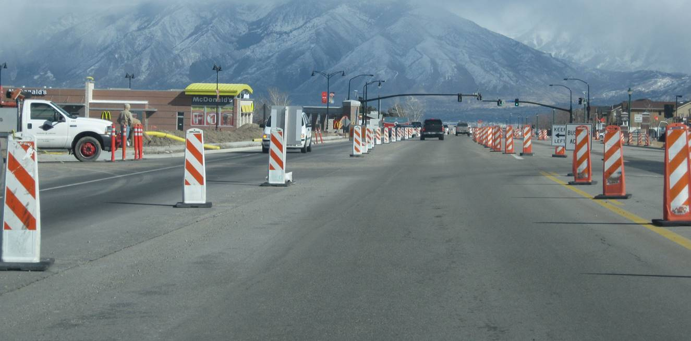

**Figure 1. Improper sign height among channelizing devices.**

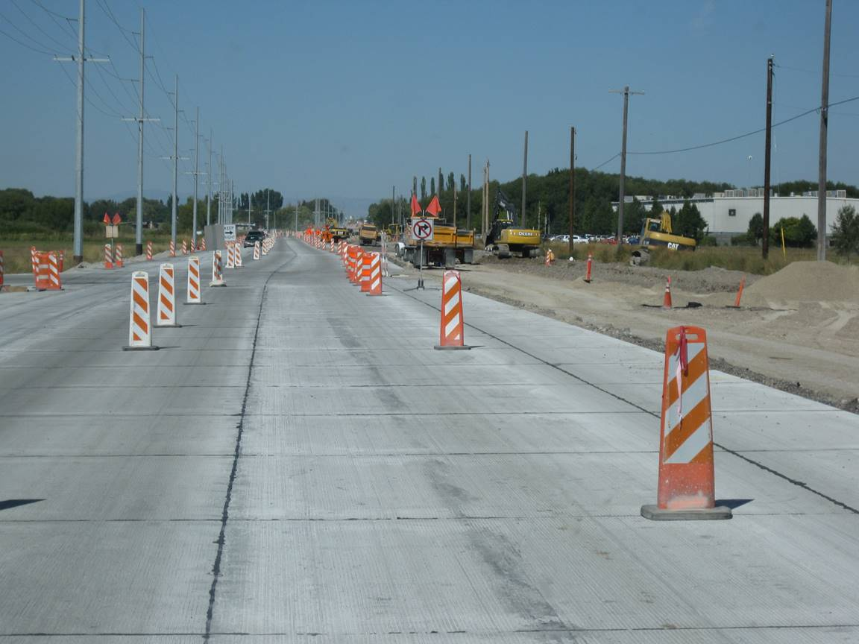

**Figure 2. Proper sign height among channelizing devices.**

**Temporary Sign Stand Examples**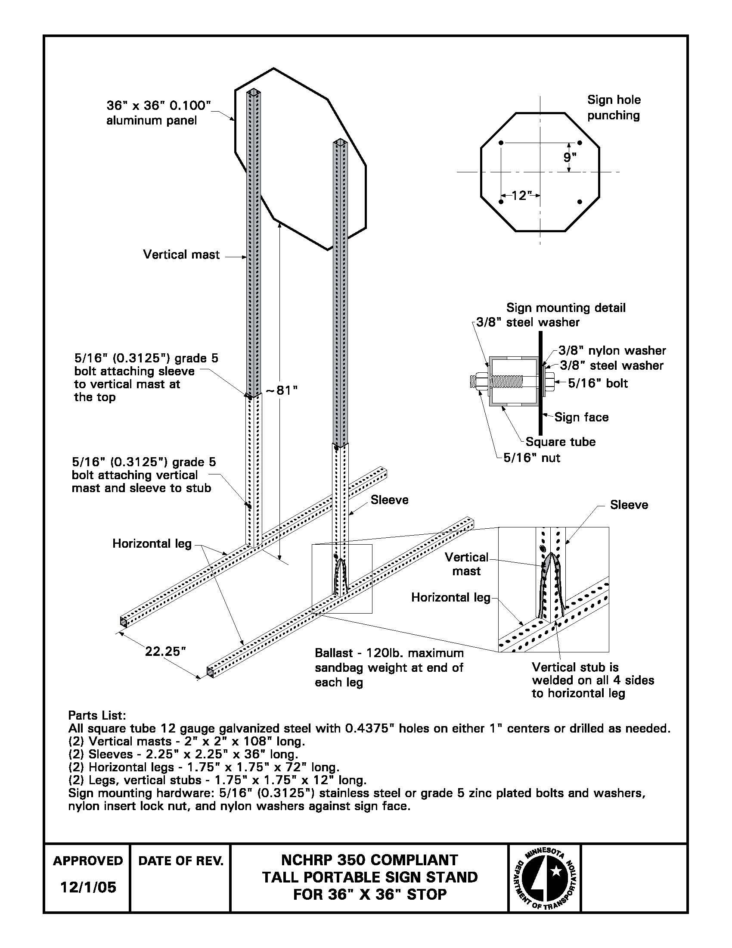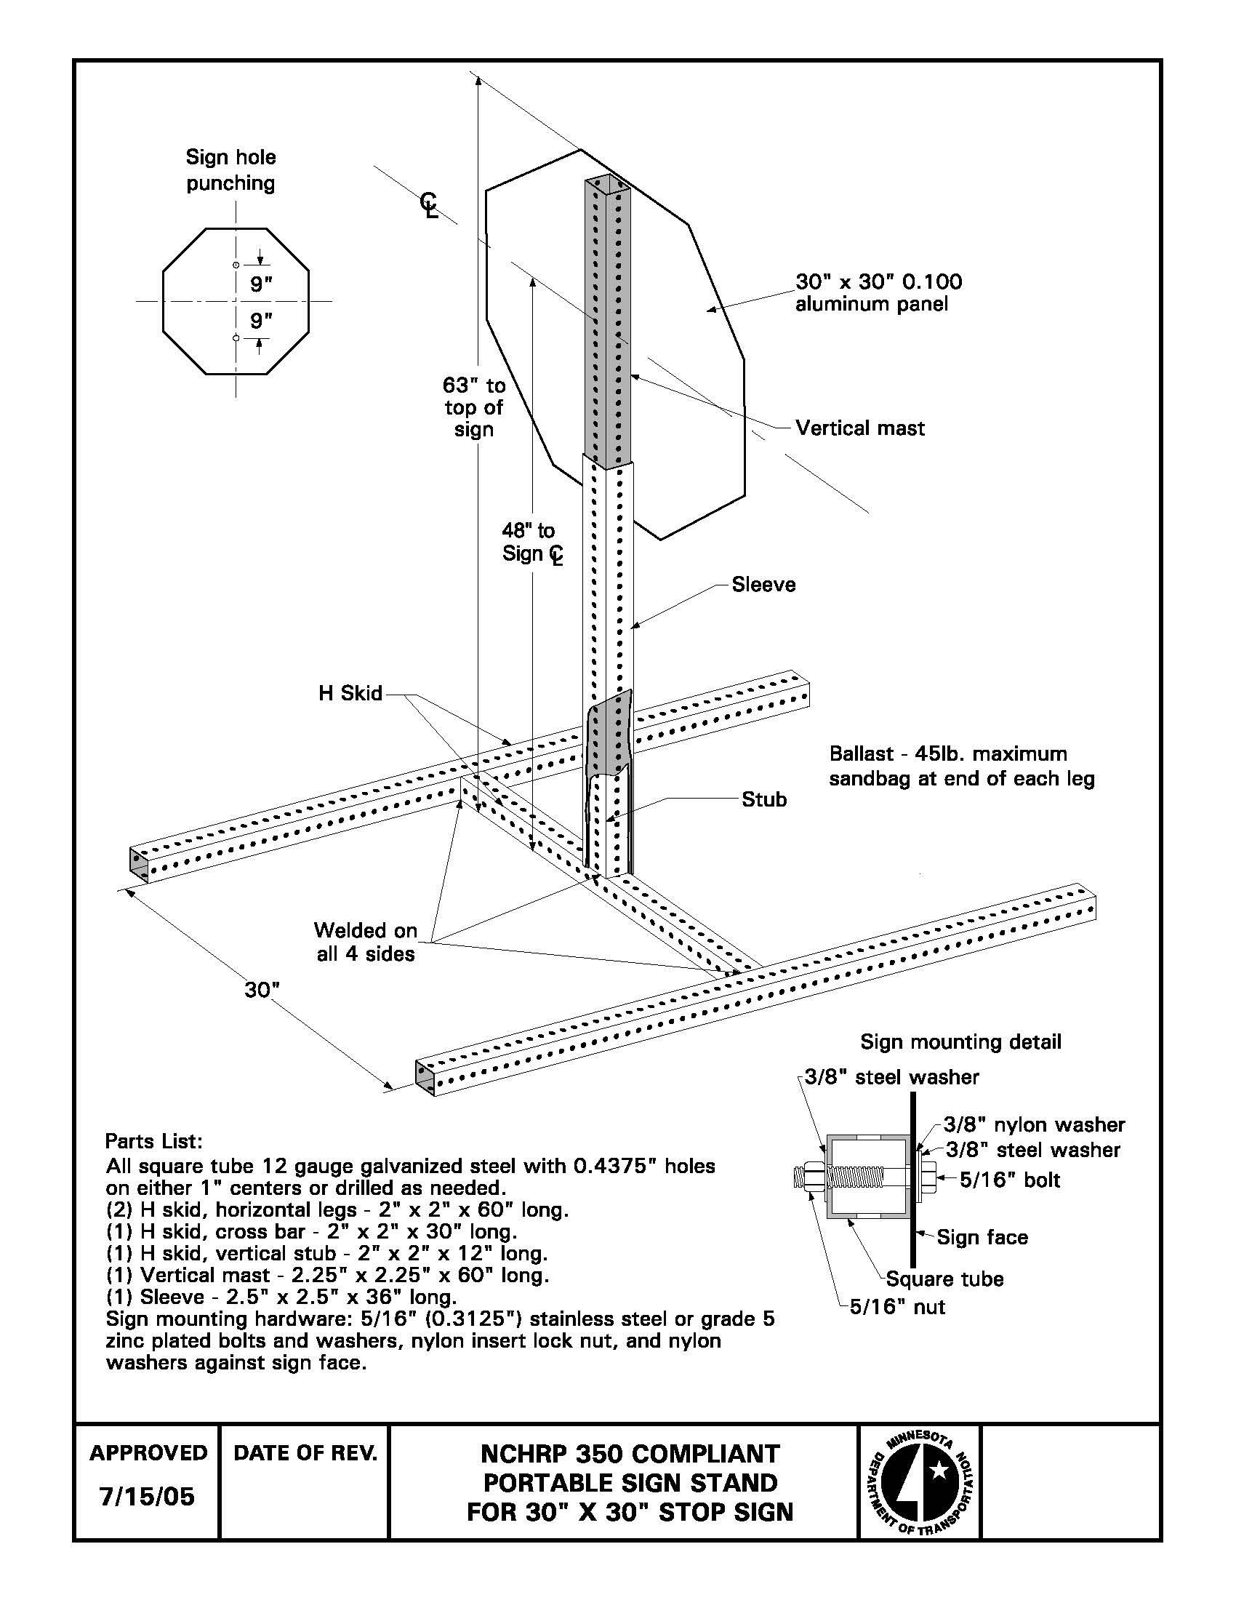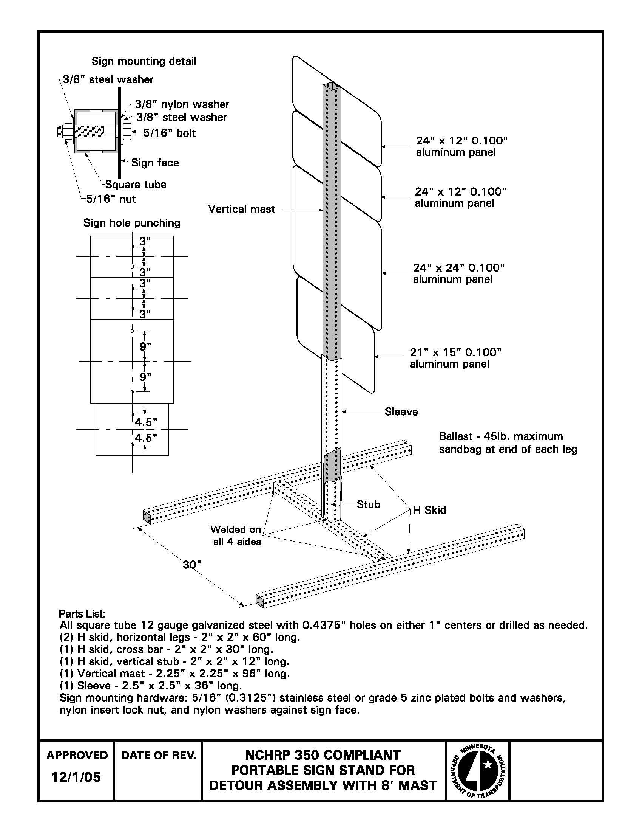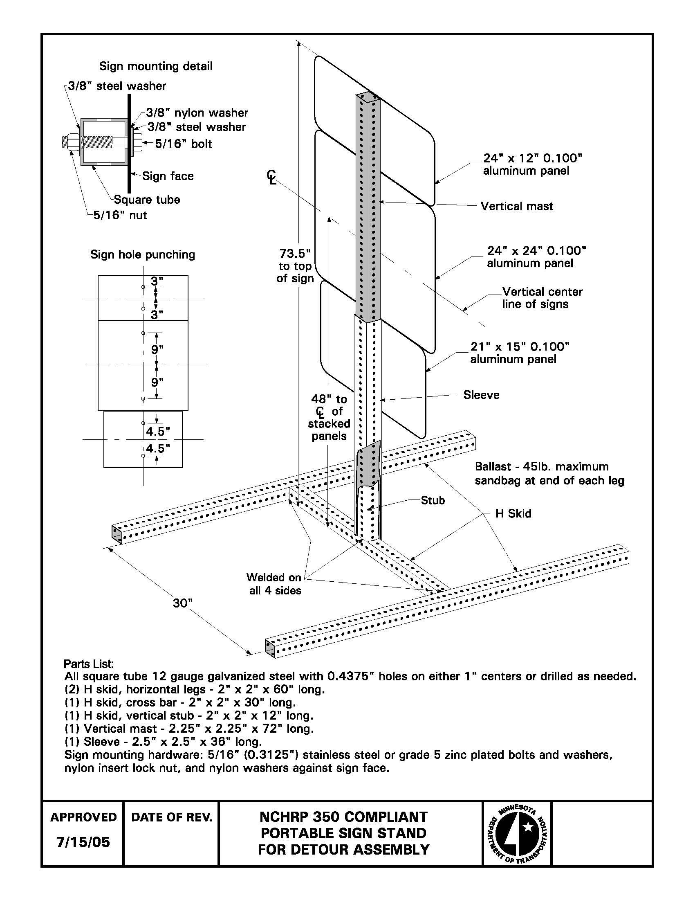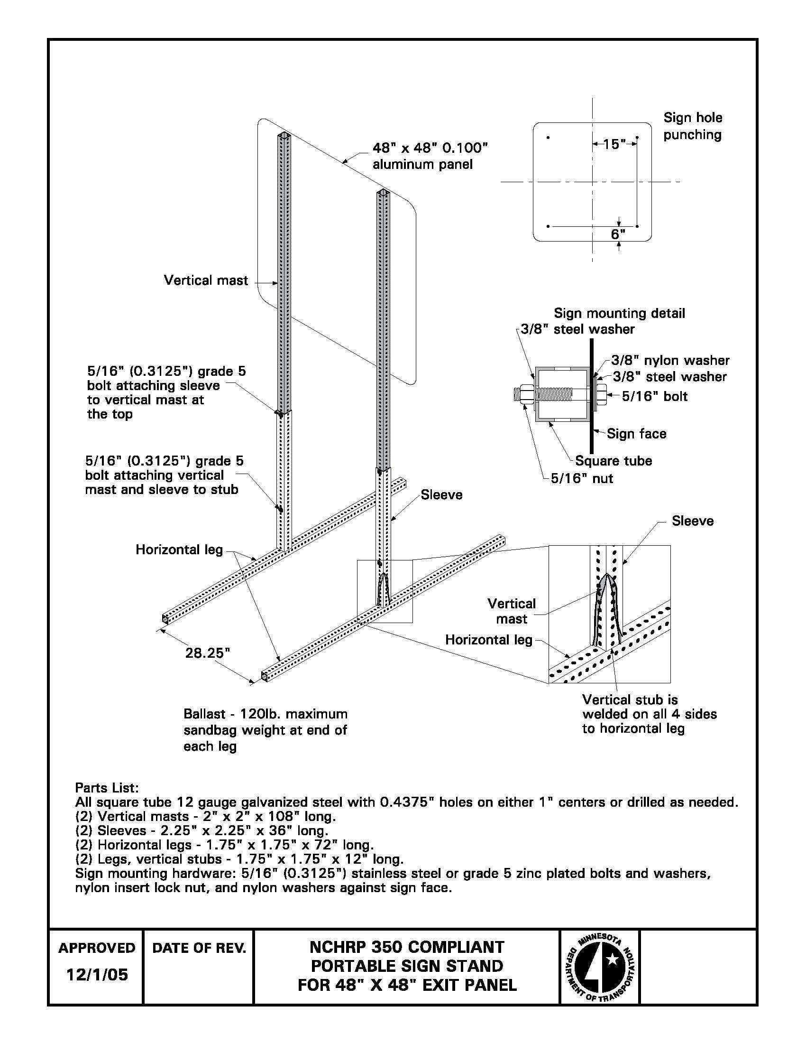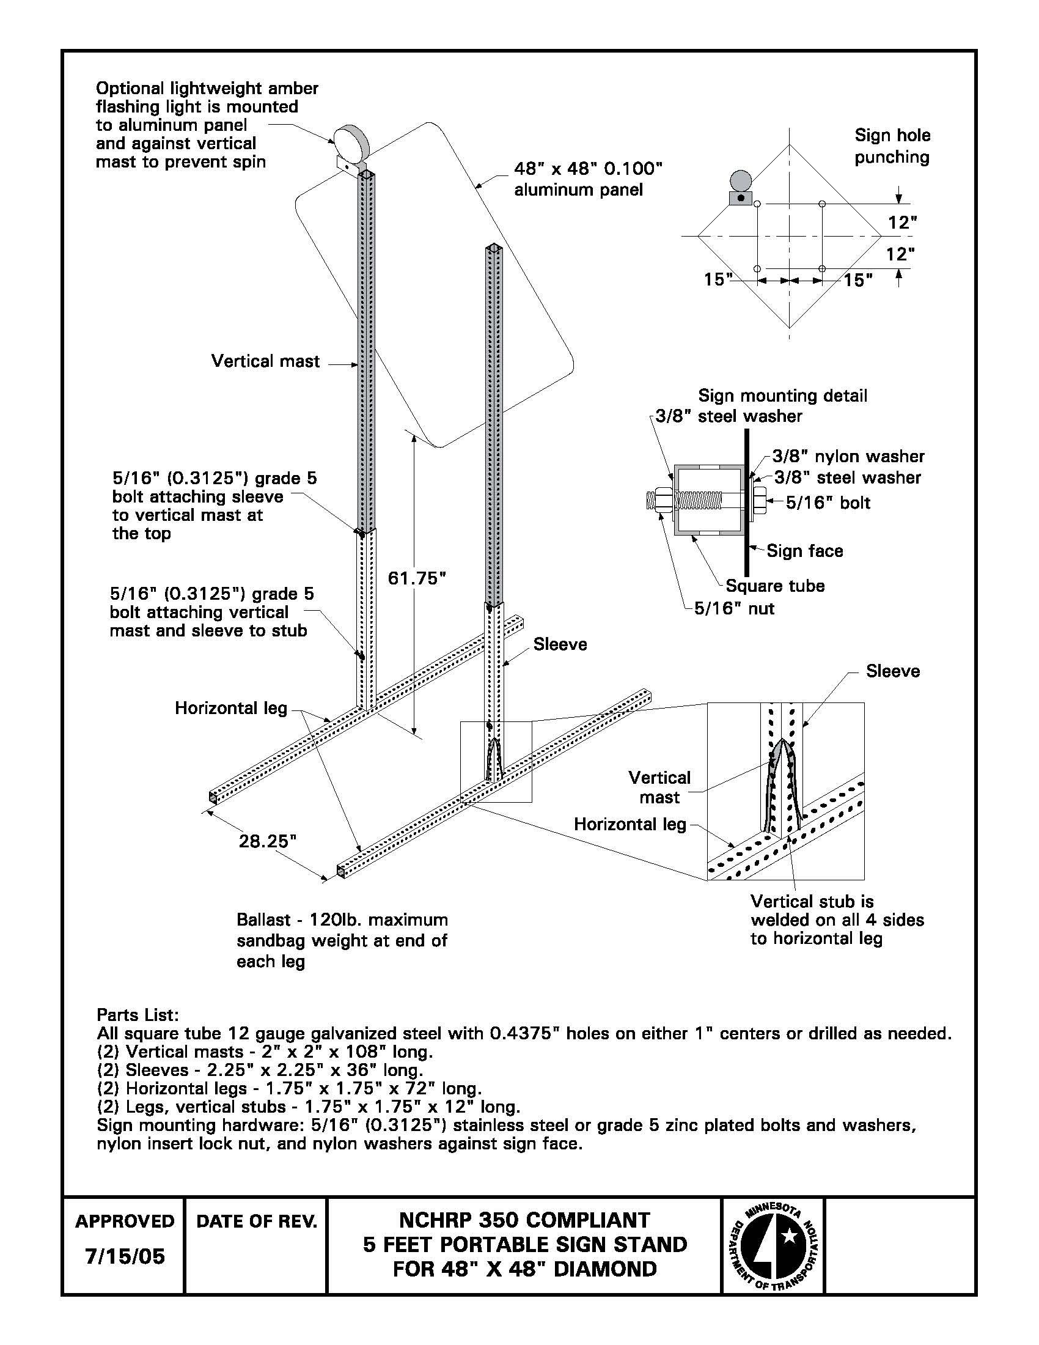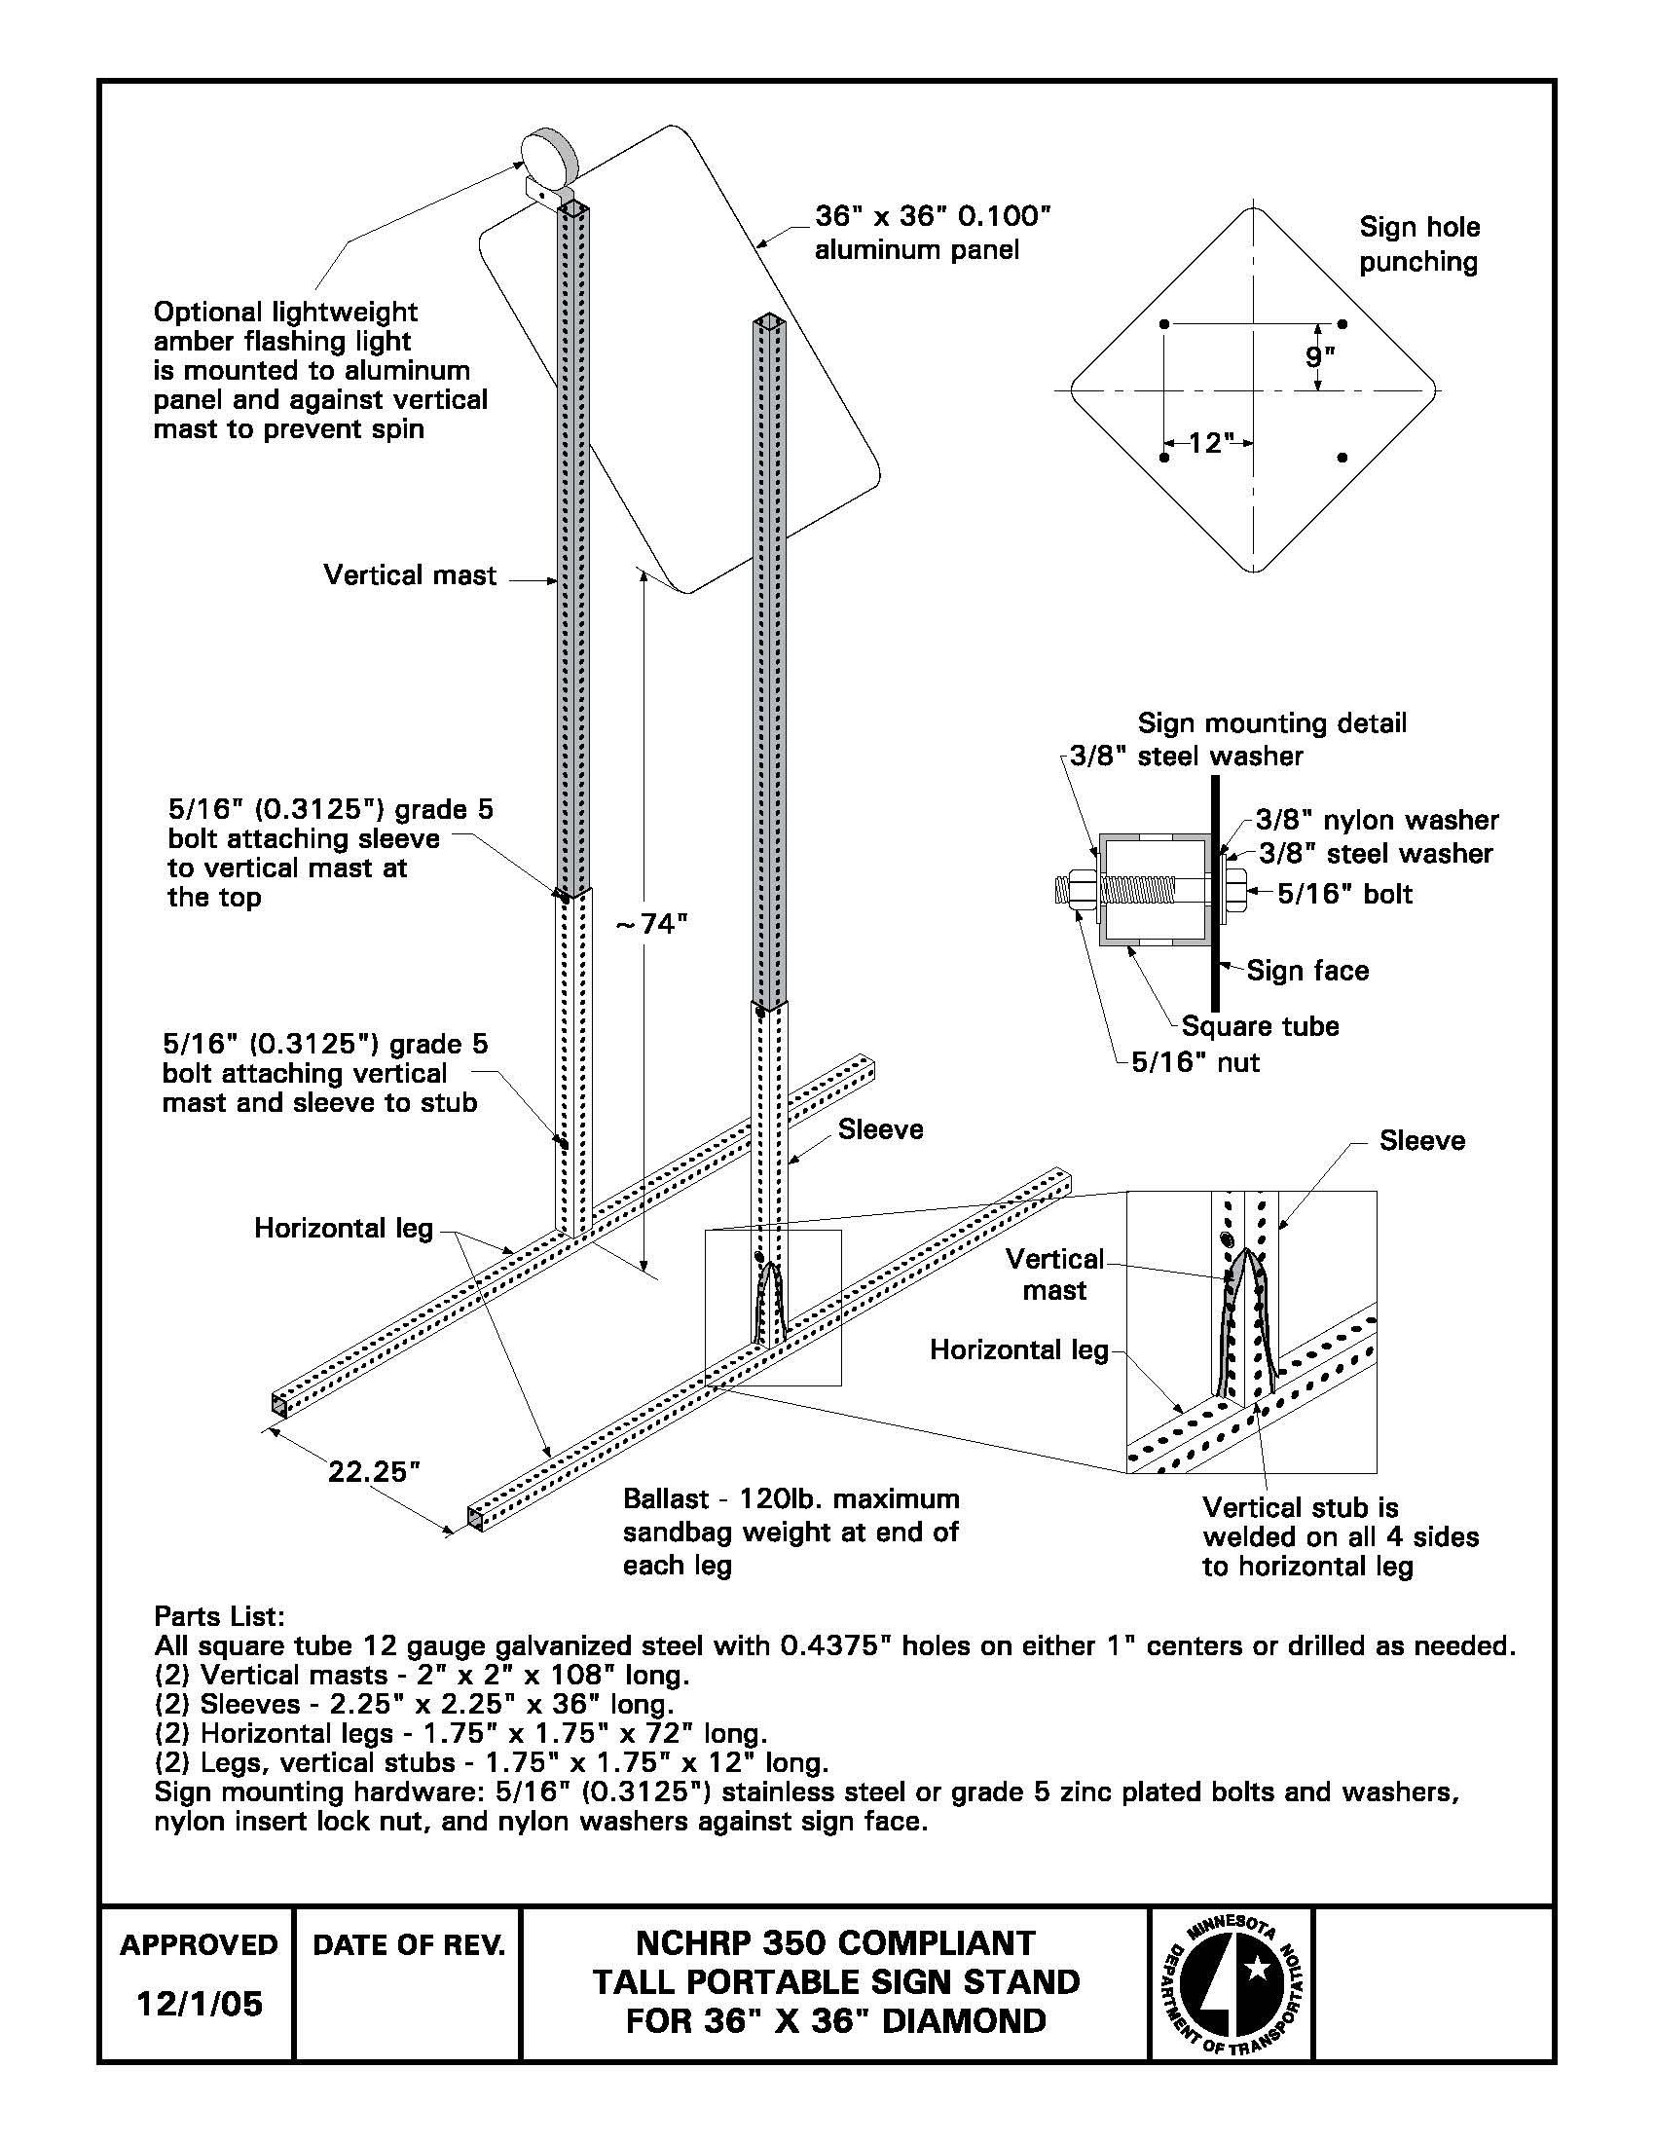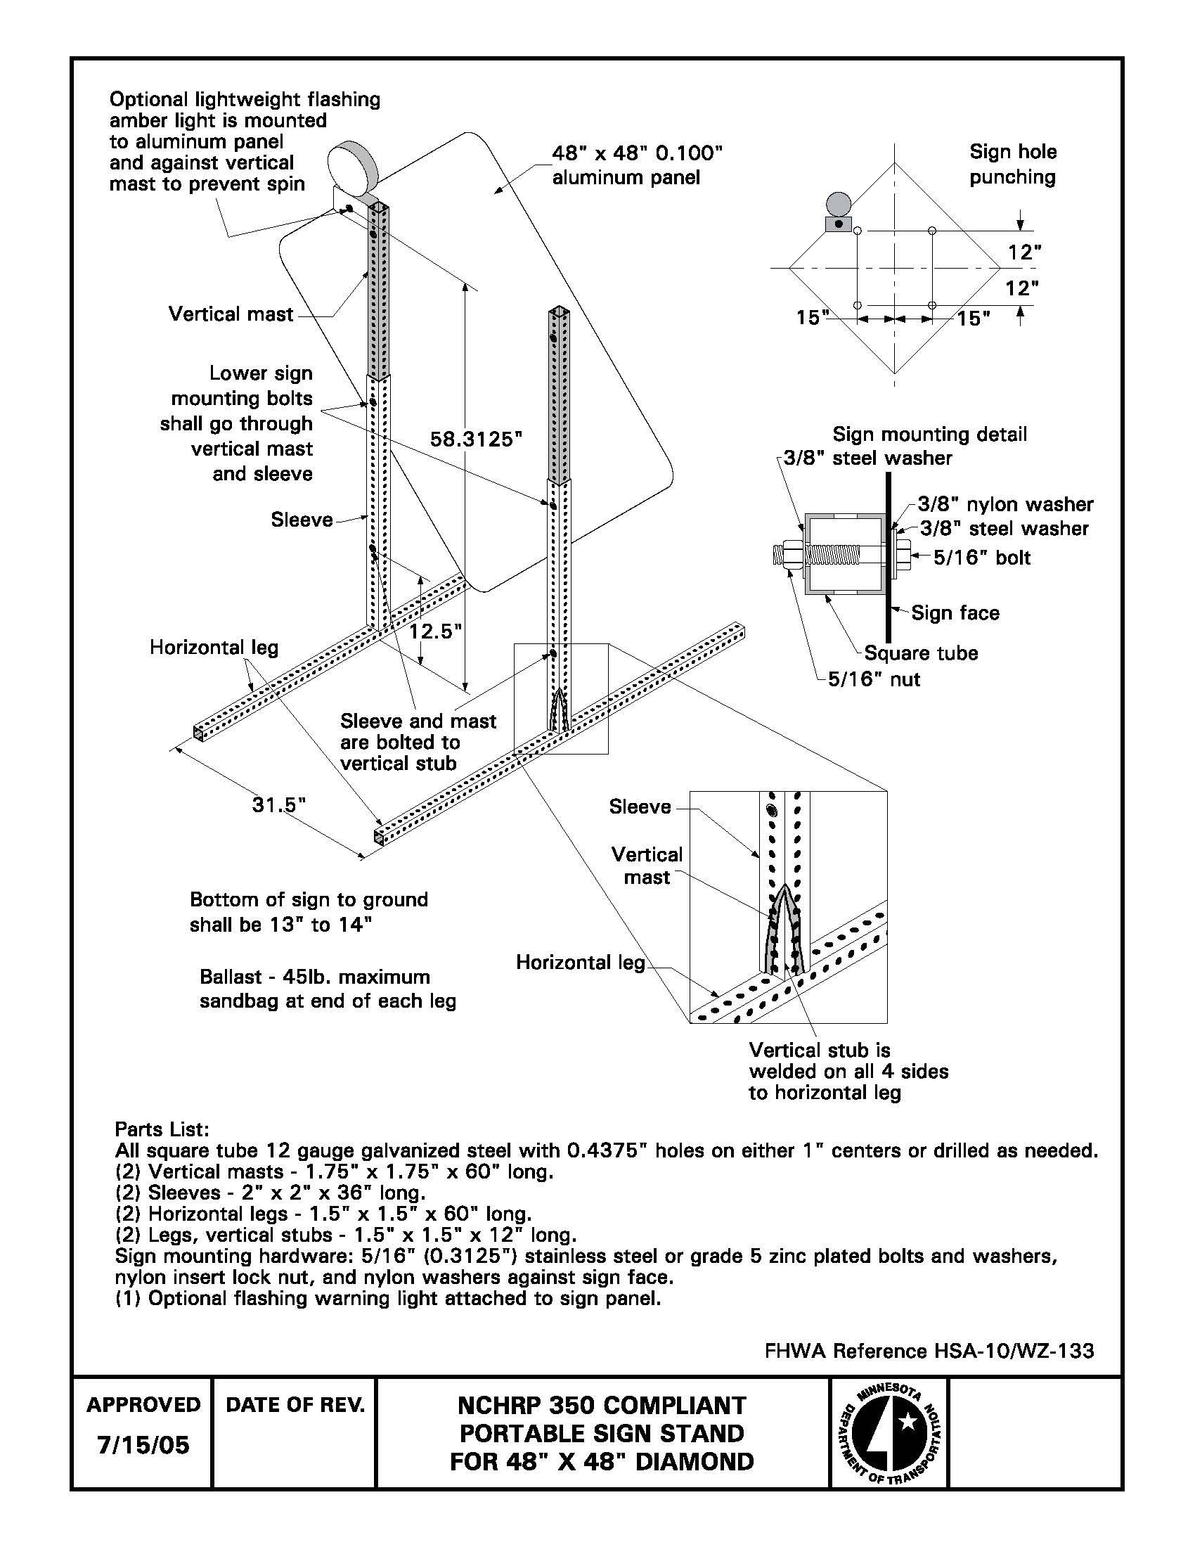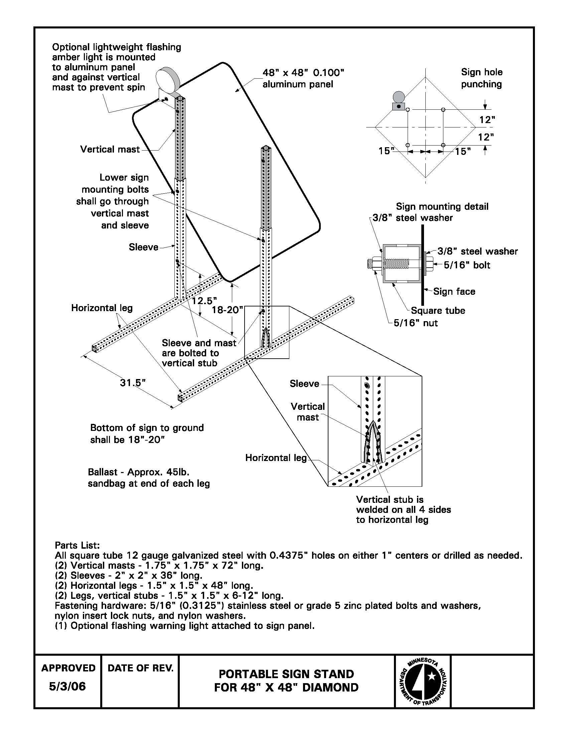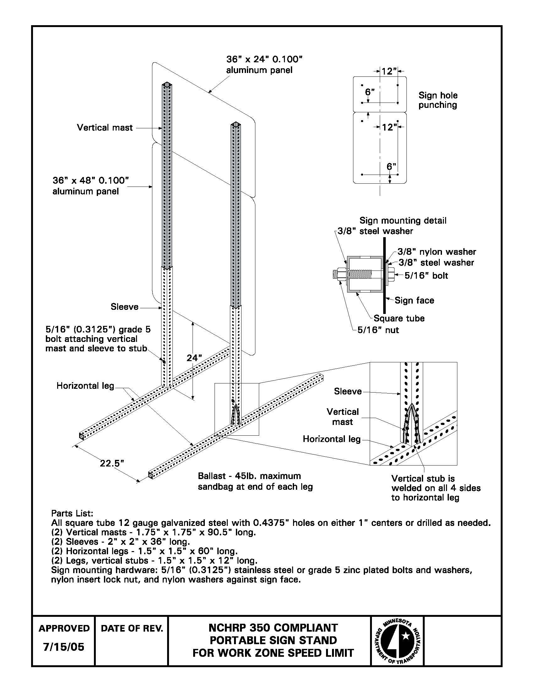

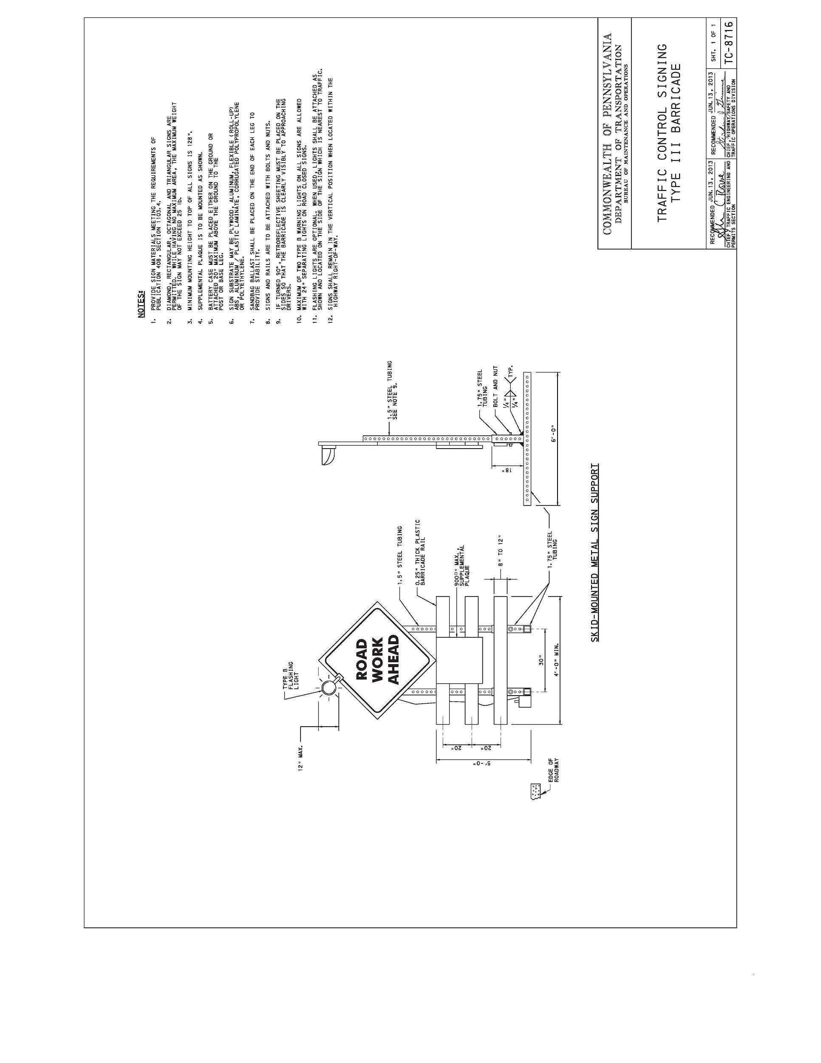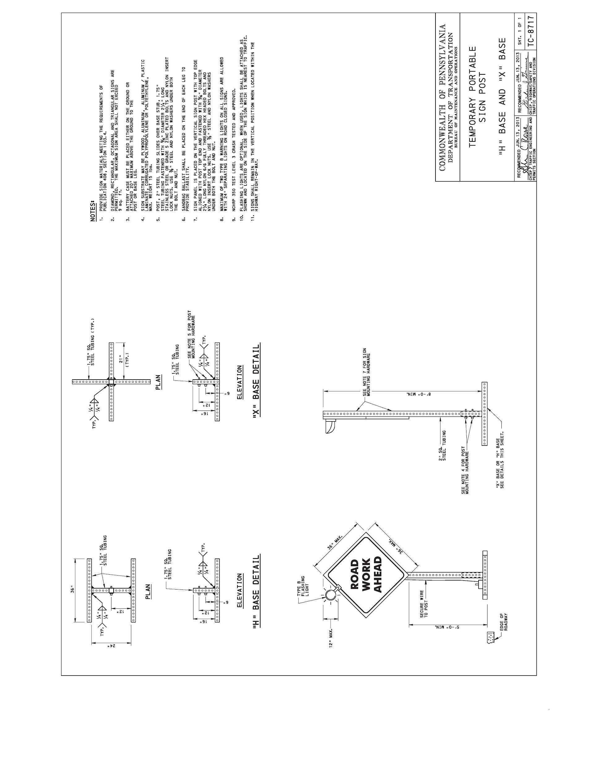



**2019-30-WZ**

**Research Problem Statement**

|  |  |
| --- | --- |
| **Project Title:** | Testing of ITS Sensor Attachments for Smart Work Zones |
| **Project Synopsis:** | The project will review existing literature, survey state use of ITS sensors for work zone applications, crash test a worst-case application with attachment location, weight, and size, and provide final guidance. |
| **Project Goal(s):** | Evaluate ITS sensors attached to sign systems for MASH compliance. Provide guidance for weight, size, and mounting location of sensor attachments. |
| **Project Background:** | Rear end crashes are the leading cause of work zone fatalities on the nations roadways. ITS sensors are a major part of reducing fatalities in work zones. Under NCHRP 350 these devices were often placed on trailers and categorized as Category 4 devices, which didn’t require testing based upon the net benefit these devices provided to the motoring public. There were also documents allowing a sensor to be attached to a sign system that didn’t take the net weight of that system over 600lbs to be approved. As it stands with MASH these sensors will need to be crash tested and for states to continue the use of queue detection systems the pooled fund study should evaluate a common method for mounting sensors of a generic weight and size. |
| **Proposed Work Plan:** | *Please describe what work or test will be done and what the result will be.*    The proposed work plan includes the following tasks:   * Literature Review and State Survey * Engineering Analysis * MASH TL-3 Crash Testing * Final Report |
| **Deliverables:** | Crash test report, photos, videos, summary of results and performance evaluation summary, ITS sensor attachment guidelines. The guidance would comprise of sensor size, weight, and mounting location. |
| **Urgency and Expected Benefit:** | MASH compliant ITS sensor use with work zone sign systems. |
| **Problem Funding and Research Period:** | *Please describe what are the estimated costs and time to complete the project*  The estimated costs to complete the proposed project is $110,000.Estimated time to complete the project is 12 months. |
| **Developer(s) of the Problem Statement:** | Name: Chris Brookes  Email: Brookesc@michigan.gov  Phone: 517-636-0300  Name: Ken Johnson  Email: [ken.johnson@state](mailto:ken.johnson@state).mn.us  Phone: |



**2019-31-WZ**

**Research Problem Statement**

|  |  |
| --- | --- |
| **Project Title:** | Generic sign cover for variable signs |
| **Project Synopsis:** | N/A |
| **Project Goal(s):** | Testing of Sign Covers for temporary and permanent signs. |
| **Project Background:** | Most work zone signs for long term projects are on driven posts (14 days in Michigan). The configuration of the work zone will change during the project either by open or closing lanes and the permanent and temporary signing is required to be modified. To due this, a common approach has been to cover signs with an old plywood sign with the back side facing outward and two hooks at the top. This method allows for reduced worker exposure as removing and placing these signs potentially daily is not practical and presents issue for worker and motorist safety. A generic method for covering signs is something that occurs in every state on every project and needs to be tested to continue being able to do business. |
| **Proposed Work Plan:** | **Tasks:**   1. **Literature Review and Engineering Analysis** 2. **Construction and Demolition** 3. **MASH TL-3 Full-Scale Crash Testing and Reporting**  * Note: Budgeting for four (4) full-scale crash tests |
| **Deliverables:** | Compile final report to document research effort, including literature review, CAD details, crash testing, and recommendations for further research in the event of the system failing testing criteria. |
| **Urgency and Expected Benefit:** | There are limitations on using soft covers due to the manufactures warranty of sign sheeting (some up to 15 years on permanent signs). Due to this, an approved and tested method needs to be evaluated. |
| **Problem Funding and Research Period:** | **Total Estimated Cost = $105,000**  **Work Schedule:** (Estimated Project Duration = 10 months from initiation of the project)  • Task 1 = 3 months  • Task 2 = 3 months  • Task 3 = 4 months |
| **Developer(s) of the Problem Statement:** | Name: Chris Brookes, Work Zone Delivery Engineer  Email: [Brookesc@Michigan.gov](mailto:Brookesc@Michigan.gov)  Phone: 517-636-0300 |



**2019-32-WZ**

**Research Problem Statement**

|  |  |
| --- | --- |
| **Project Title:** | **Effect of commonly used accessories such as Lights, sensors, sandbag ballast, and solar panels on crashworthiness of work zone category 1 and category 2 devices under MASH testing.** |
| **Project Synopsis:** | *Lightweight channelizing devices commonly referred as Category 1 devices have been allowed to continue to be self-certified under MASH testing requirements. Under NCHRP 350, drums with lights were allowed to continue to be self-certified. However, this has not been clarified under MASH. The researcher will evaluate the crashworthiness of Category 1 and Category 2 (Type I or Type II barricades) devices with attached accessories.* |
| **Project Goal(s):** | *Evaluation of Category 1 and Category 2 (Type I and Type II barricades) with attached accessories* |
| **Project Background:** | *Lightweight channelizing devices commonly referred as Category 1 devices have been allowed to continue to be self-certified under MASH testing requirements. Under NCHRP 350, drums with lights were allowed to continue to be self-certified. However, this has not been clarified under MASH. Furthermore, Category 2 devices need to be evaluated under MASH for crashworthiness with their appropriate accessories attached. Much testing has been completed on Type III barricades, and the Pooled Fund already has a problem statement for evaluating a Type III barricade with mounted signs.* |
| **Proposed Work Plan:** | *Task 1: Engineering Review*  *This task will review current Category 1 and Category 2 (Type I or Type II barricades) and available accessories. This task will also develop a testing plan for Task 2.*  *Task 2: MASH Crash Testing*  *This task will crash test Category 1 and Category 2 (Type I or Type II barricades) with mounted accessories.* |
| **Deliverables:** | -Guidance on mounting accessories on Category 1 devices.  -Non-proprietary crash tested designs for Type I and Type II barricades with mounted accessories  -Technical report documenting the work completed in this project |
| **Urgency and Expected Benefit:** | This project will provide the states with guidance on mounting accessories on Category 1 devices. The project will also provide the states with non-proprietary crash tested designs for Type I or Type II barricades. |
| **Problem Funding and Research Period:** | $130,000  12 months |
| **Developer(s) of the Problem Statement:** | Name: Juan Pava  Email: juan.pava@illinois.gov |



**2019-33-WZ**

**Research Problem Statement**

|  |  |
| --- | --- |
| **Project Title:** | Testing of a Generic Global “Warning” Sign Size |
| **Project Synopsis:** | The project will review existing literature, develop a generic sign size for testing, perform MASH crash testing, and provide final guidance. |
| **Project Goal(s):** | Evaluate global “warning” sign for MASH compliance. Provide guidance for acceptable mounting height and sign size. |
| **Project Background:** | Most state DOT place global informational signs in place during longer term construction projects to help promote awareness and increase the percentage of traffic detoured.  These signs can range in size and shape and under NCHRP 350 each size and layout was not specifically tested.  PCMS boards are a common replacement for this static sign but often are limited by the size and detail of the message, also PCMS are not MASH tested and are no longer exempt for crash testing as they were under NCHRP 350.  To continue being able to post global information work zone signs DOT should pick a standard size to design oversized messages on, so an approved system can be in place to adequately inform the motoring public. |
| **Proposed Work Plan:** | *Please describe what work or test will be done and what the result will be.*  The proposed work plan includes the following tasks:   * Literature Review * Survey of States * MASH TL-3 Crash Testing * Final Report |
| **Deliverables:** | Crash test report, photos, videos, summary of results and performance evaluation summary, warning sign size guidelines |
| **Urgency and Expected Benefit:** | Continued use of work zone signs for DOTs, which are MASH compliant. |
| **Problem Funding and Research Period:** | *Please describe what are the estimated costs and time to complete the project*  The estimated costs to complete the proposed project is $115,000.Estimated time to complete the project is 12 months. |
| **Developer(s) of the Problem Statement:** | Name: Chris Brookes  Email: brookesc@michigan.gov  Phone: 517-636-0300  Name: Ken Johnson  Email: ken.johnson@state.mn.us  Phone:  Name: Filiberto Sotelo  Email: Filiberto.sotelo@illinois.gov  Phone: |

**Notes**

**2019 Roadside Safety Pooled Fund Roster**

**TPF-5(343)**

**Alabama**

**1. Ron Johnson**

Asst. Bureau Chief, Research

Bureau of Research and Development

Alabama Dept. of Transportation

1409 Coliseum Boulevard

Montgomery, Alabama 36110

**(334) 353-6944**

(334) 850-2014 cell

[johnsonrl@dot.state.al.us](mailto:johnsonrl@dot.state.al.us)

**2. Stanley (Stan) C. Biddick, PE**

Assistant State Design Engineer

Design Bureau, Final Design Division

Alabama Dept. of Transportation

1409 Coliseum Boulevard, T-205

Montgomery, Alabama 36110

**(334) 242-6833 office**

(334) 850-0007 cell

[biddicks@dot.state.al.us](mailto:biddicks@dot.state.al.us)

**3. Steven E. Walker**

Alabama Dept. of Transportation

1409 Coliseum Blvd

Montgomery, AL 36110

**(334) 242-6488**

[walkers@dot.state.al.us](mailto:walkers@dot.state.al.us)

**Alaska**

**4. Jeff C. Jeffers, P.E.**

Statewide Standard Specifications

Alaska Department of Transportation &

Public Facilities

3132 Channel Drive

PO Box 112500

Juneau, AK 99811-2500

**(907) 465-8962**

[Jeff.jeffers@alaska.gov](mailto:Jeff.jeffers@alaska.gov)

**California**

**5. Bob Meline**

CalTrans

Office of Materials & Infrastructure

Division of Research & Innovation

5900 Folsom Blvd

Sacramento, CA 95819

**(916) 227-7031**

[Bob.meline@dot.ca.gov](mailto:Bob.meline@dot.ca.gov)

**6. John Jewell, P.E.**

Senior Crash Testing Engineer

Office of Safety Innovation and

Cooperative Research

Division of Research, Innovation & System

Information

5900 Folsom Blvd

Sacramento, CA 95819

**(916) 227-5824**

[John_jewell@dot.ca.gov](mailto:John_jewell@dot.ca.gov)

**Colorado**

**7. Joshua Keith, P.E.**

Colorado Dept. of Transportation

4201 E Arkansas Ave, 4th Floor

Denver, Colorado 80222

**(303) 757-9021**

[Josh.keith@state.co.us](mailto:Josh.keith@state.co.us)

**8. Joshua Palmer, P.E.**

Colorado Dept. of Transportation

Guardrail Engineer

2829 W. Howard PI

Denver, CO 80204

**(303) 757-9229**

(702) 769-5856 cell

[**Joshua.j.palmer@state.co.us**](mailto:Joshua.j.palmer@state.co.us)

**9. Chih Shawn Yu**

**(303) 757-9474**

[Shawn.yu@state.co.us](mailto:Shawn.yu@state.co.us)

**10. Andrew Pott, PE II**

**Staff Bridge**

**2829 W. Howard Pl., Room 309p**

**Denver, CO 80204**

**303-512-4020**

[**Andrew.pott@state.co.us**](mailto:Andrew.pott@state.co.us)

**Connecticut**

**11. David Kilpatrick**

State of Connecticut

Department of Transportation

2800 Berlin Turnpike

Newington, CT 06131-7546

**(860) 594-3288**

[David.Kilpatrick@ct.gov](mailto:David.Kilpatrick@ct.gov)

**Delaware**

**12. Mark Buckalew, P.E.**

Safety Program Manager

Delaware Dept. of Transportation

169 Brick Store Landing Road

Smyrna, DE 19977

**(302) 659-4073**

(302) 222-5905 cell

[Mark.Buckalew@state.de.us](mailto:Adam.Weiser@state.de.us)

**Florida**

**13. Derwood C. Sheppard, Jr., P.E.**

Standard Plans Publication Eng.

Florida Dept. of Transportation

Roadway Design Offices

605 Suwannee Street, MS-32

Tallahassee, FL 32399-0450

**(850) 414-4334**

[Derwood.sheppard@dot.state.fl.us](mailto:Derwood.sheppard@dot.state.fl.us)

**Idaho**

**14.** **Kevin Sablan**

Design and Traffic Engineer

Idaho Transportation Department

P.O. Box 7129

Boise, ID 83707-1129

**208-334-8558**

[Kevin.sablan@itd.idaho.gov](mailto:Kevin.sablan@itd.idaho.gov)

**15.** **Rick Jensen, P.E.**

ITD Bridge Design

P.O. Box 7129

Boise, ID 83707-1129

**(208) 334-8589**

[Rick.jensen@itd.idaho.gov](mailto:Rick.jensen@itd.idaho.gov)

**16.** **Shanon M. Murgoitio, P.E.**

Engineer Manager 1

ITD Bridge Design

Idaho Transportation Dept.

P.O. Box 7129

Boise ID 83703-1129

**(208) 334-8589**

[Shanon.murgoitio@itd.idaho.gov](mailto:Shanon.murgoitio@itd.idaho.gov)

**17**. **Marc Danley, P.E.**

Technical Engineer

Idaho Transportation Department

HQ Design/Traffic Services

P.O. Box 7129

Boise, ID 83707-1129

**(208) 334-8558**

[**marc.danley@itd.idaho.gov**](mailto:marc.danley@itd.idaho.gov)

**Illinois**

**18.** **Martha A. Brown, P.E.**

Illinois Dept. of Transportation

Safety Design Unit Chief

Bureau of Safety Programs and Engineering

2300 S. Dirksen Parkway, Room 005

Springfield, IL 62764

**(217) 785-3034**

[Martha.A.Brown@Illinois.gov](mailto:Martha.A.Brown@Illinois.gov)

**19. Tim Craven**

[Tim.craven@illinois.gov](mailto:Tim.craven@illinois.gov)

**20. Filiberto Sotelo – goes by Phil**

Safety Evaluation Engineer

Illinois Dept. of Transportation

Bureau of Safety Programs and Engineering

2300 South Dirksen Parkway, Room 005

Springfield, IL 62764

**(217) 557-2563**

[Filiberto.sotelo@illinois.gov](mailto:Filiberto.sotelo@illinois.gov)

**21. Jon M. McCormick**

Safety Policy & Initiatives Engineer

Illinois Department of Transportation

Office of Highways Project Implementation

Bureau of Safety Programs & Engineering

**(217) 785-5678**

[Jon.M.Mccormick@illinois.gov](mailto:Jon.M.Mccormick@illinois.gov)

**Louisiana**

**22. Chris Guidry,**

Bridge Manager

Louisiana Transportation Center

Bridge & Structural Design Section

P.O. Box 94245

Baton Rouge, LA 79084-9245

**(225) 379-1933**

[Chris.guidry@la.gov](mailto:Chris.guidry@la.gov)

**23. Kurt Brauner**

Bridge Manager

Louisiana Dept. Transportation

Development

Bridge & Structural Design Section

1201 Capitol Access Rd.

Baton Rouge, LA 70802

**(225) 379-1933**

[Kurt.Brauner@la.gov](mailto:Kurt.Brauner@la.gov)

**24. Brian Allen, P.E.**

Bridge Design Engineer

Bridge and Structural Design

Louisiana Dept. Transportation

Development

**(225) 379-1840**

[Brian.allen@la.gov](mailto:Brian.allen@la.gov)

**25. Steven Mazur**

Louisiana Dept. of Transportation &

Development

Bridge Design

1201 Capitol Access Rd, RM 605-D

Baton Rouge, LA 70802

**(225) 379-1094**

[Steven.Mazur@LA.GOV](mailto:Steven.Mazur@LA.GOV)

**Maryland**

**26. Jeff Robert**

Division Chief

Bridge Design Division

Office of Structures

707 N. Calvert Street, Mailstop C-203

Baltimore, MD 21202

**(410) 545-8327**

[jrobert@sha.state.md.us](mailto:jrobert@sha.state.md.us)

**27. Sharon D. Hawkins**

Project Manager

Office of Policy & Research, Research Division

707 N. Calvert Street, Mailstop C-412

Baltimore, MD 21202

**(410) 545-2920**

[Shawkins2@sha.state.md.us](mailto:Shawkins2@sha.state.md.us)

**Massachusetts**

**28.** **Alex Bardow**

Director of Bridges and Structure

Massachusetts Dept. of Transportation

10 Park Plaza, Room 6430

Boston, MA 02116

**(517) 335-9430**

[Alexander.bardow@state.ma.us](mailto:Alexander.bardow@state.ma.us)

**29. James Danila**

Assistant State Traffic Engineer

Massachusetts Dept. of Transportation

10 Park Plaza, Room 7210

Boston, MA 02116

**(857) 368-9640**

[James.Danila@state.ma.us](mailto:James.Danila@state.ma.us)

**Michigan**

**30.** **Carlos Torres, P.E.**

Crash Barrier Engineer

Michigan Dept. of Transportation

(MDOT)

Geometric Design Unit, Design Division

P.O. Box 30050

Lansing, MI 48909

**(517) 335-2852**

[torresc@michigan.gov](mailto:torresc@michigan.gov)

**Minnesota**

**31. Michael Elle, P.E.**

Design Standards Engineer

Minnesota Dept. of Transportation

395 John Ireland Blvd, M.S. 696

St. Paul, MN 55155-1899

**(651) 366-4622**

[Michael.elle@dot.state.mn.us](mailto:Michael.elle@dot.state.mn.us)

**32. Michelle Moser**

Assistant Design Standards Engineer

MnDOT-Office of Project Management and

Technical Support

**(651) 366-4708**

[Michelle.moser@state.mn.us](mailto:Michelle.moser@state.mn.us)

**Missouri**

**33. Sarah Kleinschmit, P.E.**

Policy and Innovations Engineer

MoDOT – Central Office Design

105 West Capitol

PO Box 270

Jefferson City, MO 65102

**(573) 751-7412**

[Sarah.Kleinschmit@modot.mo.gov](mailto:Sarah.Kleinschmit@modot.mo.gov)

**Mississippi**

**34. Heath T. Patterson, P.E.**

**MDOT -State Maintenance Engineer**

**Emergency Coordinating Officer**

**401 N. West Street**

**Jackson, Mississippi 39201**

**(601) 359-7113**

**Cell: (601) 613-1060**

[**hpatterson@mdot.ms.gov**](mailto:hpatterson@mdot.ms.gov)

**Ohio**

**35. Don P. Fisher, P.E.**

Ohio Department of Transportation

1980 West Broad Street

Mail Stop 1230

Columbus, Ohio 43223

Phone: 614-387-2614

[don.fisher@dot.ohio.gov](mailto:don.fisher@dot.ohio.gov)

**Oklahoma**

**36. Hebret Bokhru, P.E.**

Engineering Manager

Traffic Engineering Division

Oklahoma Dept. of Transportation

200 NE 21st street, 2-A7

Oklahoma City, OK 73105-3204

**Office (direct) (405) 522-5373**

**Office (Traffic Div.) (405) 521-2861**

[HBokhru@odot.org](mailto:HBokhru@odot.org)

**Oregon**

**37. Christopher Henson**

Sr. Roadway Engineer

Oregon Dept. of Transportation

Technical Services Branch

4040 Fairview Industrial Dr.

Salem, OR 97302

(**503) 986-3561**

[Christopher.s.henson@odot.state.or.us](mailto:Christopher.s.henson@odot.state.or.us)

**Pennsylvania**

**38. Guozhou Li**

**Pennsylvania DOT**

[guli@pa.gov](mailto:guli@pa.gov)

**39. Hassan Raza, P.E.**

Standards & Criteria Unit Manager

Highway Delivery

400 North Street, 7th Floor

Harrisburg, PA 17120

Pennsylvania DOT

**(717) 783-5110**

[Hraza@pa.gov](mailto:Hraza@pa.gov)

**Tennessee**

**40. Ali Hangul, P.E., CPESC/Assistant**

Director headquarters Roadway Design

and Office of Aerial Surveys

James K. Polk Bldg., 13th floor

505 Deaderick St.

Nashville, TN 37243

**(615) 741-0840**

[Ali.hangul@tn.gov](mailto:Ali.hangul@tn.gov)

**Texas**

**41. Chris Lindsey**

Texas Dept. of Transportation

Design Division

125 E. 11th St.

Austin, TX 8701-2483

**(512) 416-2750**

[Christopher.lindsey@txdot.gov](mailto:Christopher.lindsey@txdot.gov)

**42. Wade Odell**

Texas Dept. of Transportation

Research & Technology Implementation

Division

200 E. Riverside Dr.

Austin, TX 78704

wade.odell@txdot.gov

**43. Taya Retterer P.E.**

Texas Dept. of Transportation

Bridge Division

125 E 11th ST.

Austin, TX 78701

**(512) 416-2719**

[Taya.Retterer@txdot.gov](mailto:Taya.Retterer@txdot.gov)

**Utah**

**44. Shawn Debenham**

Traffic and Safety Division

4501 South 2700 West

PO Box 143200

Salt Lake City UT 84114-3200

**(801) 965-4590**

[sdebenham@utah.gov](mailto:sdebenham@utah.gov)

**Washington**

**45.** **John Donahue**

Design Policy and Analysis Manager

Washington State Dept. of Transportation

Development Division

P.O. Box 47329

Olympia, WA 98504-7246

**(360) 704-6381**

[donahjo@wsdot.wa.gov](mailto:donahjo@wsdot.wa.gov)

**46. Mustafa Mohamedali**

Assistant Research Project Manager

Washington State Dept. of Transportation

Development Division

P.O. Box 47372

Olympia, WA 98504-7372

**(360) 704-6307**

[Mohamem@wsdot.wa.gov](mailto:Mohamem@wsdot.wa.gov)

**47. Anne Freeman**

Program Administrator,

Research & Library Services.

Washington State Dept. of Transportation

P.O. Box 47372

Olympia, WA 98504-7372

**(360) 705-7945**

[**Freeann@wsdot.wa.gov**](mailto:Freeann@wsdot.wa.gov)

**West Virginia**

**48. Donna Hardy**

Safety Programs Engineer

WV DOT – Traffic Engineering

Building 5, Room A-550

1900 Kanawha Blvd, E

Charleston, WV 25305-0430

**(304) 558-9576**

[Donna.j.hardy@wv.gov](mailto:Donna.j.hardy@wv.gov)

**49.** **Joe Hall, P.E., P.S.**

**WV** DOT

Division of Highways & Engineering

Technical Policy QA/QC Engineer

Value Engineering Coordinator

1334 Smith Street

Charleston, WV 25301

**(304) 558-9733**

[Joe.H.Hall@wv.gov](mailto:Joe.H.Hall@wv.gov)

**50.**  **Ted Whitmore**

Traffic Services Engineer

WV DOT – Traffic Engineering

Building 5, Room A-550

1900 Kanaha Blvd, E

Charleston, WV 25305-0430

**(304) 558-9468**

[Ted.J.Whitmore@wv.gov](mailto:Ted.J.Whitmore@wv.gov)

**Wisconsin**

**51. Erik Emerson**

Standards Development Engineer –

Roadside Design

Wisconsin Dept. of Transportation

Bureau of Project Development

4802 Sheboygan Ave. Room 651

P.O. Box 7916

Madison, WI 53707-7916

**(608) 266-2842**

[Erik.Emerson@wi.gov](mailto:Erik.Emerson@wi.gov)

***Ontario, Canada***

**52. Kenneth Shannon, P.E.**

**Senior Engineer, Highway Design (A)**

301 St. Paul Street

St. Catharines, ON, L2R 7R4

**(904) 704-3106**

[Kenneth.Shannon@ontario.ca](mailto:Kenneth.Shannon@ontario.ca)

***FHWA***

**53.** **Richard B. (Dick) Albin, P.E.**

Safety Engineer

FHWA Resource Center Safety and Design

Technical Services Team

711 S. Capital

Olympia, WA 98501

**Cell: (303) 550-8804**

[Dick.albin@dot.gov](mailto:Dick.albin@dot.gov)

**54. Eduardo Arispe**

Research Highway Safety Specialist

U.S. Dept. of Transportation

Federal Highway Administration

Turner-Fairbank highway Research Center

Mail Code: HRDS-10

6300 Georgetown Pike

McLean, VA 22101

**(202) 493-3291**

[Eduardo.arispe@dot.gov](mailto:Eduardo.arispe@dot.gov)

**55. Greg Schertz, PE**

FHWA – Federal Lands Highway Division

Safety Discipline Champion

12300 West Dakota Ave. Ste. 210

Lakewood, CO 80228

**(720)-963-3764**

**(303)-588-4042 - cell**

[Greg.Schertz@dot.gov](mailto:Greg.Schertz@dot.gov)

**56. Christine Black**

Highway Safety Engineer

Central Federal Lands Highway Division

12300 W Dakota Ave

Lakewood, CO 80228

(720) 963-3662

[Christine.black@dot.gov](mailto:Christine.black@dot.gov)

**TTI**

**57.** **D. Lance Bullard, Jr., P.E.**

Texas A & M Transportation Institute

Senior Research Engineer

Roadside Safety & Physical Security Division

3135 TAMU

College Station, TX 77843-3135

**Office: (979) 317-2855**

[L-Bullard@tti.tamu.edu](mailto:L-Bullard@tti.tamu.edu)

**58.** **Roger P. Bligh Ph.D., P.E.**

Texas A & M Transportation Institute

Senior Research Engineer

Roadside Safety & Physical Security Division

3135 TAMU

College Station, TX 77843-3135

**Office: (979) 317-2703**

[R-Bligh@tti.tamu.edu](mailto:R-Bligh@tti.tamu.edu)

**59. Chiara Silvestri Dobrovolny, Ph.D.**

Associate Research Scientist

Texas A&M Transportation Institute

3135 TAMU

College Station, TX 77843-3135

**(979) 317-2687**

[c-silvestri@ttimail.tamu.edu](mailto:c-silvestri@ttimail.tamu.edu)

<Http://tti.tamu.edu>