Research Problem Statement

Project Title: | MASH Testing of Square (Solid and Perforated) and Round Tube Sign Posts with Flashing Beacon Equipment (2023-01-BD)
Project Synopsis: | Flashing beacons are regularly added to standard roadside sign installations for various reasons. The installation of this equipment alters both the weight and the wind loading of the sign structure, which may affect the performance of any installed breakaway device or interactions with a colliding vehicle.  The purpose of this research is to determine if standard breakaway features continue to function as designed and previously tested when flashing beacon equipment is added to a standard roadside sign installation.  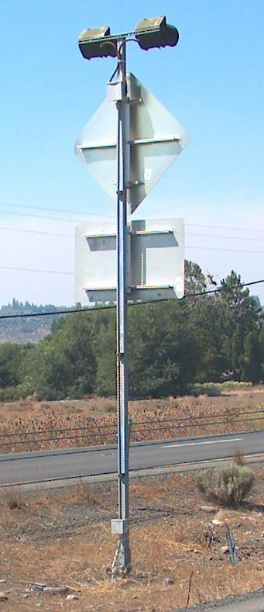
Project Goal(s): | - Determine crashworthiness of standard sign supports when flashing beacon equipment is added.  - Determine threshold of sign support sizes/types that retain crashworthiness, such as sign supports over a certain size or specific types of breakaway bases.
Project Background: | Flashing beacon systems are frequently added to signs to provided additional emphasis, stronger alerts to drivers, or perform a specific function related to a “when flashing” message. Sign supports that have been proven to meet MASH requirements may no longer do so when flashing beacon equipment is installed.
Proposed Work Plan: | - Task 1 – Investigate installation conditions for flashing beacons on standard sign supports. Determine a few basic types of beacon installations, such as: hard wired with compact control box, solar with separate panel and control box, and self-contained solar (“post-topper” type) for evaluation  - Task 2 – Engineering analysis and computer simulation. Determine appropriate representative sign support types and sizes for further evaluation.  - Task 3 – Drawings and system construction/configuration.  - Task 4 – Full scale crash testing  - Task 5 – Report and recommendations
Deliverables: | Final report documenting research and testing performed and conclusions reached. Documentation of MASH compliance for applicable installation types.
Urgency and Expected Benefit: | Moderate urgency, as these configurations are already in use in the field but there is no repository of information on collision outcomes.  Benefit is to provide FHWA and State DOTs with more concrete information regarding the crashworthiness of sign supports when flashing beacon equipment is added, and which support configurations should not be used for flashing beacon installations.
Problem Funding and Research Period: | Total Estimated Cost = $XX,XXX
Developer(s) of the Problem Statement: | Name: Flint Jackson, WSDOT  Email: JacksFl@wsdot.wa.gov  Phone: (360) 705-7392

