College Station, Texas, September 27-28
Tuesday, September 27th (Day 1)

8:30 | Welcome and Introductions (Tim Moeckel WSDOT) | 15 min.
8:45 | Organization Overview (Tim Moeckel WSDOT) – Go over Charter  Remaining TPF 5(343) Funds (Tim Moeckel WSDOT) - Consider expenditure of excess remaining funds | 15 min.
9:00 | Business Meeting (Mustafa Mohamedali WSDOT) | 30 min.
9:30 | Midwest Pooled Fund Program Overview (Derwood Sheppard FDOT) | 45 min.
10:15 | Morning Break | 15 min.
10:30 | TTI Ongoing Research Status (TTI – various lead researchers) | 1 hr. 30 min.
12:00 | Lunch Break | 1 hr.
1:00 | FHWA & TCRS Updates (Eduardo Arispe FHWA & Eric Emerson WisDOT) | 45 min.
1:45 | Proposal presentations/Q&A (Breakaway Devices, Work Zone, & Bridge Rails – 2 Problem Statements Each = 6 Total) | 1 hr. 30 min.
3:15 | Afternoon Break | 15 min.
3:30 | Group Forum | 1 hr. 30 min.
5:00 | Adjourn
6:30 | Optional Group Dinner – To be discussed during meeting
Wednesday, September 28th (Day 2)

8:30 | Roadside Safety Pooled Fund Website Overview (Ariel Sheil - TTI) | 30 min.
9:00 | Proposal presentations/Q&A (Longitudinal Concrete Barriers – 5 Problem Statements) | 1 hr. 15 min.
10:15 | Morning Break | 15 min.
10:30 | Crash Test (Gather, Travel to Site, View Crash Test, & Return) | 1 hr. 30 min.
12:00 | Lunch Break | 1 hr.
1:00 | Proposal presentations/Q&A (Longitudinal Semi-Rigid Barriers – 6 Problem Statements) | 1 hr. 30 min.
2:30 | Afternoon Break | 15 min.
2:45 | Voting | 1 hr. 45 min.
4:30 | Adjourn
Thursday, September 29th (Optional TF-13 Meeting)

8:00 | TF-13/Pooled Fund Roundtable Meeting (meeting will be held at the George Hotel - Stables II room at Cavalry Court) | 2 hr.
10:00 | Adjourn Meeting

Map and Directions to Meeting
There are two entries to RELLIS Campus. The original one on Hwy 47 (red line) and a new one on Hwy 21 (blue line) next to the Center for Infrastructure Renewal (CIR). On Hwy 21, drive west past the campus, turn left to U-turn back east, then enter a deceleration lane. Turn right at the CIR building. The Meeting will be held in the TTI Headquarters (the building marked with the red pin on the map), Room 1122/1124 (the conference room to the left of the front desk as you enter the building).
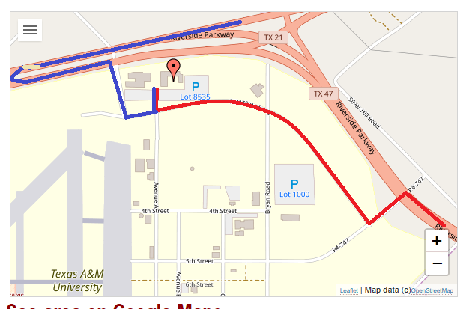
Parking at TTI Headquarters

You may park in any spot in Lot 8535. Please take the following steps to obtain a parking pass each day:
*This must be done each morning as the pass is only good for one day*
- Take a photo or notate your license plate number
- Stop at the front desk of the TTI Headquarters building with your license plate number and $5.00 payment.
Additional Info

Please note that you will need to wear closed-toe shoes for your safety when viewing the crash test and going to the crash test site.
Also, although we’ll spend a lot of time in the air-conditioned conference room (can be chilly!), please note that the weather in College Station is planned to be hot and sunny for Monday (and for the next two days for those of you are staying for the MASH pooled fund). Plan accordingly, and don’t forget hat and sunscreen!!
